

**Module Code & Module Title**

**CC6001NI - Advanced Database System Development**

**Assessment Weightage & Type**

**40% Individual Coursework**

**Year and Semester**

**2020-21 Autumn**

**Student Name: Suyogya Luitel**

**Group: C3**

**London Met ID: 19031784**

**College ID: NP01CP4A190035**

**Assignment Due Date: 23rd March 2022**

**Assignment Submission Date: 23rd March 2022**

I confirm that I understand my coursework needs to be submitted online via Google Classroom under the relevant module page before the deadline for my assignment to be accepted and marked. I am fully aware that late submissions will be treated as non-submission and a mark of zero will be awarded.

**Table of Contents**

1. Introduction 1

2. Textual Analysis 2

2.1. Teacher-Module 2

2.2. Student-Module 2

2.3. Student-Assignment 2

2.4. Department-Fees-Assignment-Result 3

3. ERD From Case Study 4

4. Normalization 5

4.1. Figure 1: Example of Teacher allocation list 5

4.1.1. UNF 6

4.1.2. 1NF 6

4.1.3. 2NF 7

4.1.4. 3NF 9

4.1.5. Final entities from figure 1 11

4.2. Fig 2: Example of Assignment and Examination Results 12

4.2.1. UNF 12

4.2.2. 1NF 13

4.2.3. 2NF 14

4.2.4. 3NF 17

4.2.5. Final entities from figure 2 19

5. Integration and Assumptions 20

6. Final ERD 22

7. Data Dictionary 23

7.1. Table: Teacher 23

7.2. Table: Student 24

7.3. Table: Address 25

7.4. Table: Department 26

7.5. Table: Assignment 27

7.6. Table: Grade 28

7.7. Table: Module 29

7.8. Table: Module_Student 30

7.9. Table: Module_Teacher 31

7.10. Table: Semester 32

7.11. Table: Student_Assignment 33

7.12. Table: Student_Attendance 34

7.13. Table: Student_Fees 35

7.14. Table: Address_Teacher 37

8. DDL Script 38

8.1. Script 38

8.2. Output 48

9. INSERT Statements 54

9.1. Teacher 54

9.2. Student 55

9.3. Semester 56

9.4. Module 57

9.5. Grade 58

9.6. Department 59

9.7. Address 60

9.8. Assignment 61

9.9. Student_Fees 62

9.10. Student_Attendance 63

9.11. Student_Assignment 64

9.12. Module_Teacher 65

9.13. Module_Student 66

9.14. Address_Teacher 67

10. SELECT Statements 68

10.1. Address 68

10.2. Address_Teacher 69

10.3. Assignment 70

10.4. Grade 71

10.5. Module 72

10.6. Module_Student 73

10.1. Module_Teacher 74

10.1. Semester 75

10.1. Student 76

10.1. Student_Assignment 77

10.1. Student_Attendance 78

10.1. Student_Fees 80

10.1. Teacher 81

11. Forms 82

11.1. Dashboard 82

11.2. Basic Forms 83

11.2.1. Teacher Form 83

11.2.2. Address Form 84

11.2.3. Module Form 85

11.2.4. Department Form 86

11.2.5. Student Form 87

11.3. Complex Forms 88

11.3.1. Teacher-Module Mapping 88

11.4. Student-Fees Mapping 91

11.5. Student-Assignment Mapping 93

12. User Manual 95

12.1. Included Content 95

12.2. Landing Page 96

12.3. Teacher Form 97

12.4. Address Form 98

12.5. Module Form 99

12.6. Department Form 100

12.7. Student Form 101

12.8. Teacher-Module Form 102

12.9. Student-Fees Form 103

12.10. Student-Assignment Form 104

13. Testing 105

13.1. Basic Forms 105

13.1.1. Teacher Form 105

13.1.2. Address Form 116

13.1.3. Module Form 129

13.1.4. Department Form 139

13.1.5. Student Form 149

13.2. Complex Forms 158

13.2.1. Teacher-Module Mapping Form 158

13.2.2. Student-Fees Mapping Form 162

13.2.3. Student-Assignment Mapping Form 166

14. Further Discussion 168

15. Conclusion 169

**Table of Figures**

Figure 1: Relation between Module and Teacher 2

Figure 2: Relation between Module and Student 2

Figure 3: Relation between Student and Assignment 3

Figure 4: Relation between Department with Fees, Assignments and Results 3

Figure 5: Initial ERD from Case Study 4

Figure 6: Final ERD After Integration 22

Figure 7:DDL Script Output 1 48

Figure 8:DDL Script Output 2 49

Figure 9:DDL Script Output 3 50

Figure 10:DDL Script Output 4 51

Figure 11:DDL Script Output 5 52

Figure 12:DDL Script Output 6 53

Figure 13: INSERT Teacher 54

Figure 14: INSERT Student 55

Figure 15: INSERT Semester 56

Figure 16: INSERT Module 57

Figure 17: INSERT Grade 58

Figure 18: INSERT Department 59

Figure 19: INSERT Address 60

Figure 20: INSERT Assignment 61

Figure 21: INSERT Student_Fees 62

Figure 22: INSERT Student_Attendance 63

Figure 23: INSERT Student_Assignment 64

Figure 24: INSERT Module_Teacher 65

Figure 25: INSERT Module_Student 66

Figure 26: INSERT Address_Teacher 67

Figure 27:Select Address 68

Figure 28:Select Address_Teacher 69

Figure 29:Select Assignment 70

Figure 30:Select Grade 71

Figure 31:Select Module 72

Figure 32:Select Module_Student 73

Figure 33:Select Module_Teacher 74

Figure 34:Select Semester 75

Figure 35:Select Student 76

Figure 36:Select Student_Assignment 77

Figure 37:Select Attendance 78

Figure 38:Select Fees 80

Figure 39:Select Teacher 81

Figure 40: WebForms Dashboard 82

Figure 41: Teacher Form 83

Figure 42: Teacher Form 84

Figure 43: Module Form 85

Figure 44: Department Form 86

Figure 45: Student Form 87

Figure 46: Teacher Module Mapping Form Before Selection 88

Figure 47: Teacher Module Mapping Form After Selection 89

Figure 48: Student-Fees Mapping Form Before Selection 91

Figure 49: Student-Fees Mapping Form After Selection 91

Figure 50: Student-Assignment Mapping Form Before Selection 93

Figure 51: Student-Fees Mapping Form After Selection 93

Figure 52: Landing Page 96

Figure 53: Teacher Form 97

Figure 54: Address Form 98

Figure 55: Module Form 99

Figure 56: Department Form 100

Figure 57: Student Form 101

Figure 58: Teacher-Module Form 102

Figure 59: Student_Fees Form 103

Figure 60: Student_Assignment Form 104

Figure 61: Teacher Test 1 evidence 106

Figure 62: Teacher Test 2 Added Data 108

Figure 63: Teacher Test 2 Addition Result 109

Figure 64: Teacher Test 3 condition 1 111

Figure 65: Edited value in Email Textbox 112

Figure 66: Teacher Test 3 Condition 2 113

Figure 67: Teacher Grid Pre-Deletion 114

Figure 68: Teacher Grid Post-Deletion 115

Figure 69: Address Test 1 evidence 117

Figure 70: Address Test 2 Data to be Added 118

Figure 71: Address Test 2 Addition Result 119

Figure 72: Address Test 3 condition 1 fail case 121

Figure 73: Issue causing the fail case 122

Figure 74: Rectification of the Issue causing the fail case 122

Figure 75: Test 3 Condition 1 post rectification 123

Figure 76: Edited value in Street Name Textbox 125

Figure 77: Address Test 3 Condition 2 126

Figure 78: Address Grid Pre-Deletion 127

Figure 79: Address Grid Post-Deletion 128

Figure 80: Module Test 1 evidence 129

Figure 81: Module Test 2 Data to be Added 130

Figure 82: Module Test 2 Addition Result 131

Figure 83: Module Test 3 condition 1 133

Figure 84: Edited value in Credit Hours Textbox 134

Figure 85: Module Test 3 Condition 2 135

Figure 86: Address Grid Pre-Deletion 136

Figure 87: Issue causing the fail case 137

Figure 88: Rectification of the Issue causing the fail case 137

Figure 89: Test 4 post deletion 138

Figure 90: Department Test 1 evidence 139

Figure 91: Department Test 2 Added Data 141

Figure 92: Department Test 2 Addition Result 142

Figure 93: Department Test 3 condition 1 144

Figure 94: Edited value in Department Textbox 145

Figure 95: Department Test 3 Condition 2 146

Figure 96: Department Grid Pre-Deletion 147

Figure 97: Department Grid Post-Deletion 148

Figure 98: Student Test 1 evidence 149

Figure 99: Student Test 2 Added Data 150

Figure 100: Student Test 2 Addition Result 151

Figure 101: Student Test 3 condition 1 153

Figure 102: Edited value in Street Number Textbox 154

Figure 103: Student Test 3 Condition 2 155

Figure 104: Student Grid Pre-Deletion 156

Figure 105: Student Grid Post-Deletion 157

Figure 106: Teacher-Module Test 1 evidence 159

Figure 107: Teacher-Module Test 2 evidence 161

Figure 108: Student-Fees Test 1 evidence 163

Figure 109: Student-Fees Test 2 evidence 165

Figure 110: Student-Assignment Test 1 evidence 166

Figure 111: Student-Assignment Test 2 evidence 167

**Table of Tables**

Table 1: Example of Teacher allocation list 5

Table 2: Teacher Table Dictionary 23

Table 3: Student Table Dictionary 24

Table 4: Address Table Dictionary 25

Table 5: Department Table Dictionary 26

Table 6: Assignment Table Dictionary 27

Table 7: Grade Table Dictionary 28

Table 8: Module Table Dictionary 29

Table 9: Module_Student Table Dictionary 30

Table 10: Module_Teacher Table Dictionary 31

Table 11: Semester Table Dictionary 32

Table 12: Student_Assignment Table Dictionary 33

Table 13: Student_Attendance Table Dictionary 34

Table 14: Student_Attendance Table Dictionary 36

Table 15: Address_Teacher Table Dictionary 37

Table 16: Teacher Test 1 105

Table 17: Teacher Test 2 107

Table 18: Teacher Test 3 110

Table 19: Teacher Test 4 114

Table 20: Address Test 1 116

Table 21: Address Test 2 118

Table 22: Address Test 3 Fail Case 120

Table 23: Address Test 3 condition 2 124

Table 24: Address Test 4 127

Table 25: Module Test 1 129

Table 26: Module Test 2 130

Table 27: Module Test 3 132

Table 28: Module Test 4 136

Table 29: Department Test 1 139

Table 30: Department Test 2 140

Table 31: Department Test 3 143

Table 32: Department Test 4 147

Table 33: Student Test 1 149

Table 34: Student Test 2 150

Table 35: Student Test 3 152

Table 36: Student Test 4 156

Table 37: Teacher-Module Test 1 158

Table 38: Teacher-Module Test 2 160

Table 39: Student-Fees Test 1 162

Table 40: Student-Fees Test 2 164

Table 41: Student-Assignment Test 1 166

Table 42: Student-Assignment Test 2 167

# Introduction

This is a report of the coursework involving analysis, design, and implementation of a web-based database application in accordance with the given business case study with the help of tools such as Oracle SQL Developer Data Modeler, Oracle SQL Developer and ASP.NET. According to the presented business scenario, the database should contain information regarding college departments; students, including fee status and attendance; assignments, and their results.

Initially the database is normalized based on given example data and integrated along with assumptions to better fit the given business scenario. The final entities and relations obtained from integration are visualized with Oracle Developer Data Modeler and a DDL script is generated. The generated DDL is then used to generate a database through Oracle SQL, which is then populated with sample data. Webforms are then created to perform CRUD operations on some tables and selective filtration operations on joined tables. Testing is then performed to make sure the system works fine.

# Textual Analysis

From the given case study, I derived the following relations between entities:

## Teacher-Module

A teacher is allowed to teach multiple modules.

A module can be taught by multiple teachers.

Hence, a many-to-many relation seems to be established.

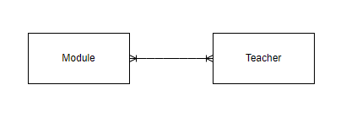

Figure 1: Relation between Module and Teacher

## Student-Module

A student can study multiple modules.

A module can be studied by multiple students.

Hence a many-to-many relation seems to be established.

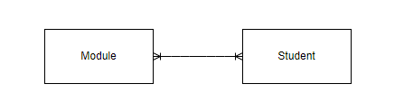

Figure 2: Relation between Module and Student

## Student-Assignment

A student can partake in multiple assignments.

An assignment is submitted by multiple students.

Hence, a many-to-many relation is established.

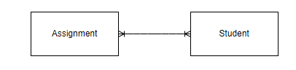

Figure 3: Relation between Student and Assignment

## Department-Fees-Assignment-Result

A department manages multiple student fees.

A department manages multiple assignments.

A department manages multiple results.

Student fee is managed by a single department.

Assignment is managed by a single department.

Result is managed by a single department.

Hence, department establishes a one-to-many relation with fees, assignments, and results.

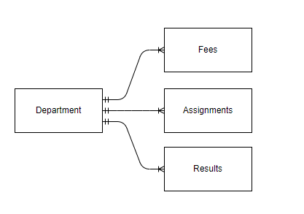

Figure 4: Relation between Department with Fees, Assignments and Results

# ERD From Case Study

Based on the relations derived in the textual analysis of the given case study and some general assumptions, the following ERD is generated.

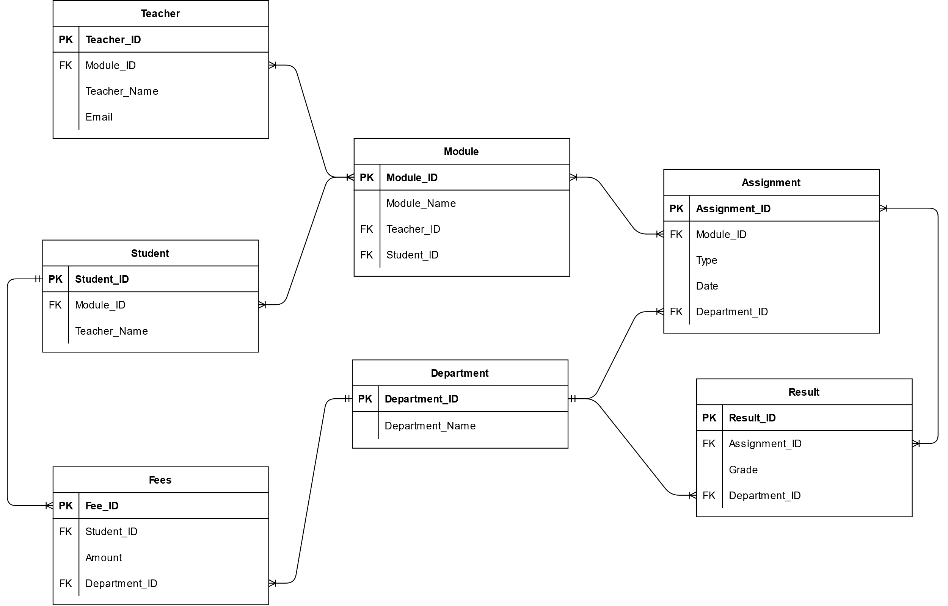

Figure 5: Initial ERD from Case Study

**Assumptions:**

* A student pays multiple fees throughout their stay in the college, and a fee belongs to only one student.
* Multiple results are published for the same assignment and a result relates to multiple assignments.
* A module may be included in multiple assignments and an assignment type may be implemented for multiple modules.

# Normalization

## Figure 1: Example of Teacher allocation list

|  |  |  |  |  |  |  |
| --- | --- | --- | --- | --- | --- | --- |
| S.N. | Teacher Name | Address | Email | Module  Code | Module Name | Credit Hours |
| 1 | Saul Goodman | 595 Green Lake Road  Black Lake  9115 Lake Street Harrietsfield | Saulthegoodman@ abc.edu.np | CC12 | Data Structure and Algorithm | 30 |
| 2 | Walter White | 696 Madison St. Pierrefonds | [whitywalker@abc.e](mailto:whitywalker@abc.e) du.np | CC12 | Data Structure and Algorithm | 30 |
| 3 | Santana Lopez | 6 Valley View Street Griffintown | Santanalopez@abc. edu.np | CC49 | Engineering Thermodynamic | 60 |
| 4 | Rust Cohle | 89 Coffee Dr. Plaster Rock | [rustycohle@abc.ed](mailto:rustycohle@abc.ed) u.np | SG101 | Software engineer | 30 |
|  |  |  |  | TG405 | Data Analysis | 50 |

Table 1: Example of Teacher allocation list

Normalization of teacher allocation:

### UNF

Identifying the repeating groups among the given figure fields, we get the following UNF:

Teacher(Teacher_ID, Teacher_Name, {Street_No., Street_Name, State_Name}, Email, {Module_Code, Module_Name, Credit_Hours,})

### 1NF

Separating the repeating groups identified in the UNF above and assigning composite keys, we get the following entities:

Teacher-1 (Teacher_ID, Teacher_Name, Email)

Address-1(Address_ID, Teacher_ID*, Street_No., Street_Name, State_Name)

Module-1(Module_Code, Teacher_ID*, Module_Name, Credit_Hours)

### 2NF

After the repeating groups were separated into different entities and assigned new composite keys, they needed to be checked for partial dependencies.

For Teacher-1:

* No composite keys were present and hence there were no partial dependencies.

Teacher_ID → Teacher_Name, Email

Teacher-2 (Teacher_ID, Teacher_Name, Email)

For Address-1:

* Address_ID key determines Street_No., Street_Name, State_Name
* Address_ID, Teacher_ID* composite key determines nothing
* Teacher_ID* foreign key determines nothing

Address_ID → (Street_No., Street_Name, State_Name)

Address_ID, Teacher_ID* → ()

Teacher_ID → ()

The partial dependencies are separated into new entities as:

Address-2 (Address_ID*, Street_No., Street_Name, State_Name)

Address-Teacher-2 (Address_ID, Teacher_ID*)

For Module-1:

* Module_Code key determines Module_Name, Credit_Hours
* Module_Code, Teacher_ID* composite key determines nothing

Module_Code → (Module_Name, Credit_Hours)

Module_Code, Teacher_ID* → ()

Module -2 (Module_Code, Module_Name, Credit_Hours)

Module-Teacher -2 (Module_Code, Teacher_ID*)

Hence, the results of 2NF are the following entities:

Teacher-2 (Teacher_ID, Teacher_Name, Email)

Address-2 (Address_ID→ Street_No., Street_Name, State_Name)

Address-Teacher-2 (Address_ID, Teacher_ID*)

Module -2 (Module_Code, Module_Name, Credit_Hours)

Module-Teacher -2 (Module_Code, Teacher_ID*)

### 3NF

After checking and removing any partial dependencies, transitive dependencies are required to be checked and removed.

For Teacher-2:

* Teacher_ID determines Teacher_Name and Email
* Teacher_Name determines nothing
* Email determines nothing

There are no transitive dependencies.

Teacher-3 (Teacher_ID, Teacher_Name, Email)

For Address-2:

* Address_ID determines Street_No., Street_Name, State_Name
* Address determines nothing

There are no transitive dependencies.

Address-3 (Address_ID, Street_No., Street_Name, State_Name)

For Address-Teacher 2:

There are no transitive dependencies, the entity contains only a composite primary key.

Address-Teacher-3 (Address_ID, Teacher_ID*)

For Module-Teacher 2:

There are no transitive dependencies, the entity contains only a composite primary key.

Module-Teacher-3 (Module_ID, Teacher_ID*)

For Module-2:

* Module_Code determines Module_Name, Credit_Hours
* Module_Name determines nothing
* Credit_Hours determines nothing

Module_Code → (Module_Name, Credit_Hours)

The transitive dependencies are separated into entities as follows:

Module-3 → (Module_Code, Module_Name, Credit_Hours)

Hence, the results of 3NF are the following entities:

Teacher-3 (Teacher_ID, Teacher_Name, Email)

Address-3 (Address_ID, Address)

Address-Teacher-3 (Address_ID, Teacher_ID*)

Module-3 (Module_Code, Module_Name, Credit_Hours)

Module-Teacher-3 (Module_ID, Teacher_ID*)

### Final entities from figure 1

After normalizing figure 1 up to third normal form, the following entities are obtained:

Teacher (Teacher_ID, Teacher_Name, Email)

Address (Address_ID, Street_No., Street_Name, State_Name)

Address-Teacher (Address_ID, Teacher_ID*)

Module (Module_Code, Module_Name, Credit_Hours)

Module-Teacher (Module_ID, Teacher_ID*)

## Fig 2: Example of Assignment and Examination Results

Student ID: 149893

Student Name: Mr. William Ishee

Student Address: 2508 Shinn Street New York

|  |  |  |  |  |
| --- | --- | --- | --- | --- |
| Module  Code | Module Name | Assignment Type | Grade | Status |
| CC12 | Data Structure and Algorithm | Coursework | A | Pass |
| CC49 | Engineering Thermodynamic | Coursework | B | Pass |
| CC49 | Engineering Thermodynamic | Written Exam | F | Fail |
| SG101 | Software engineer | Individual  Assignment | B+ | Pass |
| SG101 | Software engineer | Group Assignment | B | Pass |
| SG101 | Software engineer | Unseen Examination | A | Pass |

**Assumptions**:

* A student cannot have multiple addresses.

### UNF

Adding the above-mentioned fields to the given Figure 2 fields, and identifying the repeating groups among them, we get the following UNF:

Student (Student_ID, Sudent_Name, Street_No., Street_Name, State_Name, {Module_Code, Module_Name {Assignment_Type, Grade, Status}})

### 1NF

Separating the repeating groups identified in the UNF above and assigning composite keys, we get the following entities:

Student-1(Student_ID, Student_Name, Street_No., Street_Name, State_Name)

Module-1 (Module_Code, Student_ID*, Module_Name)

Assignment-1(Assignment_ID, Student_ID*, Module_Code*, Assignment_Type, Grade, Status)

### 2NF

After the repeating groups were separated into different entities and assigned new composite keys, they needed to be checked for partial dependencies.

For Student-1:

* No composite keys were present and hence there were no partial dependencies.

Student_ID → (Student_Name, Street_No., Street_Name, State_Name)

Student-2 (Student_ID, Student_Name, Street_No., Street_Name, State_Name)

For Module-1:

* Module_Code key determines Module_Name
* Module_Code, Student_ID* composite key determines nothing
* Student _ID* foreign key determines nothing

Student_ID, Module_Code → ()

Student_ID → ()

Module_Code → (Module_Name)

Module-Student-2 (Student_ID*, Module_Code*)

Module-2(Module_Code, Module_Name)

For Assignment-1:

* Assignment_ID key determines Assigment_Type
* Assignment_ID, Student_ID*, Module_Code* composite key determines Grade, Status
* Student _ID* foreign key determines nothing
* Module _Code* foreign key determines nothing

Assignment_ID → (Assignment_Type)

Assignment_ID, Student_ID, Module_Code → (Grade, Status)

Student_ID → ()

Module_Code → ()

The partial dependencies are separated into new entities as:

Assignment-2 (Assignment_ID, Assignment_Type)

Student-Assignment-2(Assignment_ID*, Student_ID*, Module_Code*, Grade, Status)

Hence, the results of 2NF are the following entities:

Student-2 (Student_ID, Student_Name, Street_No., Street_Name, State_Name)

Module-Student-2 (Student_ID*, Module_Code*)

Module-2(Module_Code, Module_Name)

Assignment-2 (Assignment_ID, Assignment_Type)

Student-Assignment-2(Assignment_ID*, Student_ID*, Module_Code*, Grade, Status)

### 3NF

After checking and removing any partial dependencies, transitive dependencies are required to be checked and removed.

For Student-2 :

* Student_ID determines Student_Name, Street_No., Street_Name, State_Name Student_Name determines nothing
* Student_Address determines nothing

Student_ID → (Student_Name, Street_No., Street_Name, State_Name)

There are no transitive dependencies.

Student-3 (Student_ID, Student_Name, Street_No., Street_Name, State_Name)

For Module-Student-2:

There are no transitive dependencies, the entity contains only a composite primary key.

Module-Student-3 (Student_ID*, Module_Code*)

For Module-2:

* Module_Code determines Module_Name
* Module_Name determines nothing

There are no transitive dependencies.

Module-3(Module_Code, Module_Name)

For Assignment-2:

* Assignment_ID determines Assigment_Type
* Assignment_Type determines nothing
* Module_Name determines nothing

There are no transitive dependencies.

Assignment-3 (Assignment_ID, Assignment_Type)

For Student-Assignment-2:

* Assignment_ID, Student_ID, Module_Code composite key determines Grade
* Grade determines Status
* Status determines nothing

Assignment_ID*, Student_ID*, Module_Code* → Grade

Grade → Status

The transitive dependencies are separated as:

Student-Assignment-3 (Assignment_ID*, Student_ID*, Module_Code*, Grade_ID*)

Grade-3 (Grade_ID, Grade, Status)

Hence, the results of 3NF are the following entities :

Student-3 (Student_ID, Student_Name, Street_No., Street_Name, State_Name)

Module-Student-3 (Student_ID*, Module_Code*)

Module-3(Module_Code, Module_Name)

Assignment-3 (Assignment_ID, Assignment_Type)

Student-Assignment-3 (Assignment_ID*, Student_ID*, Module_Code*, Grade_ID*)

Grade-3 (Grade_ID, Grade, Status)

### Final entities from figure 2

After normalizing figure 2 up to third normal form, the following entities are obtained:

Student (Student_ID, Student_Name, Street_No., Street_Name, State_Name)

Module-Student (Student_ID*, Module_Code*)

Module(Module_Code, Module_Name)

Assignment (Assignment_ID, Assignment_Type)

Student-Assignment (Assignment_ID*, Student_ID*, Module_Code*, Grade_ID*)

Grade (Grade_ID, Grade, Status)

# Integration and Assumptions

Assumptions:

* A teacher may have multiple addresses, but a student can only have one address recorded.
* Grade is evaluated in a single alphabet optionally followed by a sign (Ex: A, A+).
* College has additional departments for managing examinations, assessments, results, as well as fees.
* Attendance of students is managed by a different system and recorded for each semester in percentage value in this database at the end of each semester right before examinations are conducted.
* Each semester has a fee associated with it which may or may not be equal for all semesters.
* Semester fees of the students are common regardless of the modules they study. This implies that students A and B studying module sets C and D have the same semester fees if they both are in semester E.
* Each semester, students are required to pay the allocated semester fees in a single installment.
* When a student pays semester fees, their fee status is updated to paid.
* To store the fees paid amount, the fee amount is redundantly added to the student_fees table so it always remains the same even if the semester fees change over time.
* Assignments and their results, attendance, and fees are managed by departments
* A student can study any three module they want.
* A teacher can teach one or multiple modules.
* Different semesters may have different fees.
* Student assignments for each module are recorded only after their grades have been evaluated.
* A student, after graduation, may become a teacher. Hence, a reference for student_id is added to the teacher table in case a student does become a teacher after graduation.

While the given example tables are very informative, they do not contain information regarding college departments. They also do not contain information regarding semester, semester fees, attendance, and fee status. Thus, the entities "Department", and "Semester", "Student_Fees" and "Student_Attendance" are added to the result of normalizing figures one and two with appropriate relations to existing entities.

Teacher (Teacher_ID, Teacher_Name, Email, Student_ID*)

Address (Address_ID, Street_No., Street_Name, State_Name)

Address-Teacher (Address_ID, Teacher_ID*)

Module (Module_Code, Module_Name, Credit_Hours)

Module-Teacher (Module_ID*, Teacher_ID*)

Student (Student_ID, Student_Name, Street_No., Street_Name, State_Name)

Module-Student (Student_ID*, Module_Code*)

Department (Department_ID, Department_Name)

Assignment (Assignment_ID, Assignment_Type, Department_ID*)

Student-Assignment (Assignment_ID*, Student_ID*, Module_Code*, Grade_ID*)

Grade (Grade_ID, Grade, Status)

Semester (Semester_ID, Semester, Semester_Fees)

Student_Fees (Semester_ID*, Student_ID*, Fee_Status, Department_ID*, Fee_Amount)

Student_Attendance (Semester_ID*, Student_ID*, Attendance_Percentage)

# Final ERD

After normalization and integration of the given two example figures, the obtained entities form the following ERD:

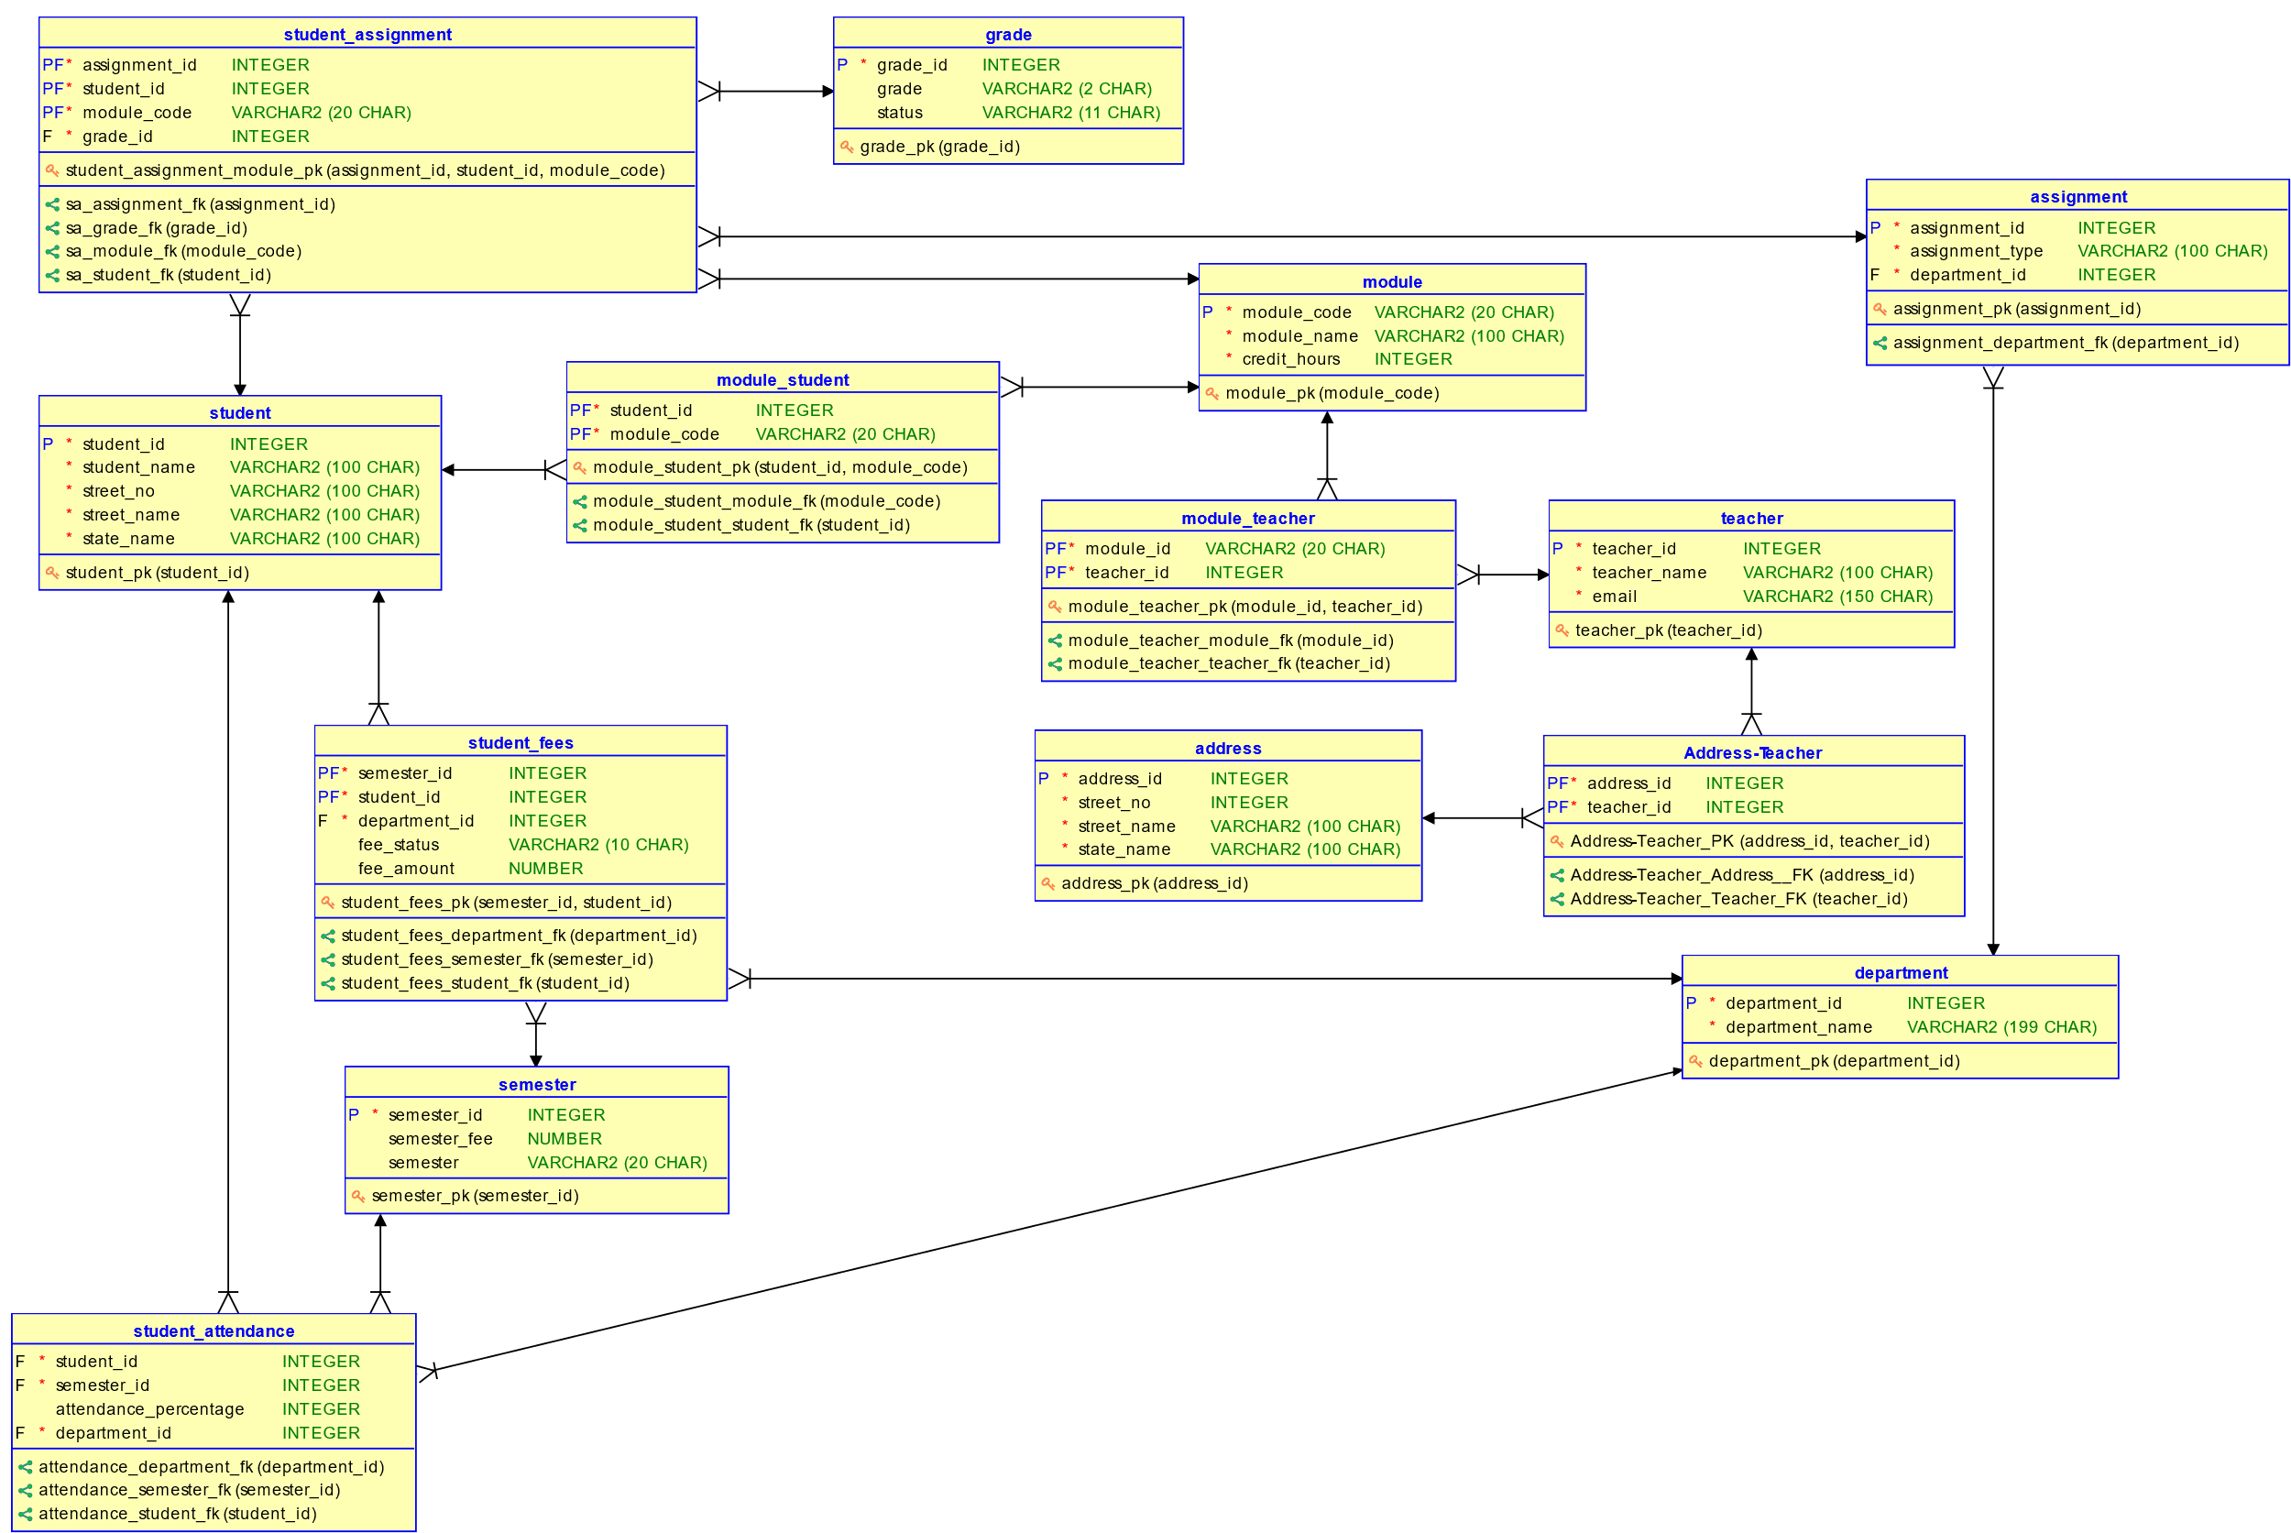

Figure 6: Final ERD After Integration

# Data Dictionary

## Table: Teacher

|  |  |  |  |  |  |  |  |
| --- | --- | --- | --- | --- | --- | --- | --- |
| Column Name | Data Type | Size | Constraint | Reference Table | Reference Column | Description | Sample Data |
| Teacher_ID | INTEGER | 38 | Primary Key |  |  | Uniquely identifies each teacher | 9 |
| Teacher_Name | VARCHAR | 100 | NOT NULL |  |  | Stores the name of the teacher | 4251 |
| Email | VARCHAR | 100 | NOT NULL, UNIQUE |  |  | Stores the active email address of the teacher | Ethan_  Cunningham  2529@brety  .org |
| Student_ID | INTEGER | 38 |  |  |  | Stores student id of the person if they were a graduated student | 6 |

Table 2: Teacher Table Dictionary

## Table: Student

|  |  |  |  |  |  |  |  |
| --- | --- | --- | --- | --- | --- | --- | --- |
| Column Name | Data Type | Size | Constraint | Reference Table | Reference Column | Description | Sample Data |
| Student_ID | INTEGER | 38 | Primary Key |  |  | Uniquely identifies each student | 5 |
| Student_Name | VARCHAR | 100 | NOT NULL |  |  | Stores the name of the student | Ethan Shrestha |
| Street_No | INTEGER | 38 | NOT NULL |  |  | Stores street number of an address | 4251 |
| Street_Name | VARCHAR | 100 | NOT NULL |  |  | Stores street name of an address | Sheffield Walk |
| State_Name | VARCHAR | 100 | NOT NULL |  |  | Stores state name of an address | Hawaii |

Table 3: Student Table Dictionary

## Table: Address

|  |  |  |  |  |  |  |  |
| --- | --- | --- | --- | --- | --- | --- | --- |
| Column Name | Data Type | Size | Constraint | Reference Table | Reference Column | Description | Sample Data |
| Address_ID | INTEGER | 38 | Primary Key |  |  | Uniquely identifies each address | 3 |
| Street_No | INTEGER | 38 | NOT NULL |  |  | Stores street number of an address | 4251 |
| Street_Name | VARCHAR | 100 | NOT NULL |  |  | Stores street name of an address | Sheffield Walk |
| State_Name | VARCHAR | 100 | NOT NULL |  |  | Stores state name of an address | Hawaii |

Table 4: Address Table Dictionary

## Table: Department

|  |  |  |  |  |  |  |  |
| --- | --- | --- | --- | --- | --- | --- | --- |
| Column Name | Data Type | Size | Constraint | Reference Table | Reference Column | Description | Sample Data |
| Department_ID | INTEGER | 38 | Primary Key |  |  | Uniquely identifies each department | 9 |
| Department_Name | VARCHAR | 100 | NOT NULL, UNIQUE |  |  | Stores the name of the department | RTE |

Table 5: Department Table Dictionary

## Table: Assignment

|  |  |  |  |  |  |  |  |
| --- | --- | --- | --- | --- | --- | --- | --- |
| Column Name | Data Type | Size | Constraint | Reference Table | Reference Column | Description | Sample Data |
| Assignment_ID | INTEGER | 38 | Primary Key |  |  | Uniquely identifies each assignment | 2 |
| Assignment_Type | VARCHAR | 100 | NOT NULL, UNIQUE |  |  | Stores the type of current assignment | 4251 |
| Department_ID | VARCHAR | 100 | NOT NULL | Department | Department  _ID | Stores the department ID that manages assignments | Sheffield Walk |

Table 6: Assignment Table Dictionary

## Table: Grade

|  |  |  |  |  |  |  |  |
| --- | --- | --- | --- | --- | --- | --- | --- |
| Column Name | Data Type | Size | Constraint | Reference Table | Reference Column | Description | Sample Data |
| Grade_ID | INTEGER | 38 | Primary Key |  |  | Uniquely identifies each grade as a number | 2 |
| Grade | VARCHAR | 100 | NOT NULL, UNIQUE |  |  | Stores the grade | D+ |
| Status | VARCHAR | 100 | NOT NULL |  |  | Stores the pass or fail status of the grade | Pass |

Table 7: Grade Table Dictionary

## Table: Module

|  |  |  |  |  |  |  |  |
| --- | --- | --- | --- | --- | --- | --- | --- |
| Column Name | Data Type | Size | Constraint | Reference Table | Reference Column | Description | Sample Data |
| Module_Code | VARCHAR | 20 | Primary Key |  |  | Uniquely identifies each assignment | CC12 |
| Module_Name | VARCHAR | 100 | NOT NULL, UNIQUE |  |  | Stores the name of the module | Data Structure and Algorithm |
| Credit_Hours | INTEGER | 38 | NOT NULL |  |  | Stores the credit hours of the module | 30 |

Table 8: Module Table Dictionary

## Table: Module_Student

|  |  |  |  |  |  |  |  |
| --- | --- | --- | --- | --- | --- | --- | --- |
| Column Name | Data Type | Size | Constraint | Reference Table | Reference Column | Description | Sample Data |
| Student_ID | VARCHAR | 100 | FOREIGN KEY, PRIMARY KEY (composite primary key) | Student | Student_ID | Stores the student id of the student associated with a module | 6 |
| Module_Code | VARCHAR | 20 | FOREIGN KEY, PRIMARY KEY (composite primary key) | Module | Module_Code | Stores the module code of a module associated with the student | CC12 |

Table 9: Module_Student Table Dictionary

## Table: Module_Teacher

|  |  |  |  |  |  |  |  |
| --- | --- | --- | --- | --- | --- | --- | --- |
| Column Name | Data Type | Size | Constraint | Reference Table | Reference Column | Description | Sample Data |
| Teacher_ID | VARCHAR | 100 | FOREIGN KEY, PRIMARY KEY (composite primary key) | Teacher | Teacher_ID | Stores the teacher id of the teacher associated with a module | 9 |
| Module_ID | VARCHAR | 20 | FOREIGN KEY, PRIMARY KEY (composite primary key) | Module | Module_Code | Stores the module code of a module associated with the teacher | CC12 |

Table 10: Module_Teacher Table Dictionary

## Table: Semester

|  |  |  |  |  |  |  |  |
| --- | --- | --- | --- | --- | --- | --- | --- |
| Column Name | Data Type | Size | Constraint | Reference Table | Reference Column | Description | Sample Data |
| Semester_ID | INTEGER | 38 | Primary Key |  |  | Uniquely identifies each semester | 6 |
| Semester | INTEGER | 38 | NOT NULL, UNIQUE |  |  | Stores the semester number | 9 |
| Semester_Fees | INTEGER | 38 | NOT NULL |  |  | Stores the fee for the semester | 650 |

Table 11: Semester Table Dictionary

## Table: Student_Assignment

|  |  |  |  |  |  |  |  |
| --- | --- | --- | --- | --- | --- | --- | --- |
| Column Name | Data Type | Size | Constraint | Reference Table | Reference Column | Description | Sample Data |
| Assignment_ID | INTEGER | 38 | FOREIGN KEY, PRIMARY KEY (composite primary key) | Assignment | Assignment_ID | Stores the assignment id of the assignment | 6 |
| Student_ID | INTEGER | 38 | FOREIGN KEY, PRIMARY KEY (composite primary key) | Student | Student_ID | Stores the student id of the student associated with the assignment | 9 |
| Module_Code | VARCHAR | 20 | FOREIGN KEY, PRIMARY KEY (composite primary key) | Module | Module_Code | Stores the module id of the module of which thew assignment is | CC12 |
| Grade_ID | INTEGER | 38 | FOREIGN KEY | Grade | Grade_ID | Stores the grade id of the grade obtained by the student | 3 |

Table 12: Student_Assignment Table Dictionary

## Table: Student_Attendance

|  |  |  |  |  |  |  |  |
| --- | --- | --- | --- | --- | --- | --- | --- |
| Column Name | Data Type | Size | Constraint | Reference Table | Reference Column | Description | Sample Data |
| Student_ID | INTEGER | 38 | FOREIGN KEY, PRIMARY KEY (composite primary key) | Student | Student_ID | Stores the student id of the student whose attendance is being recorded | 6 |
| Semester_ID | INTEGER | 38 | FOREIGN KEY, PRIMARY KEY (composite primary key) | Semester | Semester_ID | Stores the semester id of the semester in which the attendance was recorded | 3 |
| Department_ID | INTEGER | 38 | FOREIGN KEY, NOT NULL | Department | Department_ID | Stores the department id of the department responsible for managing attendance | 1 |

Table 13: Student_Attendance Table Dictionary

## Table: Student_Fees

|  |  |  |  |  |  |  |  |
| --- | --- | --- | --- | --- | --- | --- | --- |
| Column Name | Data Type | Size | Constraint | Reference Table | Reference Column | Description | Sample Data |
| Student_ID | INTEGER | 38 | FOREIGN KEY, PRIMARY KEY (composite primary key) | Student | Student_ID | Stores the student id of the student whose fee detail is being recorded | 6 |
| Semester_ID | INTEGER | 38 | FOREIGN KEY, PRIMARY KEY (composite primary key) | Semester | Semester_ID | Stores the semester id of the semester for which the fee detail was recorded | 3 |
| Department_ID | INTEGER | 38 | FOREIGN KEY, NOT NULL | Department | Department_ID | Stores the department id of the department responsible for managing fees | 2 |
| Fee_Amount | NUMBER | (30,8) |  |  |  | Stores the amount of fee paid by the student | 700 |
| Fee_Status | VARCHAR | 10 |  |  |  | Stores the status of fees determining if the fee has been paid or not | Due |
| Payment_Date | DATE |  |  |  |  | Stores the date of payment of | TO_DATE( '09, 01, 2017', 'MM, DD, YYYY' ) |

Table 14: Student_Attendance Table Dictionary

## Table: Address_Teacher

|  |  |  |  |  |  |  |  |
| --- | --- | --- | --- | --- | --- | --- | --- |
| Column Name | Data Type | Size | Constraint | Reference Table | Reference Column | Description | Sample Data |
| Teacher_ID | INTEGER | 38 | FOREIGN KEY, PRIMARY KEY (composite primary key) | Teacher | Teacher_ID | Stores the teacher id of the teacher associated with an address | 6 |
| Address_ID | INTEGER | 38 | FOREIGN KEY, PRIMARY KEY (composite primary key) | Address | Address_ID | Stores the address id of the address that is associated with the teacher | 9 |

Table 15: Address_Teacher Table Dictionary

# DDL Script

## Script

*-- Generated by Oracle SQL Developer Data Modeler 21.4.1.349.1605*

*--   at:        2022-03-12 18:05:35 NPT*

*--   site:      Oracle Database 11g*

*--   type:      Oracle Database 11g*

*-- predefined type, no DDL - MDSYS.SDO_GEOMETRY*

*-- predefined type, no DDL - XMLTYPE*

CREATE SEQUENCE address_address_id_seq START WITH 1 NOCACHE ORDER;

CREATE SEQUENCE assignment_assignment_id_seq START WITH 1 NOCACHE ORDER;

CREATE SEQUENCE department_department_id_seq START WITH 1 NOCACHE ORDER;

CREATE SEQUENCE grade_grade_id_seq START WITH 1 NOCACHE ORDER;

CREATE SEQUENCE semester_semester_id_seq START WITH 1 NOCACHE ORDER;

CREATE SEQUENCE student_student_id_seq START WITH 1 NOCACHE ORDER;

CREATE SEQUENCE teacher_teacher_id_seq START WITH 1 NOCACHE ORDER;

CREATE TABLE address (

    address_id  INTEGER NOT NULL,

    street_no   INTEGER NOT NULL,

    street_name VARCHAR2(100 CHAR) NOT NULL,

    state_name  VARCHAR2(100 CHAR) NOT NULL

)

;

ALTER TABLE address ADD *CONSTRAINT* address_pk PRIMARY KEY ( address_id );

CREATE TABLE address_teacher (

    address_id INTEGER NOT NULL,

    teacher_id INTEGER NOT NULL

)

;

ALTER TABLE address_teacher ADD *CONSTRAINT* "Address_Teacher_PK" PRIMARY KEY ( address_id,

                                                                                teacher_id );

CREATE TABLE assignment (

    assignment_id   INTEGER NOT NULL,

    assignment_type VARCHAR2(100 CHAR) NOT NULL,

    department_id   INTEGER DEFAULT 1 NOT NULL

)

;

ALTER TABLE assignment ADD *CONSTRAINT* assignment_pk PRIMARY KEY ( assignment_id );

ALTER TABLE assignment ADD *CONSTRAINT* assignment_assignment_type_un UNIQUE ( assignment_type );

CREATE TABLE department (

    department_id   INTEGER NOT NULL,

    department_name VARCHAR2(199 CHAR) NOT NULL

)

;

ALTER TABLE department ADD *CONSTRAINT* department_pk PRIMARY KEY ( department_id );

ALTER TABLE department ADD *CONSTRAINT* department_department_name_un UNIQUE ( department_name );

CREATE TABLE grade (

    grade_id INTEGER NOT NULL,

    grade    VARCHAR2(2 CHAR),

    status   VARCHAR2(11 CHAR)

)

;

ALTER TABLE grade ADD *CONSTRAINT* grade_pk PRIMARY KEY ( grade_id );

ALTER TABLE grade ADD *CONSTRAINT* grade__un UNIQUE ( grade );

CREATE TABLE module (

    module_code  VARCHAR2(20 CHAR) NOT NULL,

    module_name  VARCHAR2(100 CHAR) NOT NULL,

    credit_hours INTEGER NOT NULL

)

;

ALTER TABLE module ADD *CONSTRAINT* module_pk PRIMARY KEY ( module_code );

ALTER TABLE module ADD *CONSTRAINT* module_module_name_un UNIQUE ( module_name );

CREATE TABLE module_student (

    student_id  INTEGER NOT NULL,

    module_code VARCHAR2(20 CHAR) NOT NULL

)

;

ALTER TABLE module_student ADD *CONSTRAINT* module_student_pk PRIMARY KEY ( student_id,

                                                                          module_code );

CREATE TABLE module_teacher (

    module_id  VARCHAR2(20 CHAR) NOT NULL,

    teacher_id INTEGER NOT NULL

)

;

ALTER TABLE module_teacher ADD *CONSTRAINT* module_teacher_pk PRIMARY KEY ( module_id,

                                                                          teacher_id );

CREATE TABLE semester (

    semester_id  INTEGER NOT NULL,

    semester_fee NUMBER,

    semester     VARCHAR2(20 CHAR)

)

;

ALTER TABLE semester ADD *CONSTRAINT* semester_pk PRIMARY KEY ( semester_id );

ALTER TABLE semester ADD *CONSTRAINT* semester_semester_un UNIQUE ( semester );

CREATE TABLE student (

    student_id   INTEGER NOT NULL,

    student_name VARCHAR2(100 CHAR) NOT NULL,

    street_no    VARCHAR2(100 CHAR) NOT NULL,

    street_name  VARCHAR2(100 CHAR) NOT NULL,

    state_name   VARCHAR2(100 CHAR) NOT NULL

)

;

ALTER TABLE student ADD *CONSTRAINT* student_pk PRIMARY KEY ( student_id );

CREATE TABLE student_assignment (

    assignment_id INTEGER NOT NULL,

    student_id    INTEGER NOT NULL,

    module_code   VARCHAR2(20 CHAR) NOT NULL,

    grade_id      INTEGER NOT NULL

)

;

ALTER TABLE student_assignment

    ADD *CONSTRAINT* student_assignment_module_pk PRIMARY KEY ( assignment_id,

                                                              student_id,

                                                              module_code );

CREATE TABLE student_attendance (

    student_id            INTEGER NOT NULL,

    semester_id           INTEGER NOT NULL,

    attendance_percentage INTEGER,

    department_id         INTEGER DEFAULT 1 NOT NULL

)

;

ALTER TABLE student_attendance ADD *CONSTRAINT* student_attendance_pk PRIMARY KEY (student_id,

                                                                                    semester_id);

CREATE TABLE student_fees (

    semester_id   INTEGER NOT NULL,

    student_id    INTEGER NOT NULL,

    department_id INTEGER DEFAULT 2 NOT NULL,

    fee_status    VARCHAR2(10 CHAR),

    fee_amount    NUMBER(30,8),

    payment_date  DATE

)

;

ALTER TABLE student_fees ADD *CONSTRAINT* student_fees_pk PRIMARY KEY ( semester_id,

                                                                      student_id );

CREATE TABLE teacher (

    teacher_id   INTEGER NOT NULL,

    teacher_name VARCHAR2(100 CHAR) NOT NULL,

    email        VARCHAR2(150 CHAR) NOT NULL,

    student_id   INTEGER DEFAULT NULL

)

;

ALTER TABLE teacher ADD *CONSTRAINT* teacher_pk PRIMARY KEY ( teacher_id );

ALTER TABLE teacher ADD *CONSTRAINT* teacher_email_un UNIQUE ( email );

ALTER TABLE address_teacher

    ADD *CONSTRAINT* "address_teacher_Address__FK" *FOREIGN KEY* ( address_id )

*REFERENCES* address ( address_id )

*ON DELETE CASCADE*

    NOT DEFERRABLE;

ALTER TABLE address_teacher

    ADD *CONSTRAINT* "address_teacher_Teacher_FK" *FOREIGN KEY* ( teacher_id )

*REFERENCES* teacher ( teacher_id )

*ON DELETE CASCADE*

    NOT DEFERRABLE;

ALTER TABLE assignment

    ADD *CONSTRAINT* assignment_department_fk *FOREIGN KEY* ( department_id )

*REFERENCES* department ( department_id )

*ON DELETE CASCADE*

    NOT DEFERRABLE;

ALTER TABLE student_attendance

    ADD *CONSTRAINT* attendance_department_fk *FOREIGN KEY* ( department_id )

*REFERENCES* department ( department_id )

*ON DELETE CASCADE*

    NOT DEFERRABLE;

ALTER TABLE student_attendance

    ADD *CONSTRAINT* attendance_semester_fk *FOREIGN KEY* ( semester_id )

*REFERENCES* semester ( semester_id )

*ON DELETE CASCADE*

    NOT DEFERRABLE;

ALTER TABLE student_attendance

    ADD *CONSTRAINT* attendance_student_fk *FOREIGN KEY* ( student_id )

*REFERENCES* student ( student_id )

*ON DELETE CASCADE*

    NOT DEFERRABLE;

ALTER TABLE module_student

    ADD *CONSTRAINT* module_student_module_fk *FOREIGN KEY* ( module_code )

*REFERENCES* module ( module_code )

*ON DELETE CASCADE*

    NOT DEFERRABLE;

ALTER TABLE module_student

    ADD *CONSTRAINT* module_student_student_fk *FOREIGN KEY* ( student_id )

*REFERENCES* student ( student_id )

*ON DELETE CASCADE*

    NOT DEFERRABLE;

ALTER TABLE module_teacher

    ADD *CONSTRAINT* module_teacher_module_fk *FOREIGN KEY* ( module_id )

*REFERENCES* module ( module_code )

*ON DELETE CASCADE*

    NOT DEFERRABLE;

ALTER TABLE module_teacher

    ADD *CONSTRAINT* module_teacher_teacher_fk *FOREIGN KEY* ( teacher_id )

*REFERENCES* teacher ( teacher_id )

*ON DELETE CASCADE*

    NOT DEFERRABLE;

ALTER TABLE student_assignment

    ADD *CONSTRAINT* sa_assignment_fk *FOREIGN KEY* ( assignment_id )

*REFERENCES* assignment ( assignment_id )

*ON DELETE CASCADE*

    NOT DEFERRABLE;

ALTER TABLE student_assignment

    ADD *CONSTRAINT* sa_grade_fk *FOREIGN KEY* ( grade_id )

*REFERENCES* grade ( grade_id )

*ON DELETE CASCADE*

    NOT DEFERRABLE;

ALTER TABLE student_assignment

    ADD *CONSTRAINT* sa_module_fk *FOREIGN KEY* ( module_code )

*REFERENCES* module ( module_code )

*ON DELETE CASCADE*

    NOT DEFERRABLE;

ALTER TABLE student_assignment

    ADD *CONSTRAINT* sa_student_fk *FOREIGN KEY* ( student_id )

*REFERENCES* student ( student_id )

*ON DELETE CASCADE*

    NOT DEFERRABLE;

ALTER TABLE student_fees

    ADD *CONSTRAINT* student_fees_department_fk *FOREIGN KEY* ( department_id )

*REFERENCES* department ( department_id )

*ON DELETE CASCADE*

    NOT DEFERRABLE;

ALTER TABLE student_fees

    ADD *CONSTRAINT* student_fees_semester_fk *FOREIGN KEY* ( semester_id )

*REFERENCES* semester ( semester_id )

*ON DELETE CASCADE*

    NOT DEFERRABLE;

ALTER TABLE student_fees

    ADD *CONSTRAINT* student_fees_student_fk *FOREIGN KEY* ( student_id )

*REFERENCES* student ( student_id )

*ON DELETE CASCADE*

    NOT DEFERRABLE;

ALTER TABLE teacher

    ADD *CONSTRAINT* teacher_student_fk *FOREIGN KEY* ( student_id )

*REFERENCES* student ( student_id )

*ON DELETE CASCADE*

    NOT DEFERRABLE;

CREATE OR REPLACE TRIGGER address_address_id_trg BEFORE

    INSERT ON address

    FOR EACH ROW

    WHEN ( new.address_id IS NULL )

BEGIN

    :new.address_id := address_address_id_seq.nextval;

END;

/

CREATE OR REPLACE TRIGGER assignment_assignment_id_trg BEFORE

    INSERT ON assignment

    FOR EACH ROW

    WHEN ( new.assignment_id IS NULL )

BEGIN

    :new.assignment_id := assignment_assignment_id_seq.nextval;

END;

/

CREATE OR REPLACE TRIGGER department_department_id_trg BEFORE

    INSERT ON department

    FOR EACH ROW

    WHEN ( new.department_id IS NULL )

BEGIN

    :new.department_id := department_department_id_seq.nextval;

END;

/

CREATE OR REPLACE TRIGGER grade_grade_id_trg BEFORE

    INSERT ON grade

    FOR EACH ROW

    WHEN ( new.grade_id IS NULL )

BEGIN

    :new.grade_id := grade_grade_id_seq.nextval;

END;

/

CREATE OR REPLACE TRIGGER semester_semester_id_trg BEFORE

    INSERT ON semester

    FOR EACH ROW

    WHEN ( new.semester_id IS NULL )

BEGIN

    :new.semester_id := semester_semester_id_seq.nextval;

END;

/

CREATE OR REPLACE TRIGGER student_student_id_trg BEFORE

    INSERT ON student

    FOR EACH ROW

    WHEN ( new.student_id IS NULL )

BEGIN

    :new.student_id := student_student_id_seq.nextval;

END;

/

CREATE OR REPLACE TRIGGER teacher_teacher_id_trg BEFORE

    INSERT ON teacher

    FOR EACH ROW

    WHEN ( new.teacher_id IS NULL )

BEGIN

    :new.teacher_id := teacher_teacher_id_seq.nextval;

END;

/

*-- Oracle SQL Developer Data Modeler Summary Report:*

*--*

*-- CREATE TABLE                            14*

*-- CREATE INDEX                             0*

*-- ALTER TABLE                             30*

*-- CREATE VIEW                              0*

*-- ALTER VIEW                               0*

*-- CREATE PACKAGE                           0*

*-- CREATE PACKAGE BODY                      0*

*-- CREATE PROCEDURE                         0*

*-- CREATE FUNCTION                          0*

*-- CREATE TRIGGER                           7*

*-- ALTER TRIGGER                            0*

*-- CREATE COLLECTION TYPE                   0*

*-- CREATE STRUCTURED TYPE                   0*

*-- CREATE STRUCTURED TYPE BODY              0*

*-- CREATE CLUSTER                           0*

*-- CREATE CONTEXT                           0*

*-- CREATE DATABASE                          0*

*-- CREATE DIMENSION                         0*

*-- CREATE DIRECTORY                         0*

*-- CREATE DISK GROUP                        0*

*-- CREATE ROLE                              0*

*-- CREATE ROLLBACK SEGMENT                  0*

*-- CREATE SEQUENCE                          7*

*-- CREATE MATERIALIZED VIEW                 0*

*-- CREATE MATERIALIZED VIEW LOG             0*

*-- CREATE SYNONYM                           0*

*-- CREATE TABLESPACE                        0*

*-- CREATE USER                              0*

*--*

*-- DROP TABLESPACE                          0*

*-- DROP DATABASE                            0*

*--*

*-- REDACTION POLICY                         0*

*--*

*-- ORDS DROP SCHEMA                         0*

*-- ORDS ENABLE SCHEMA                       0*

*-- ORDS ENABLE OBJECT                       0*

*--*

*-- ERRORS                                   0*

*-- WARNINGS                                 0*

## Output

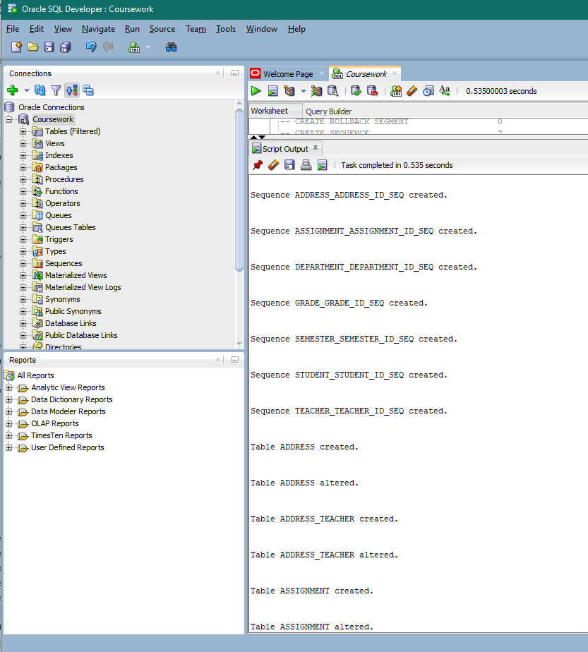

Figure 7:DDL Script Output 1

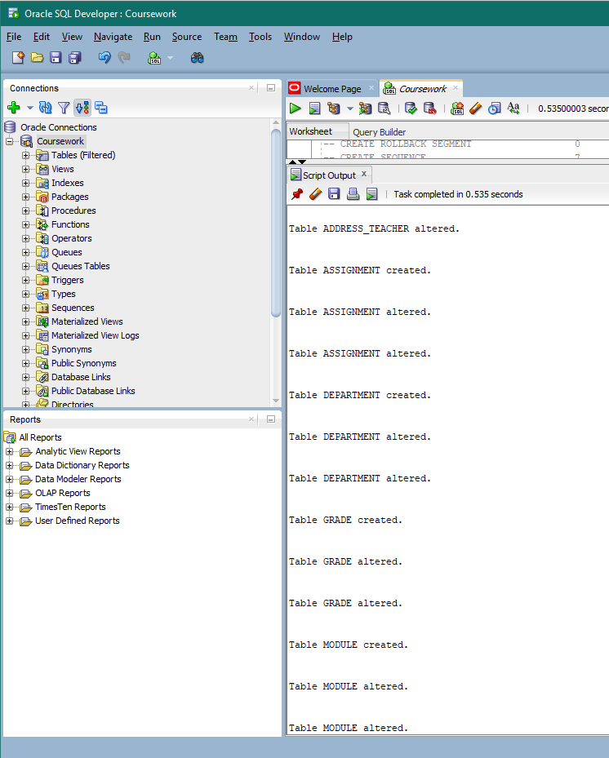

Figure 8:DDL Script Output 2

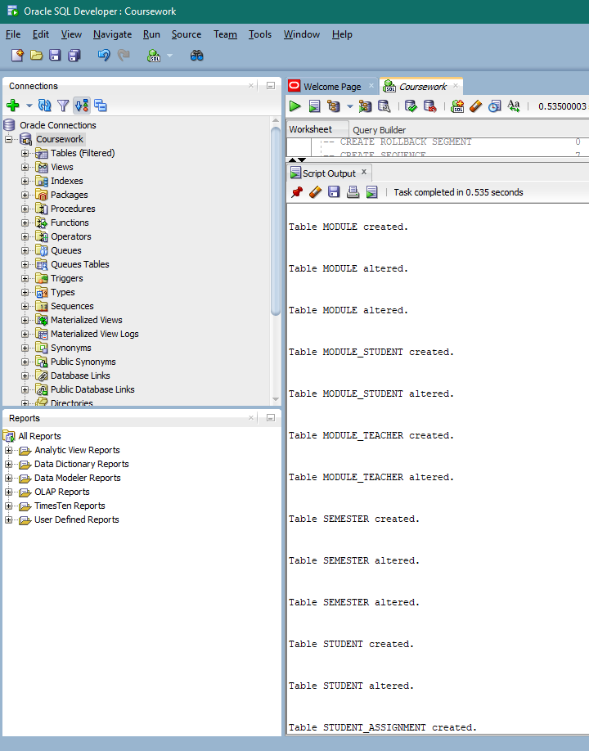

Figure 9:DDL Script Output 3

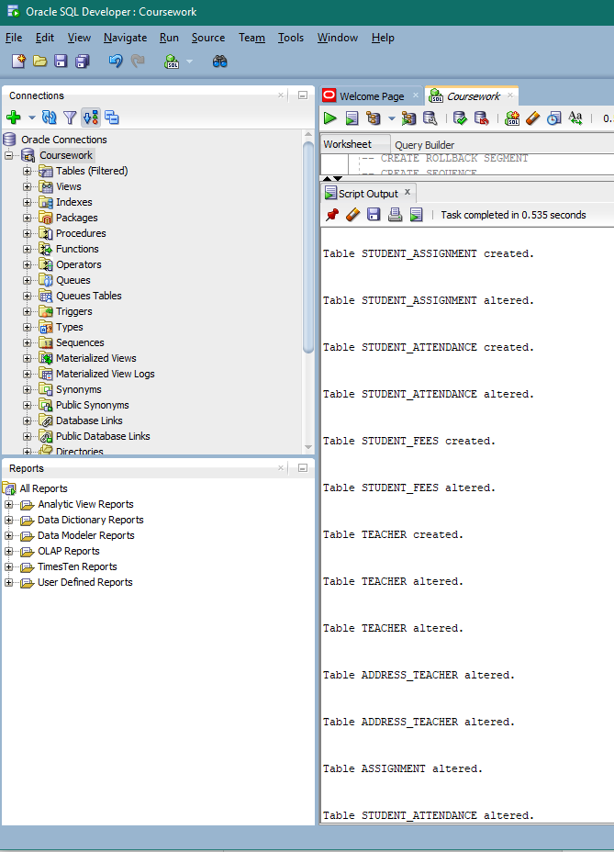

Figure 10:DDL Script Output 4

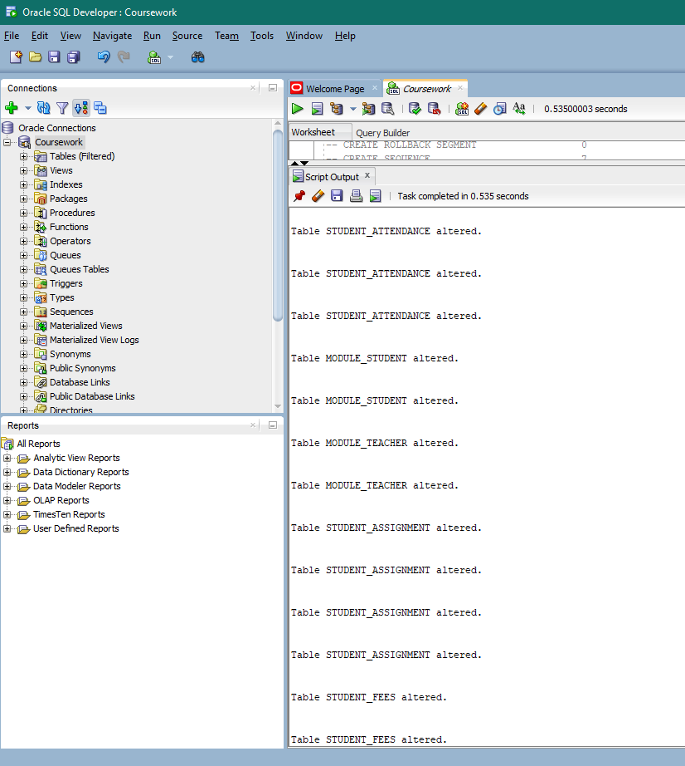

Figure 11:DDL Script Output 5

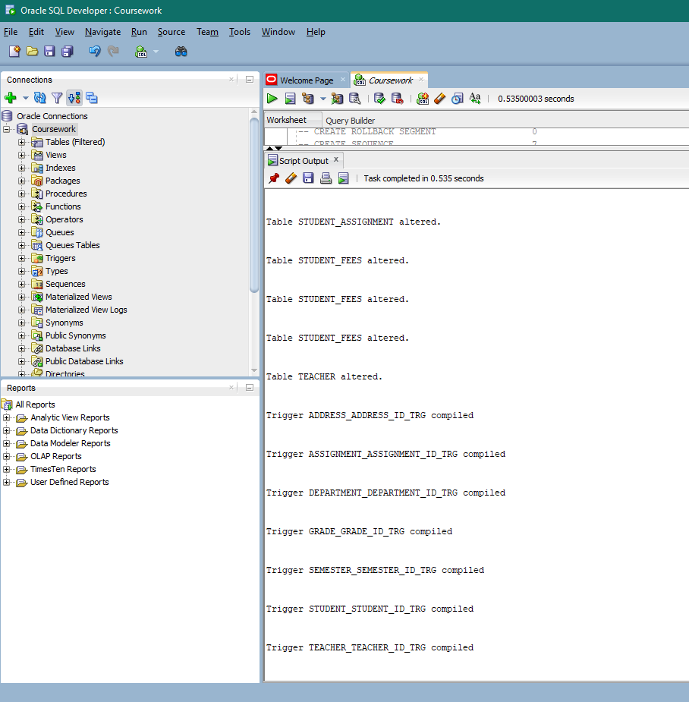 Figure 12:DDL Script Output 6

# INSERT Statements

## Teacher

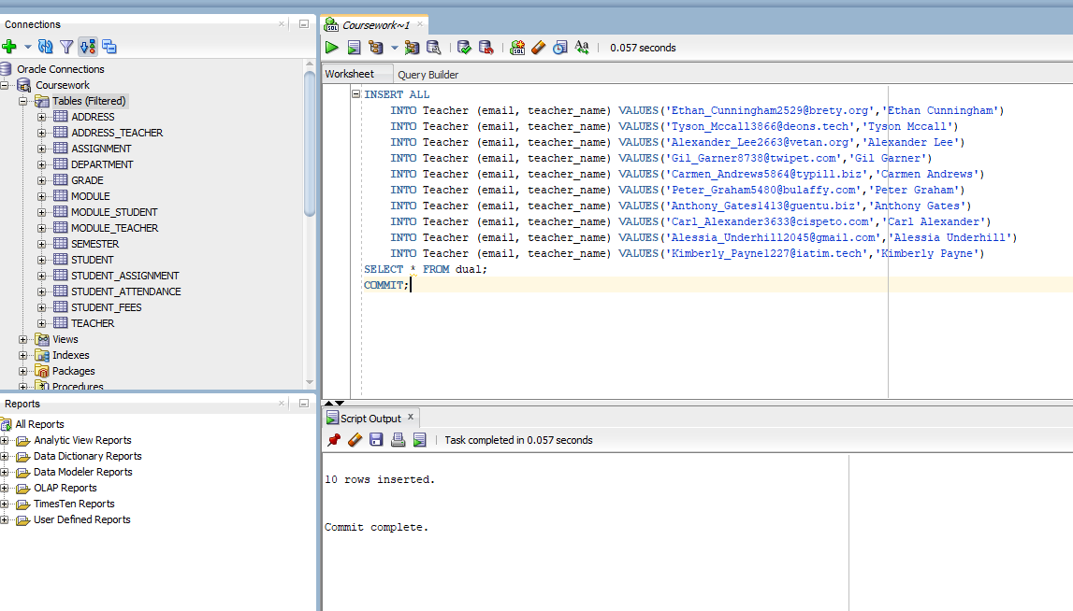

Figure 13: INSERT Teacher

## Student

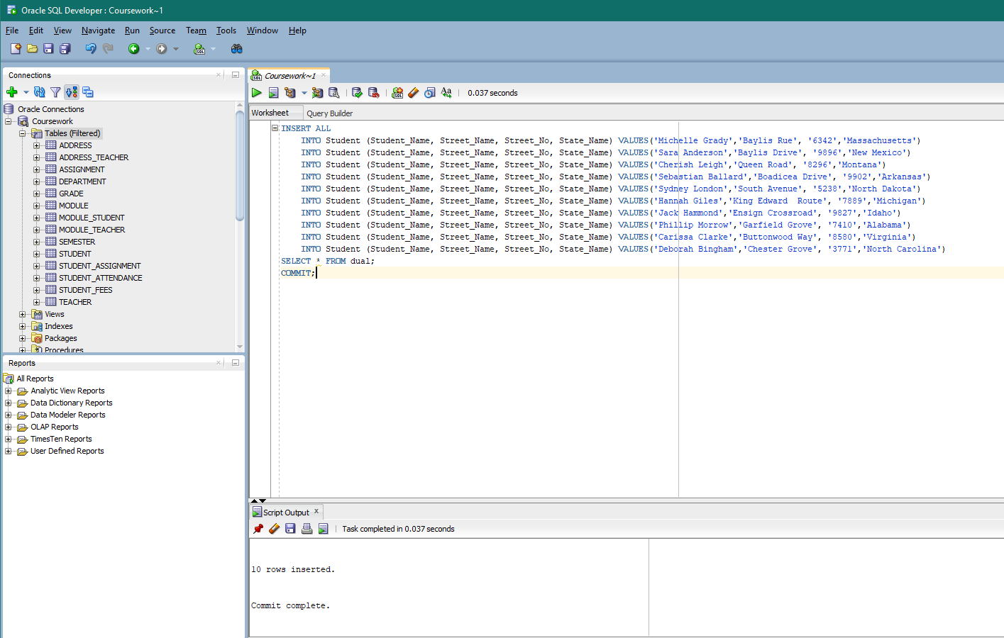 Figure 14: INSERT Student

## Semester

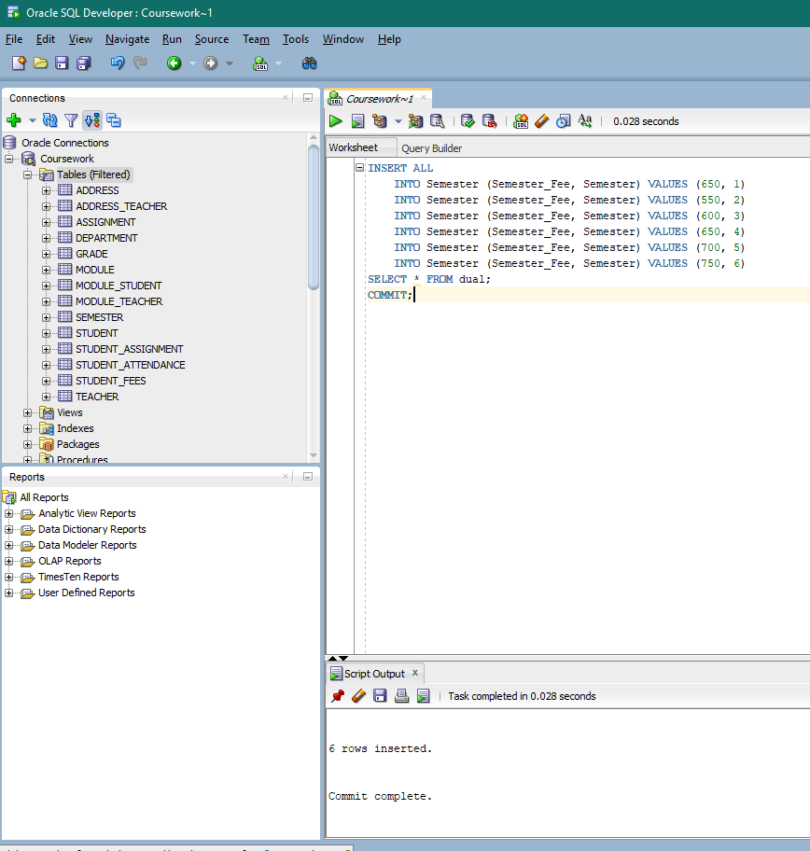 Figure 15: INSERT Semester

## Module

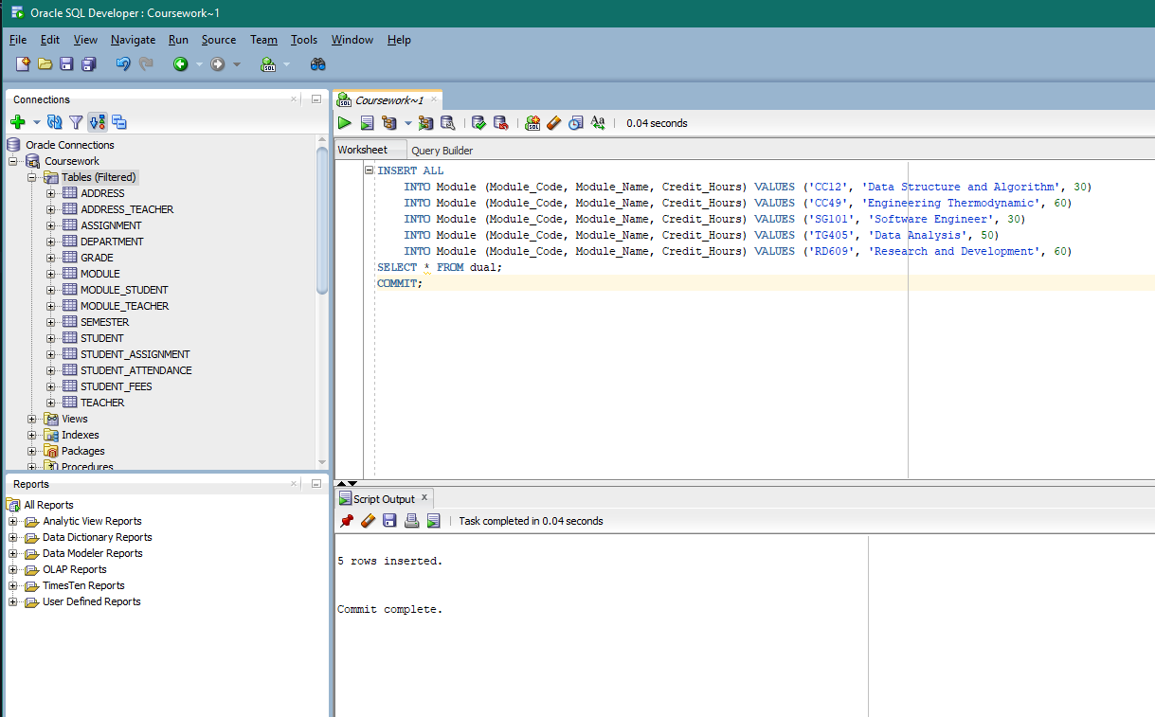

Figure 16: INSERT Module

## Grade

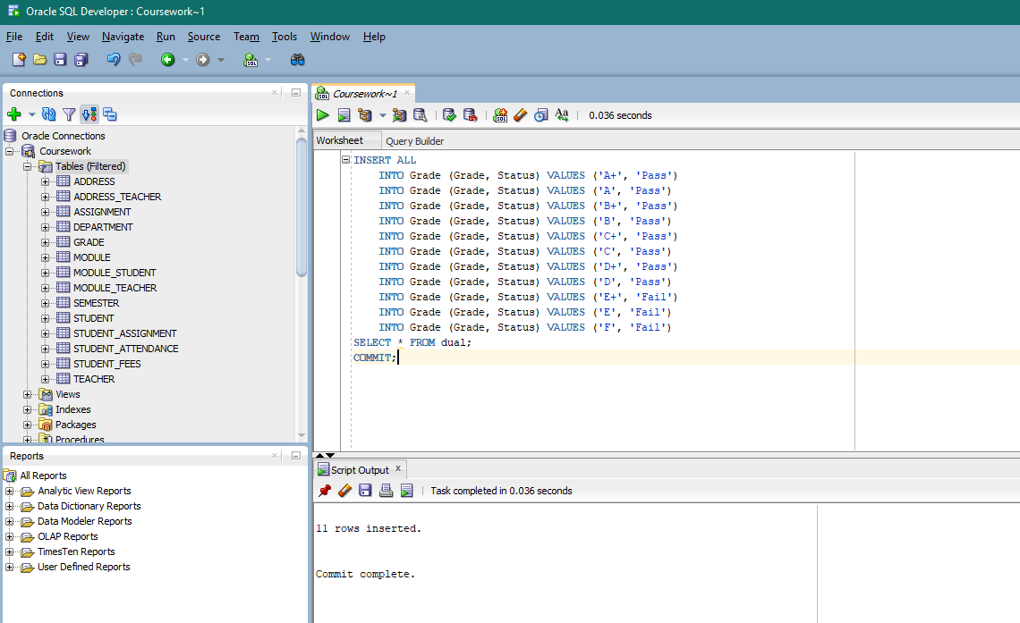

Figure 17: INSERT Grade

## Department

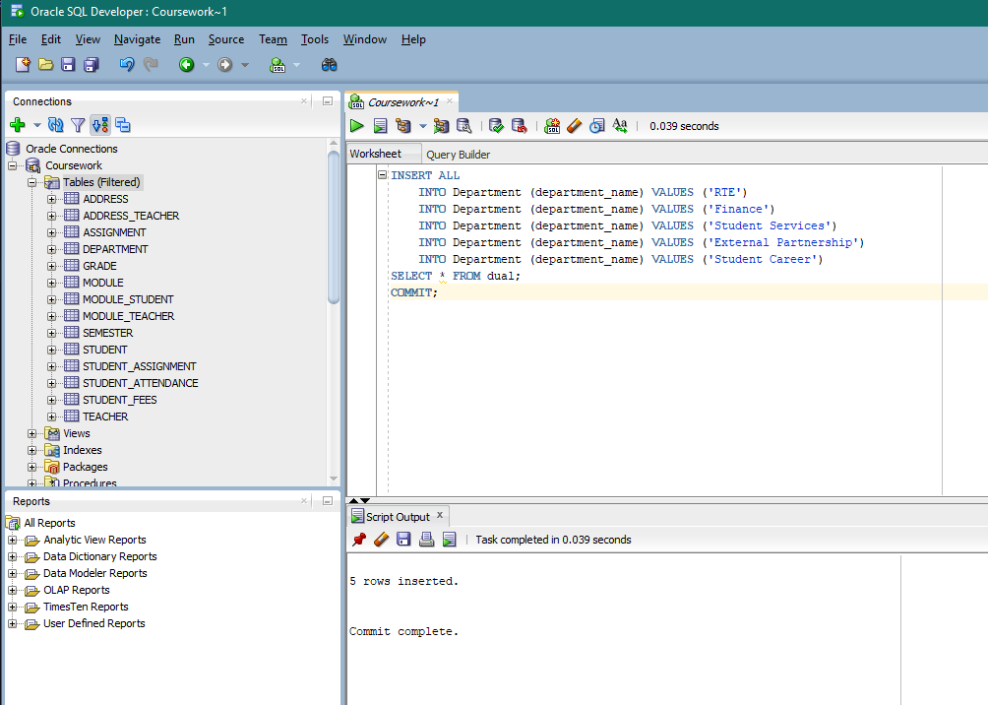

Figure 18: INSERT Department

## Address

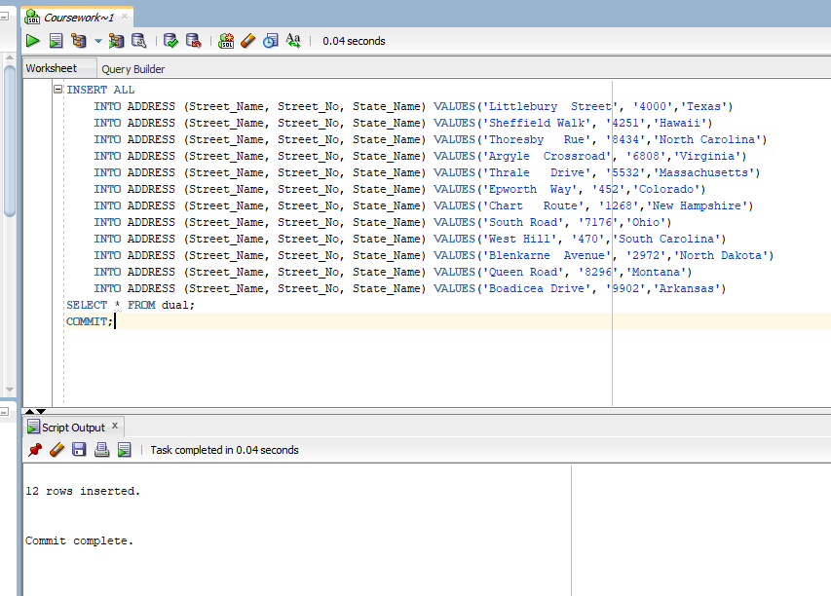 Figure 19: INSERT Address

## Assignment

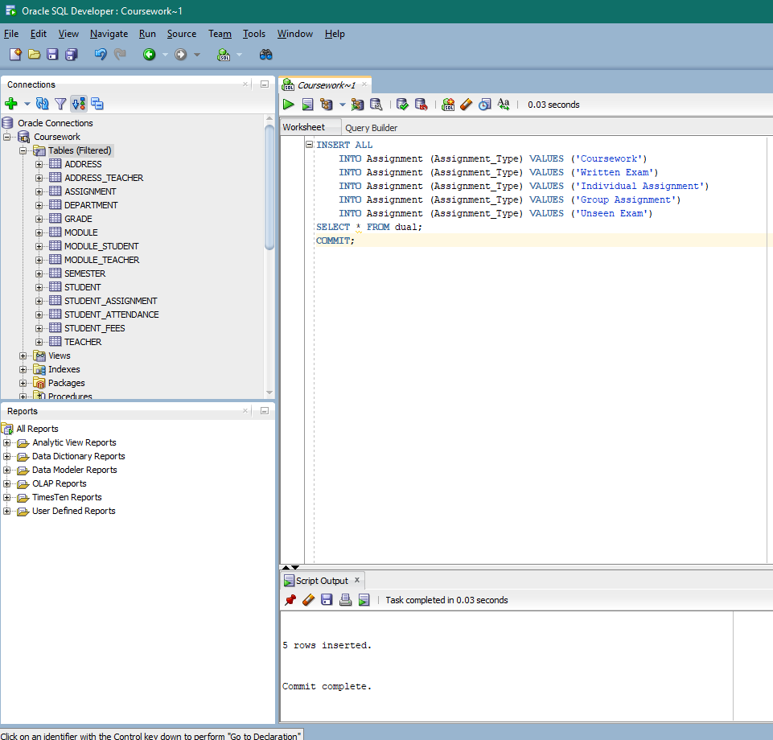

Figure 20: INSERT Assignment

## Student_Fees

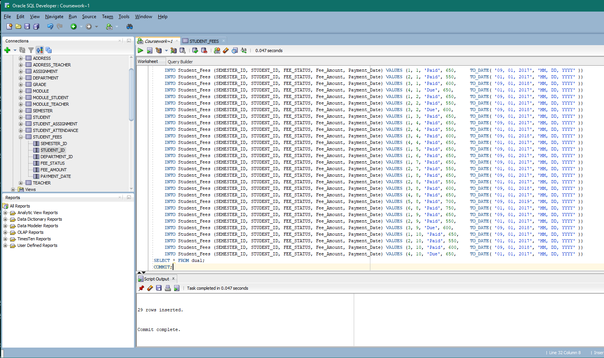 Figure 21: INSERT Student_Fees

## Student_Attendance

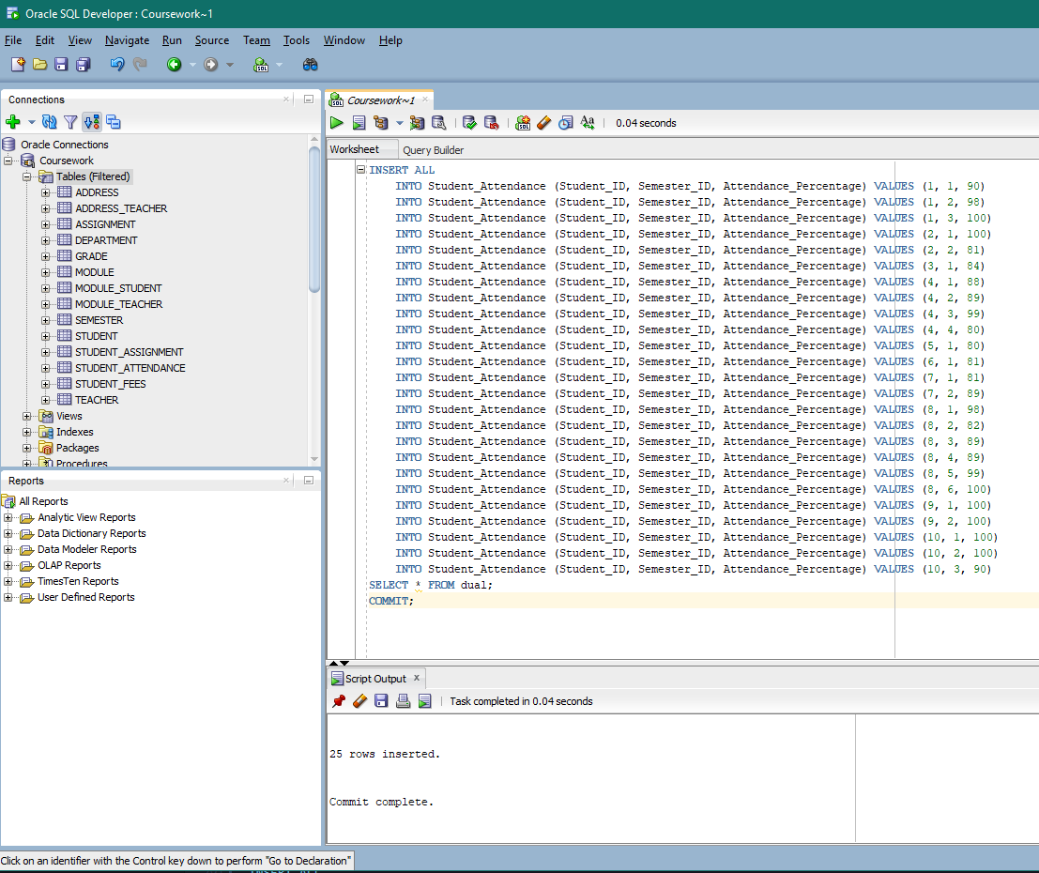 Figure 22: INSERT Student_Attendance

## Student_Assignment

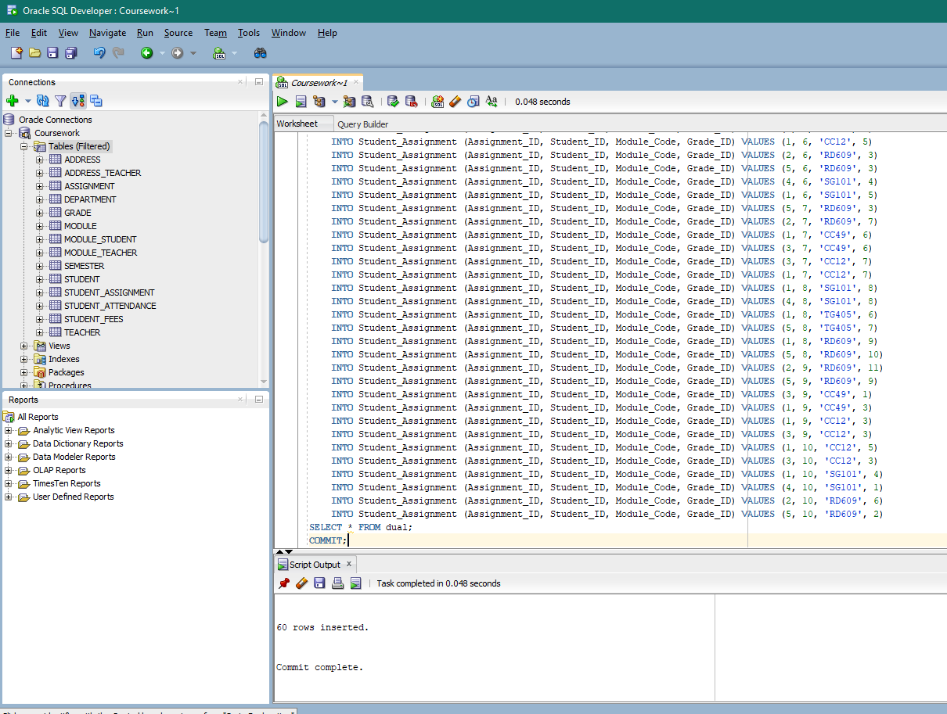 Figure 23: INSERT Student_Assignment

## Module_Teacher

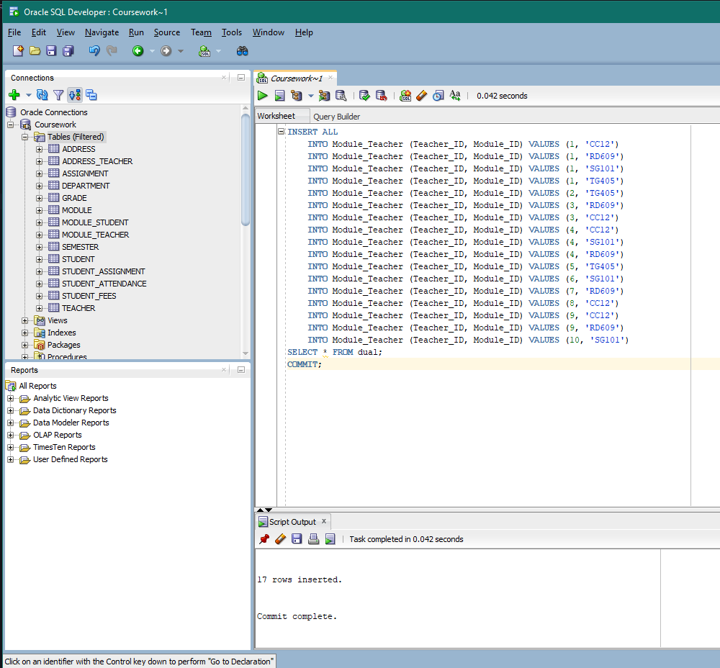 Figure 24: INSERT Module_Teacher

## Module_Student

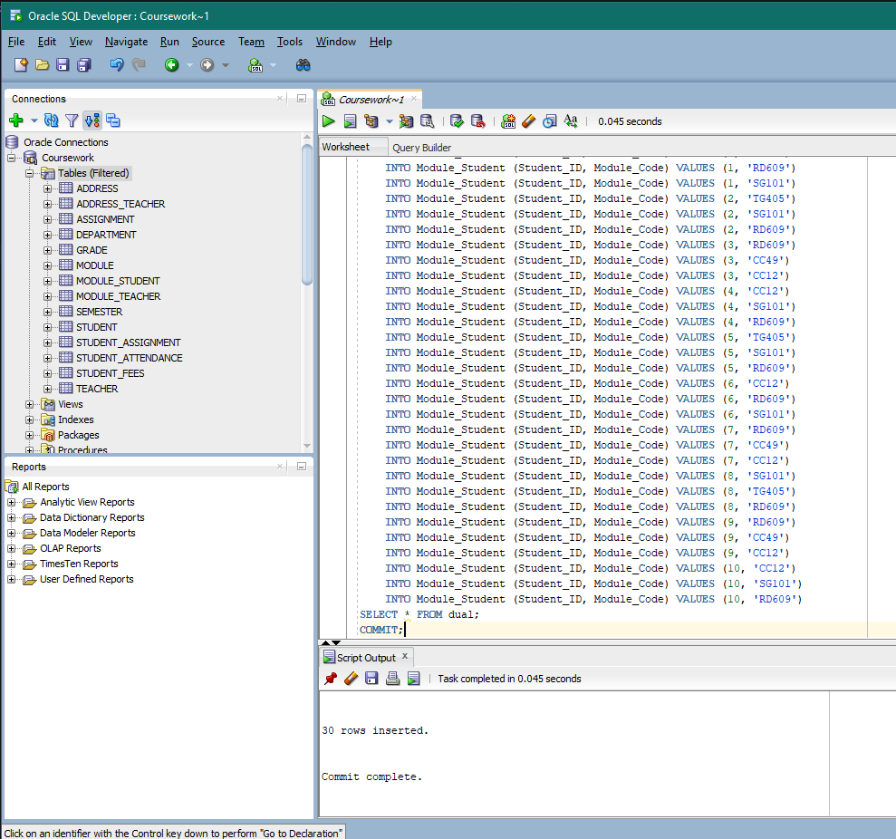 Figure 25: INSERT Module_Student

## Address_Teacher

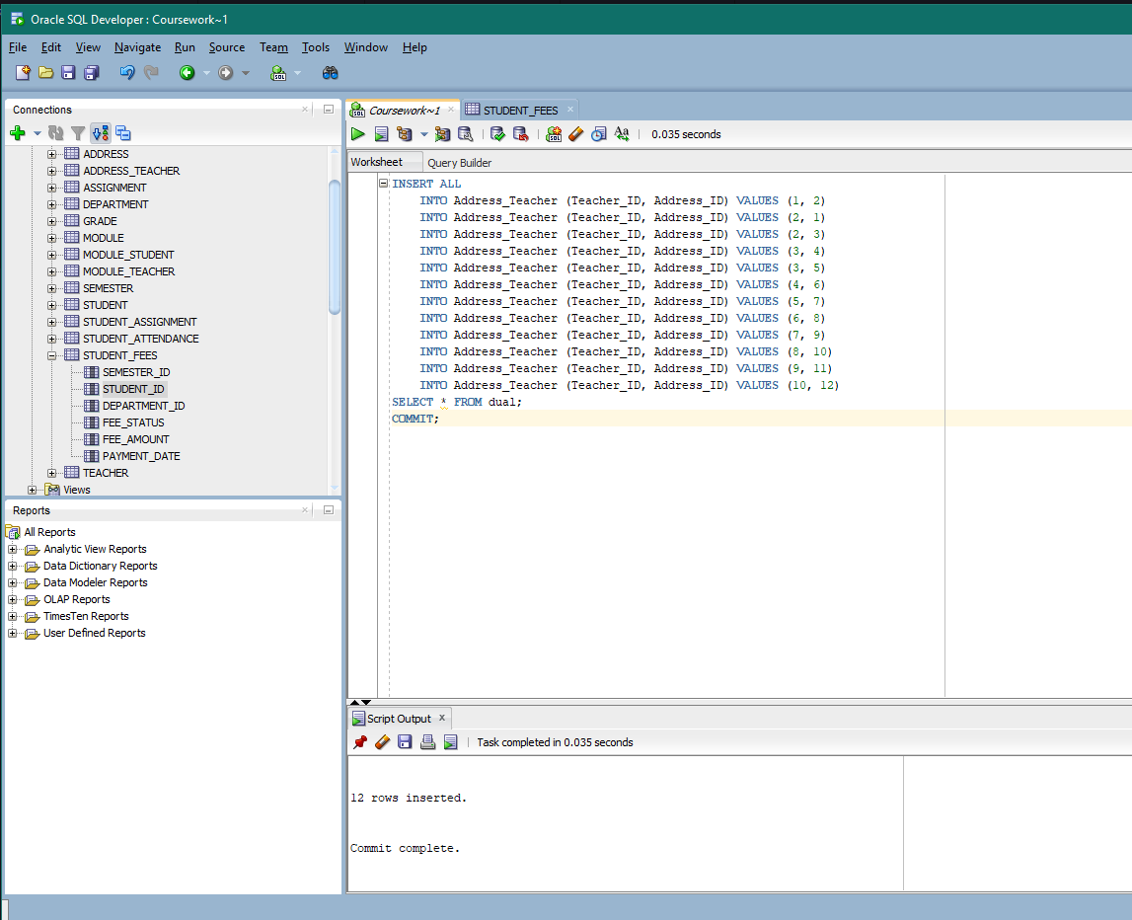

Figure 26: INSERT Address_Teacher

# SELECT Statements

## Address

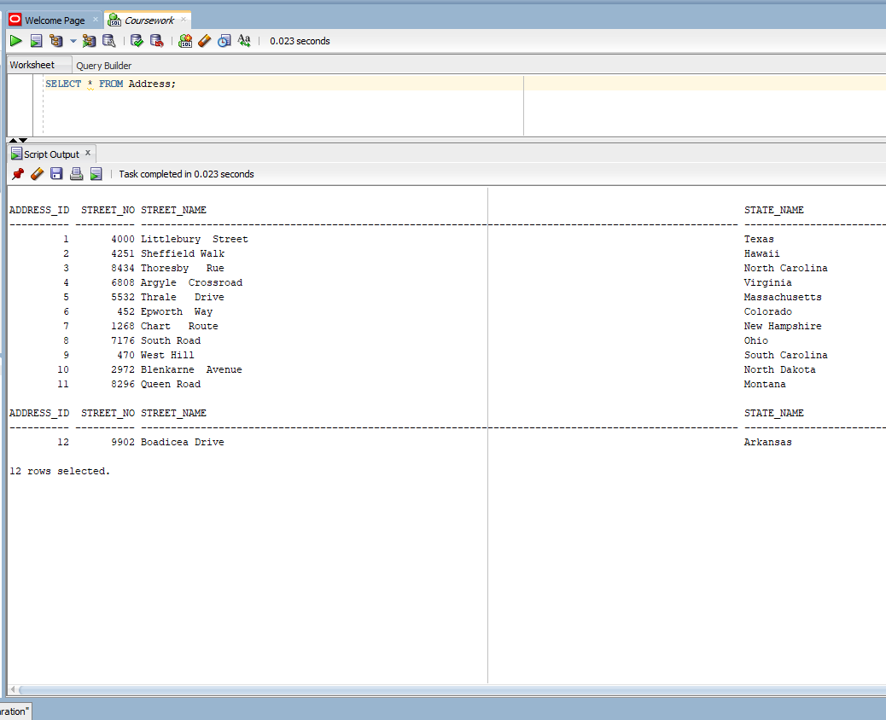

Figure 27:Select Address

## Address_Teacher

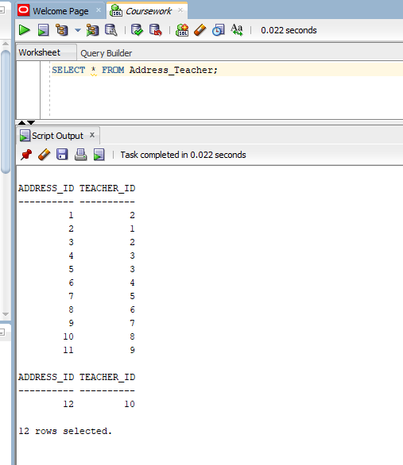

Figure 28:Select Address_Teacher

## Assignment

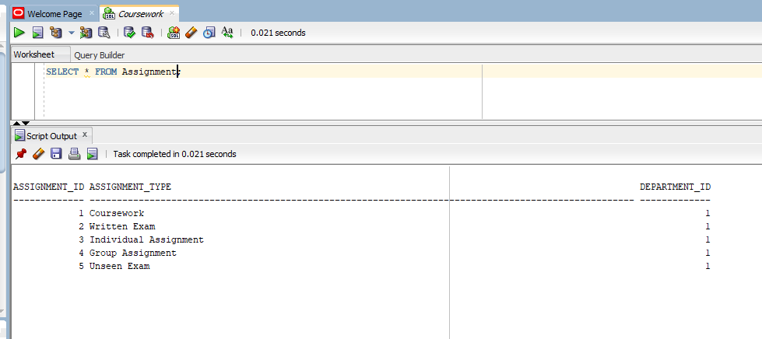

Figure 29:Select Assignment

## Grade

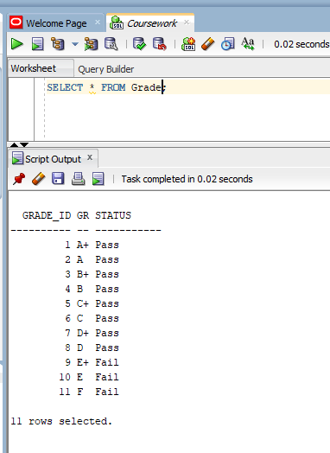

Figure 30:Select Grade

## Module

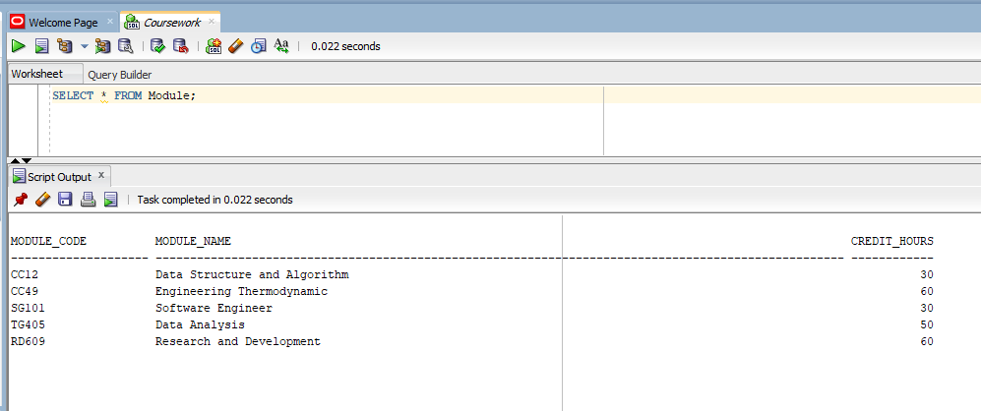

Figure 31:Select Module

## Module_Student

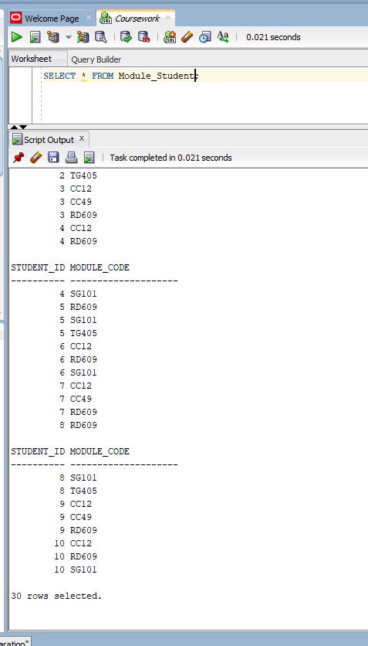

Figure 32:Select Module_Student

## Module_Teacher

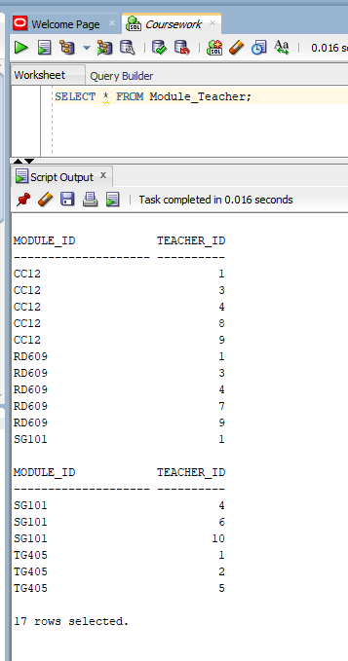

Figure 33:Select Module_Teacher

## Semester

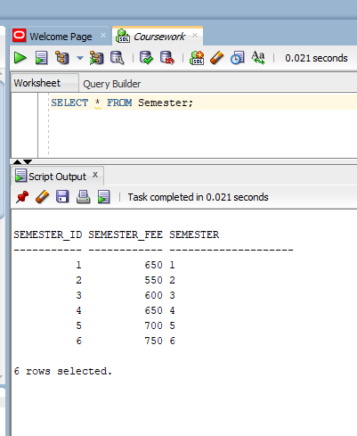

Figure 34:Select Semester

## Student

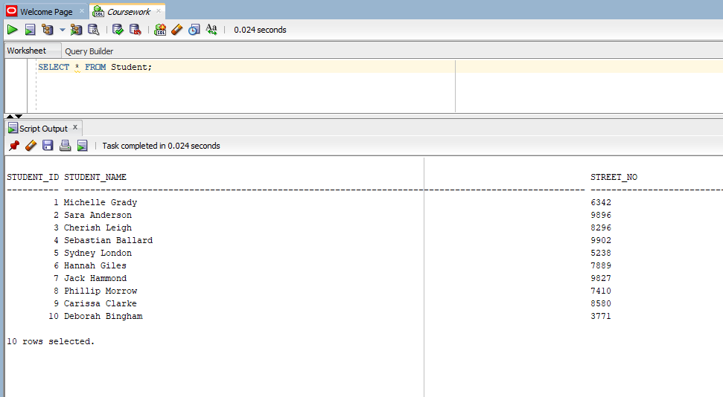

Figure 35:Select Student

## Student_Assignment

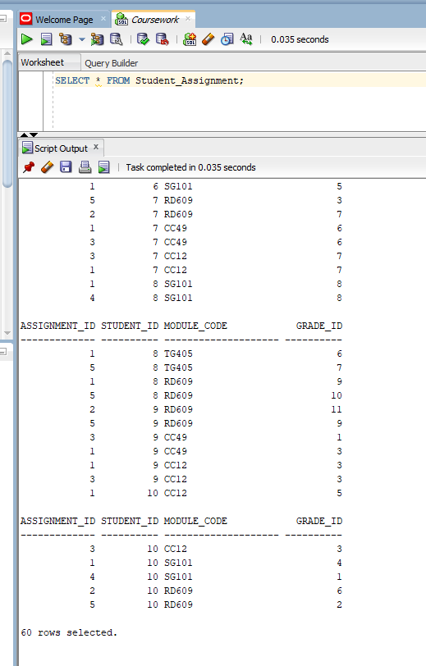

Figure 36:Select Student_Assignment

## Student_Attendance

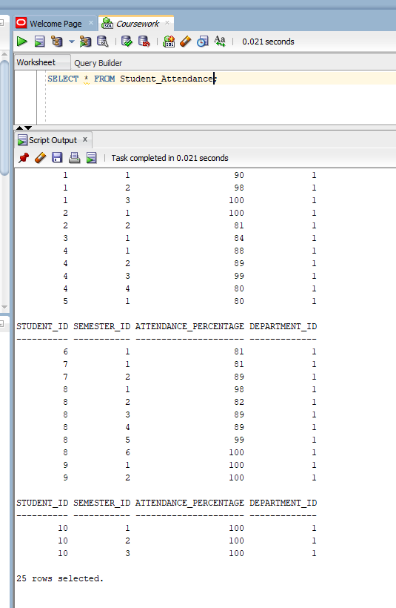

Figure 37:Select Attendance

## Student_Fees

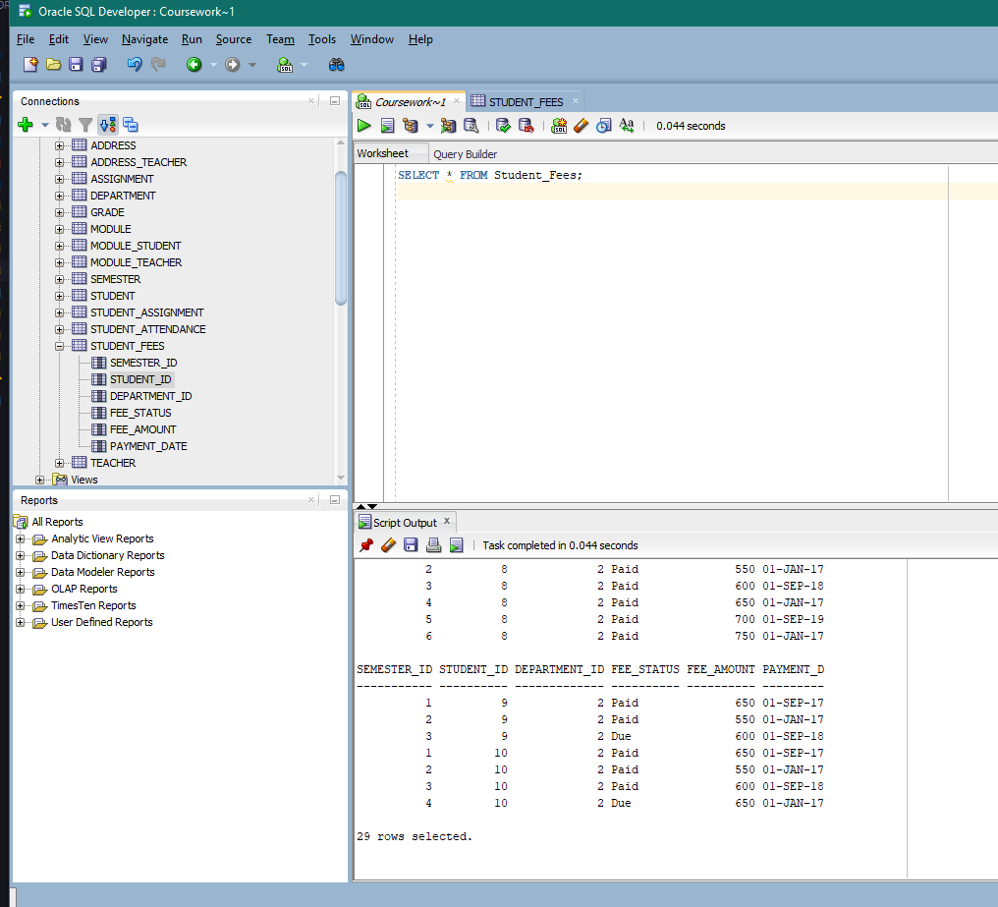

Figure 38:Select Fees

## Teacher

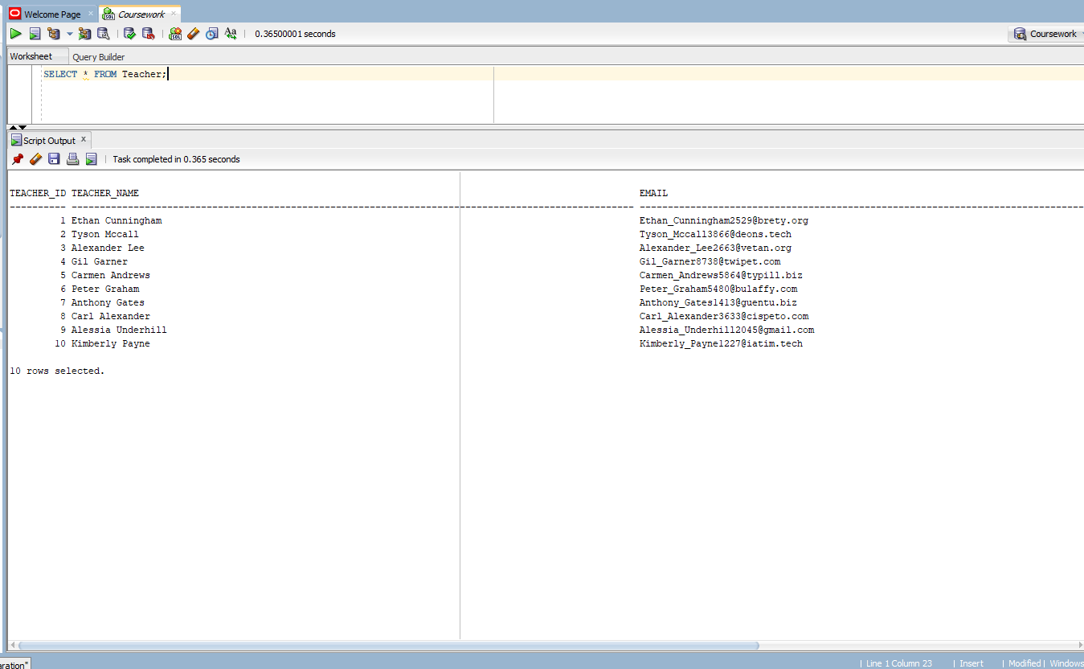

Figure 39:Select Teacher

# Forms

## Dashboard

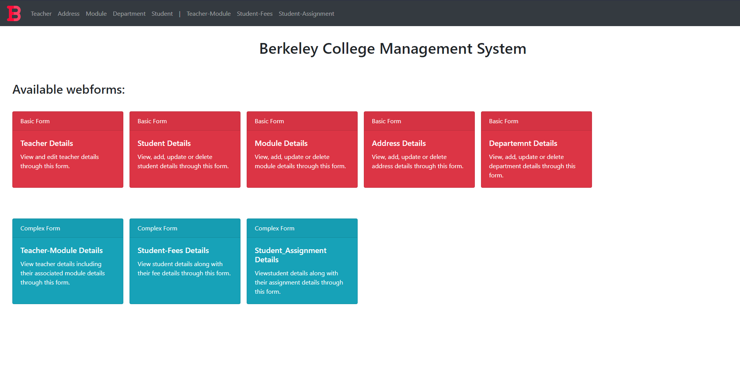

Figure 40: WebForms Dashboard

## Basic Forms

### Teacher Form

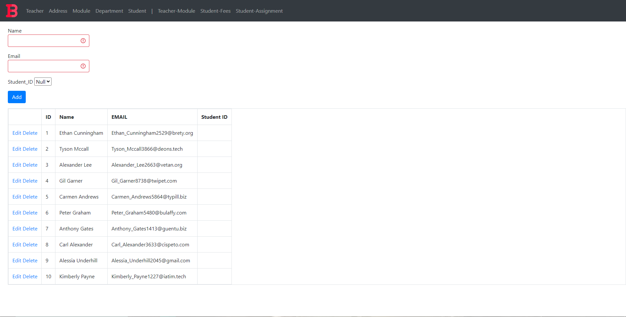

Figure 41: Teacher Form

### Address Form

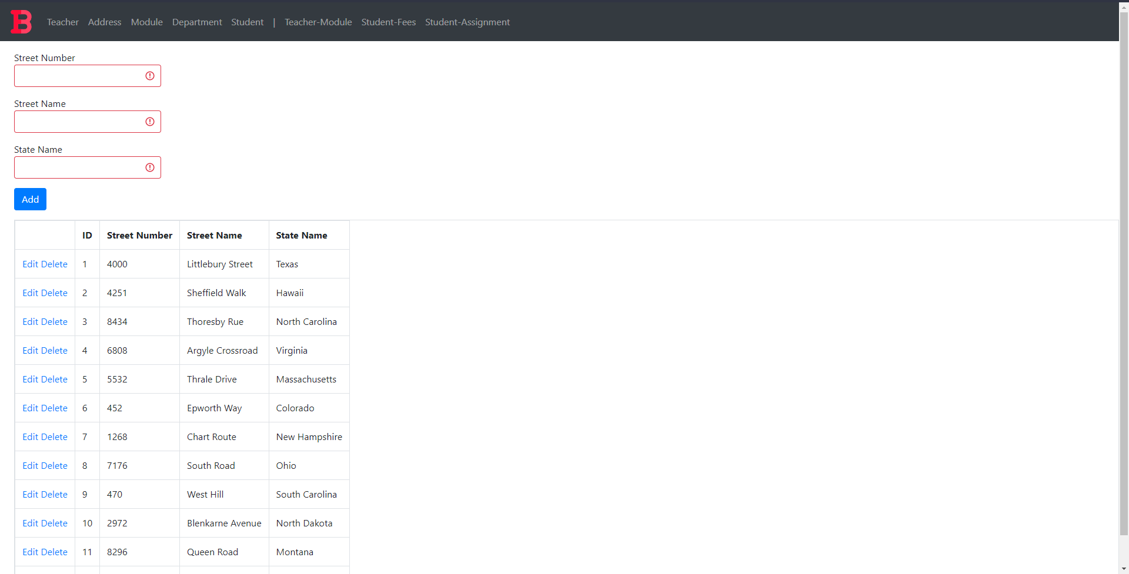

Figure 42: Teacher Form

### Module Form

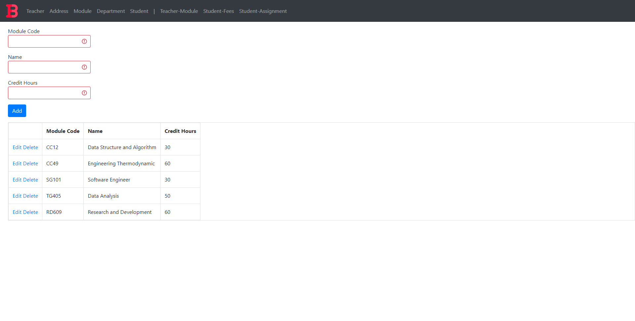

Figure 43: Module Form

### Department Form

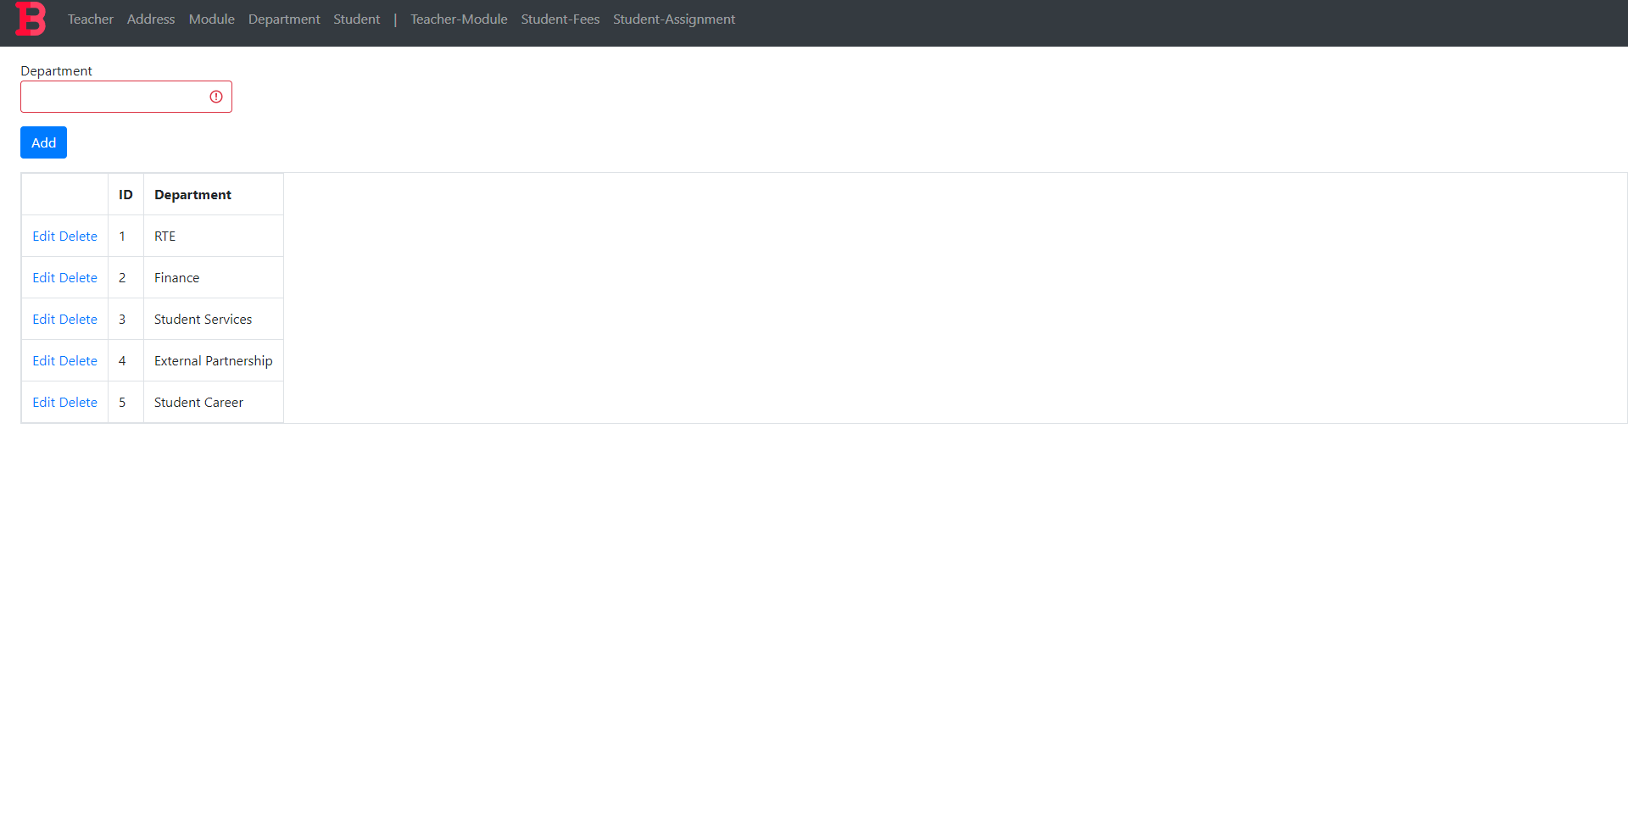

Figure 44: Department Form

### Student Form

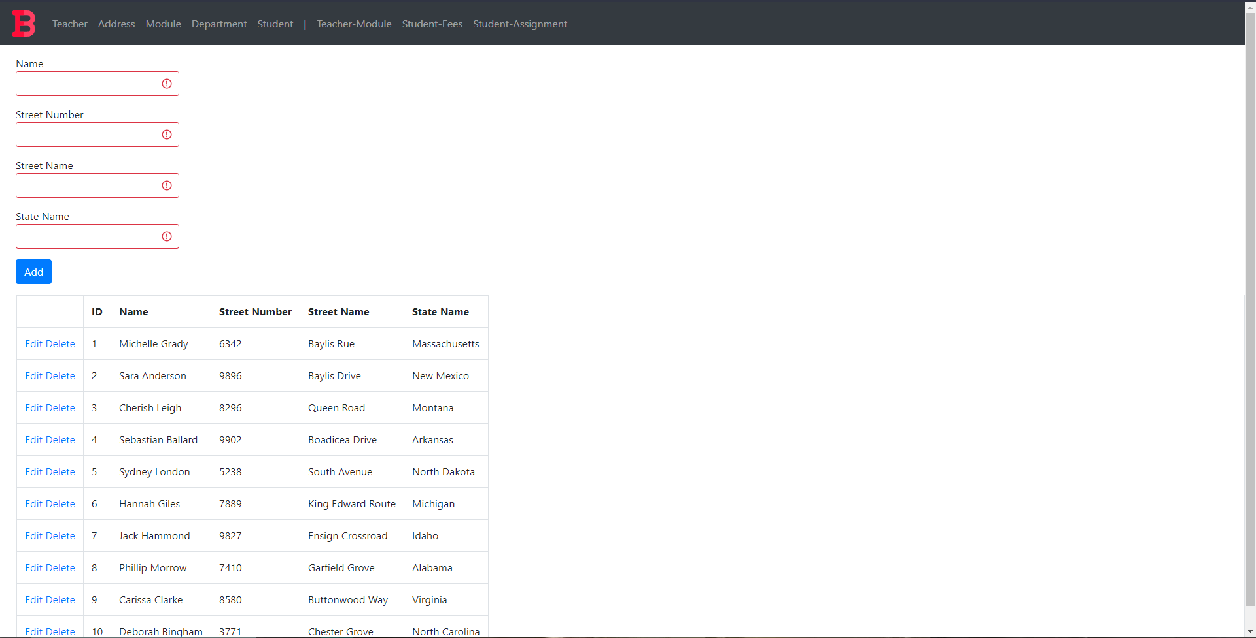

Figure 45: Student Form

## Complex Forms

### Teacher-Module Mapping

#### Form

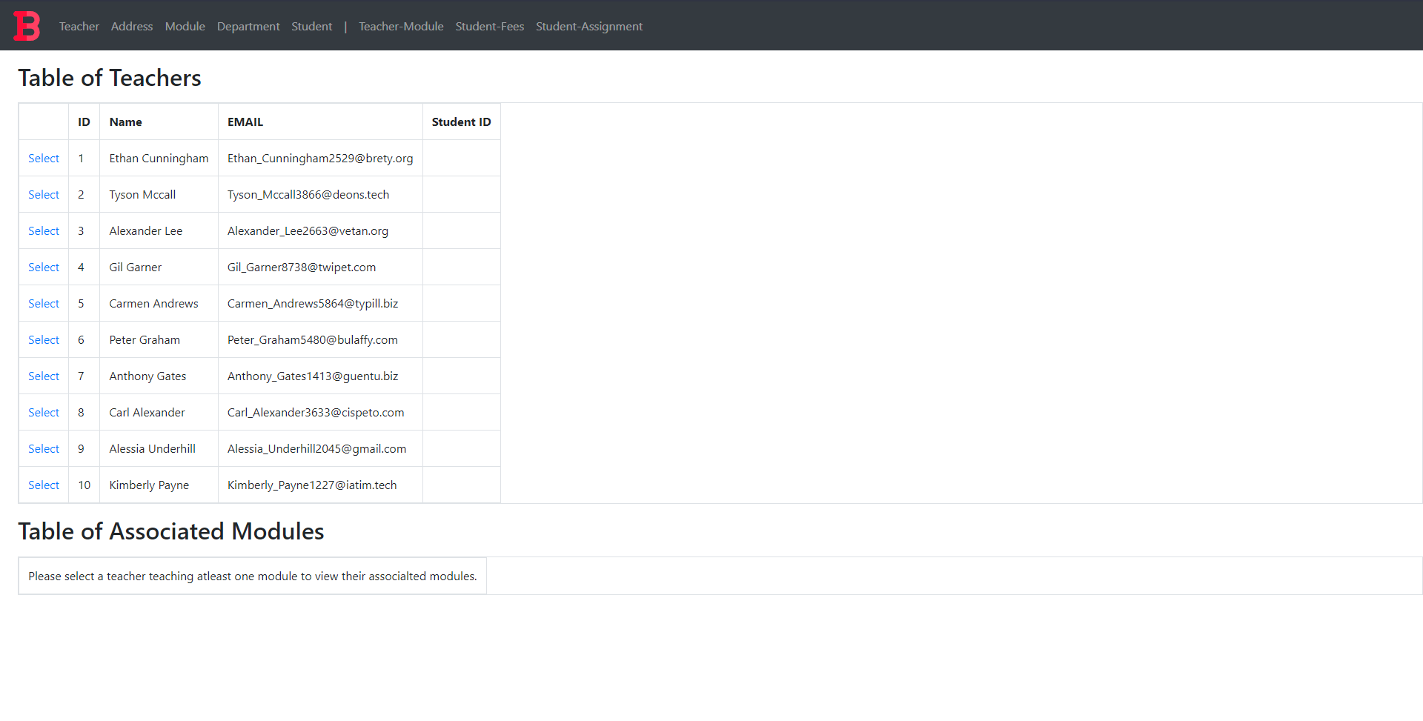

Figure 46: Teacher Module Mapping Form Before Selection

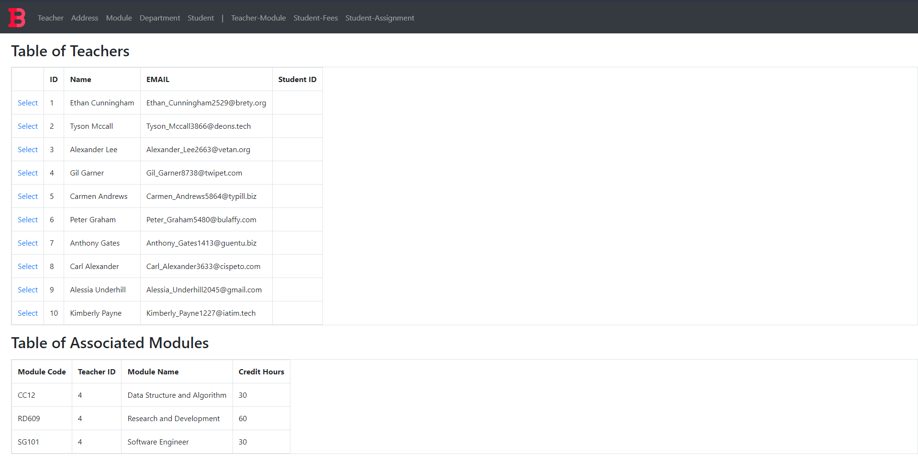 Figure 47: Teacher Module Mapping Form After Selection

#### Query

Assuming the selected student has student_id 1, the query is as following:

1. SELECT m.Module_Code as "Module Code", mt.Teacher_ID "Teacher ID", m.Module_Name as "Module Name", m.Credit_Hours "Credit Hours"
2. FROM Module m
3. INNER JOIN Module_Teacher mt ON mt.Module_ID = m.Module_Code
4. WHERE mt.Teacher_ID = 1
5. ;

In the webform the query string is written as:

1. $@"SELECT m.Module_Code as ""Module Code"", mt.Teacher_ID ""Teacher ID"", m.Module_Name as ""Module Name"", m.Credit_Hours ""Credit Hours""
2. FROM Module m
3. INNER JOIN Module_Teacher mt ON mt.Module_ID = m.Module_Code
4. WHERE mt.Teacher_ID = {teacherID}
5. ";

## Student-Fees Mapping

#### Form

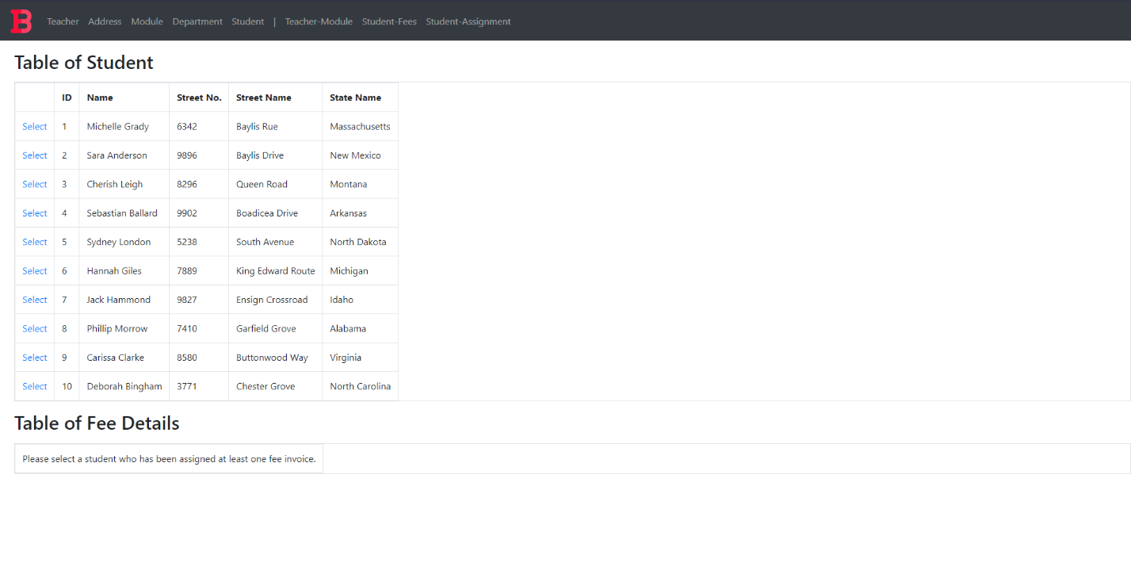

Figure 48: Student-Fees Mapping Form Before Selection

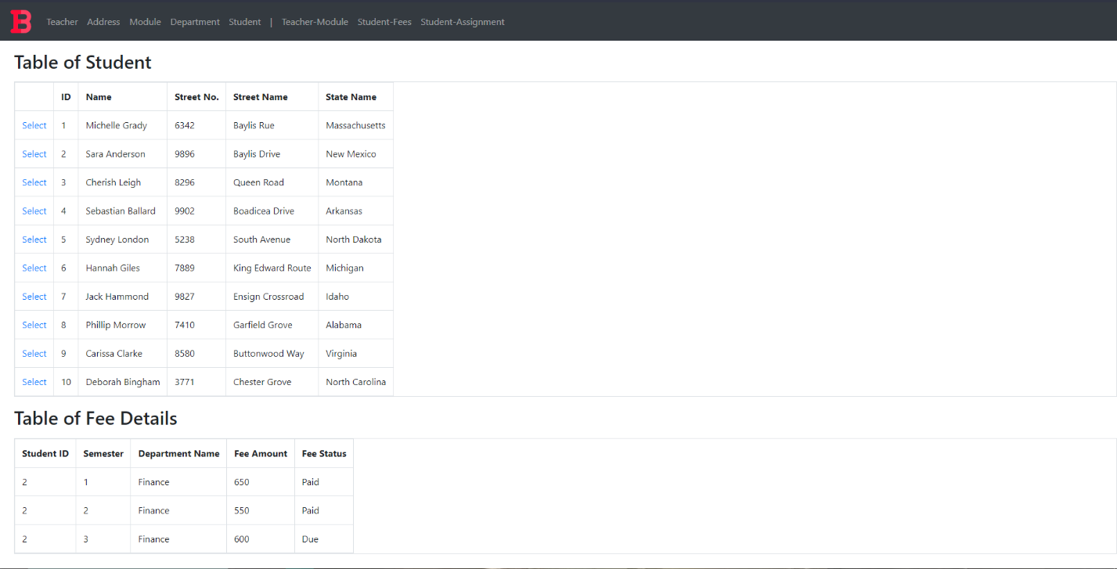 Figure 49: Student-Fees Mapping Form After Selection

#### Query

Assuming the selected student has student_id 1, the query is as following:

1. SELECT sf.Student_ID "Student ID", se.Semester "Semester", d.Department_Name as "Department Name", sf.Fee_Amount "Fee Amount", sf.Fee_Status "Fee Status"
2. FROM Student s
3. INNER JOIN Student_Fees sf ON sf.Student_ID = s.Student_ID
4. INNER JOIN Semester se ON se.Semester_ID = sf.Semester_ID
5. INNER JOIN Department d ON d.Department_ID = sf.Department_ID
6. WHERE sf.Student_ID = 1
7. ;

In the webform the query string is written as:

1. $@"SELECT sf.Student_ID ""Student ID"", se.Semester ""Semester"", d.Department_Name as ""Department Name"", sf.Fee_Amount ""Fee Amount"", sf.Fee_Status ""Fee Status""
2. FROM Student s
3. INNER JOIN Student_Fees sf ON sf.Student_ID = s.Student_ID
4. INNER JOIN Semester se ON se.Semester_ID = sf.Semester_ID
5. INNER JOIN Department d ON d.Department_ID = sf.Department_ID
6. WHERE sf.Student_ID = {studentID}
7. ";

## Student-Assignment Mapping

#### Form

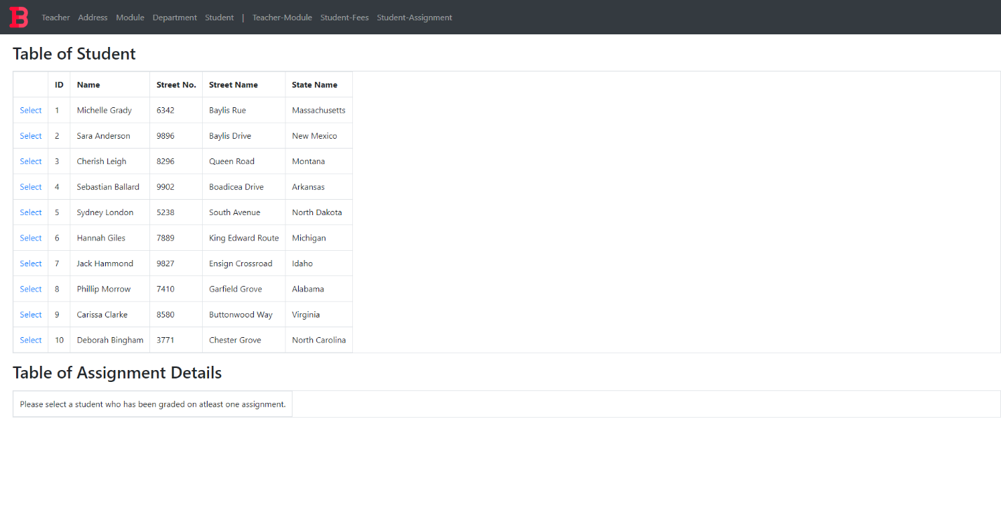

Figure 50: Student-Assignment Mapping Form Before Selection

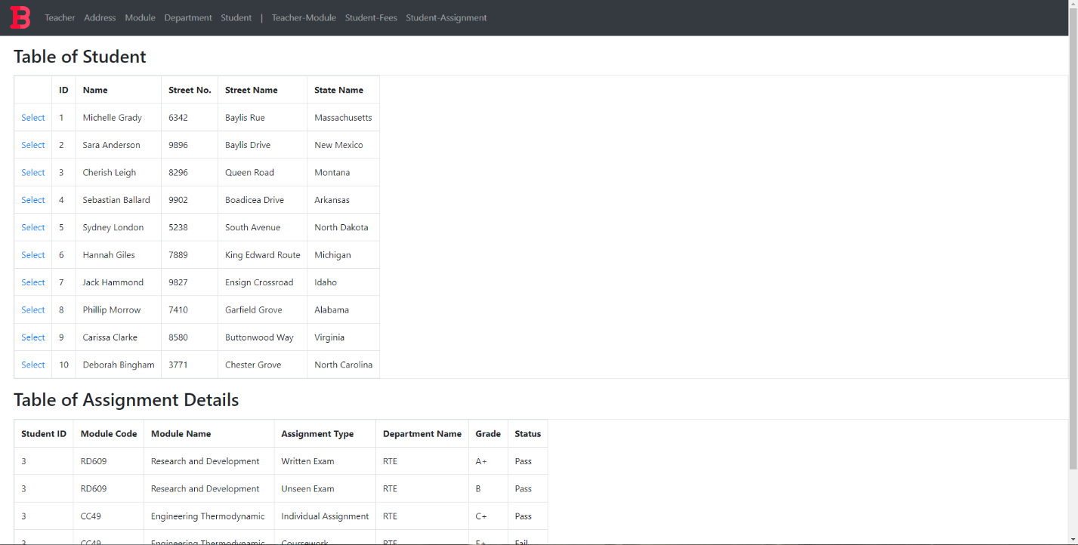 Figure 51: Student-Fees Mapping Form After Selection

#### Query

Assuming the selected student has student_id 1, the query is as following:

1. SELECT sa.Student_ID "Student ID", m.Module_Code "Module Code" , m.Module_Name "Module Name", a.Assignment_Type "Assignment Type" , d.Department_Name "Department Name" , g.Grade "Grade", g.Status "Status"
2. FROM Student s
3. INNER JOIN Student_Assignment sa ON sa.Student_ID = s.Student_ID
4. INNER JOIN Grade g ON sa.Grade_ID = g.Grade_ID
5. INNER JOIN Module m ON sa.Module_Code = m.Module_Code
6. INNER JOIN Assignment a ON sa.Assignment_ID = a.Assignment_ID
7. INNER JOIN Department d ON a.Department_ID = d.Department_ID
8. WHERE sa.Student_ID = 1;

In the webform the query string is written as:

1. $@"SELECT sa.Student_ID ""Student ID"", m.Module_Code ""Module Code"" , m.Module_Name ""Module Name"", a.Assignment_Type ""Assignment Type"" ,
2. d.Department_Name ""Department Name"" , g.Grade ""Grade"", g.Status ""Status""
3. FROM Student s
4. INNER JOIN Student_Assignment sa ON sa.Student_ID = s.Student_ID
5. INNER JOIN Grade g ON sa.Grade_ID = g.Grade_ID
6. INNER JOIN Module m ON sa.Module_Code = m.Module_Code
7. INNER JOIN Assignment a ON sa.Assignment_ID = a.Assignment_ID
8. INNER JOIN Department d ON a.Department_ID = d.Department_ID
9. WHERE sa.Student_ID = {studentID}
10. ";

# User Manual

If the project is run without changing the port settings, then the url for the project is:

**https://localhost:44370/Index.aspx**

## Included Content

1. Landing Page
2. Teacher Form
3. Address Form
4. Module Form
5. Teacher-Module Form
6. Student-Fees Form
7. Student-Assignment Form

## Landing Page

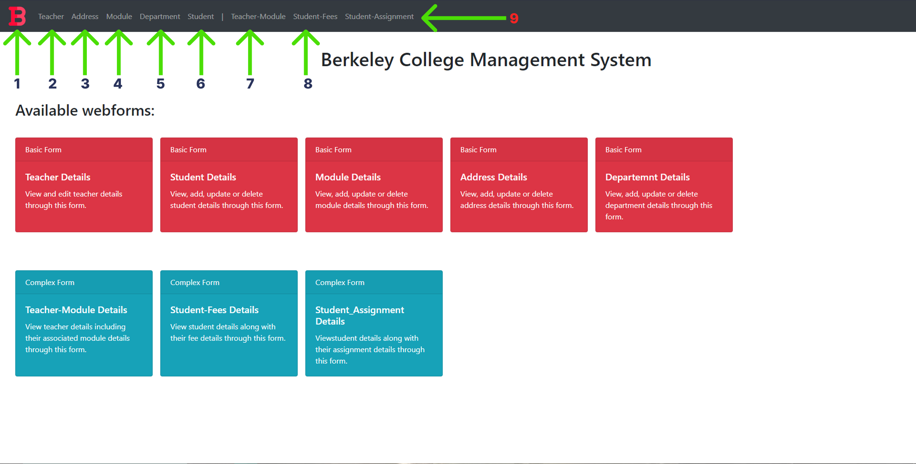

Figure 52: Landing Page

1. The logo can be pressed to navigate to the dashboard
2. The Teacher text in the navbar can be pressed to navigate to the Teacher form
3. The Module text in the navbar can be pressed to navigate to the Module form
4. The Department text in the navbar can be pressed to navigate to the Department form
5. The Student text in the navbar can be pressed to navigate to the Student form
6. The Teacher-Module text in the navbar can be pressed to navigate to the Teacher-Module form
7. The Student-Fees text in the navbar can be pressed to navigate to the Student-Fees form
8. The Student-Assignment text in the navbar can be pressed to navigate to the Student-Assignment form

## Teacher Form

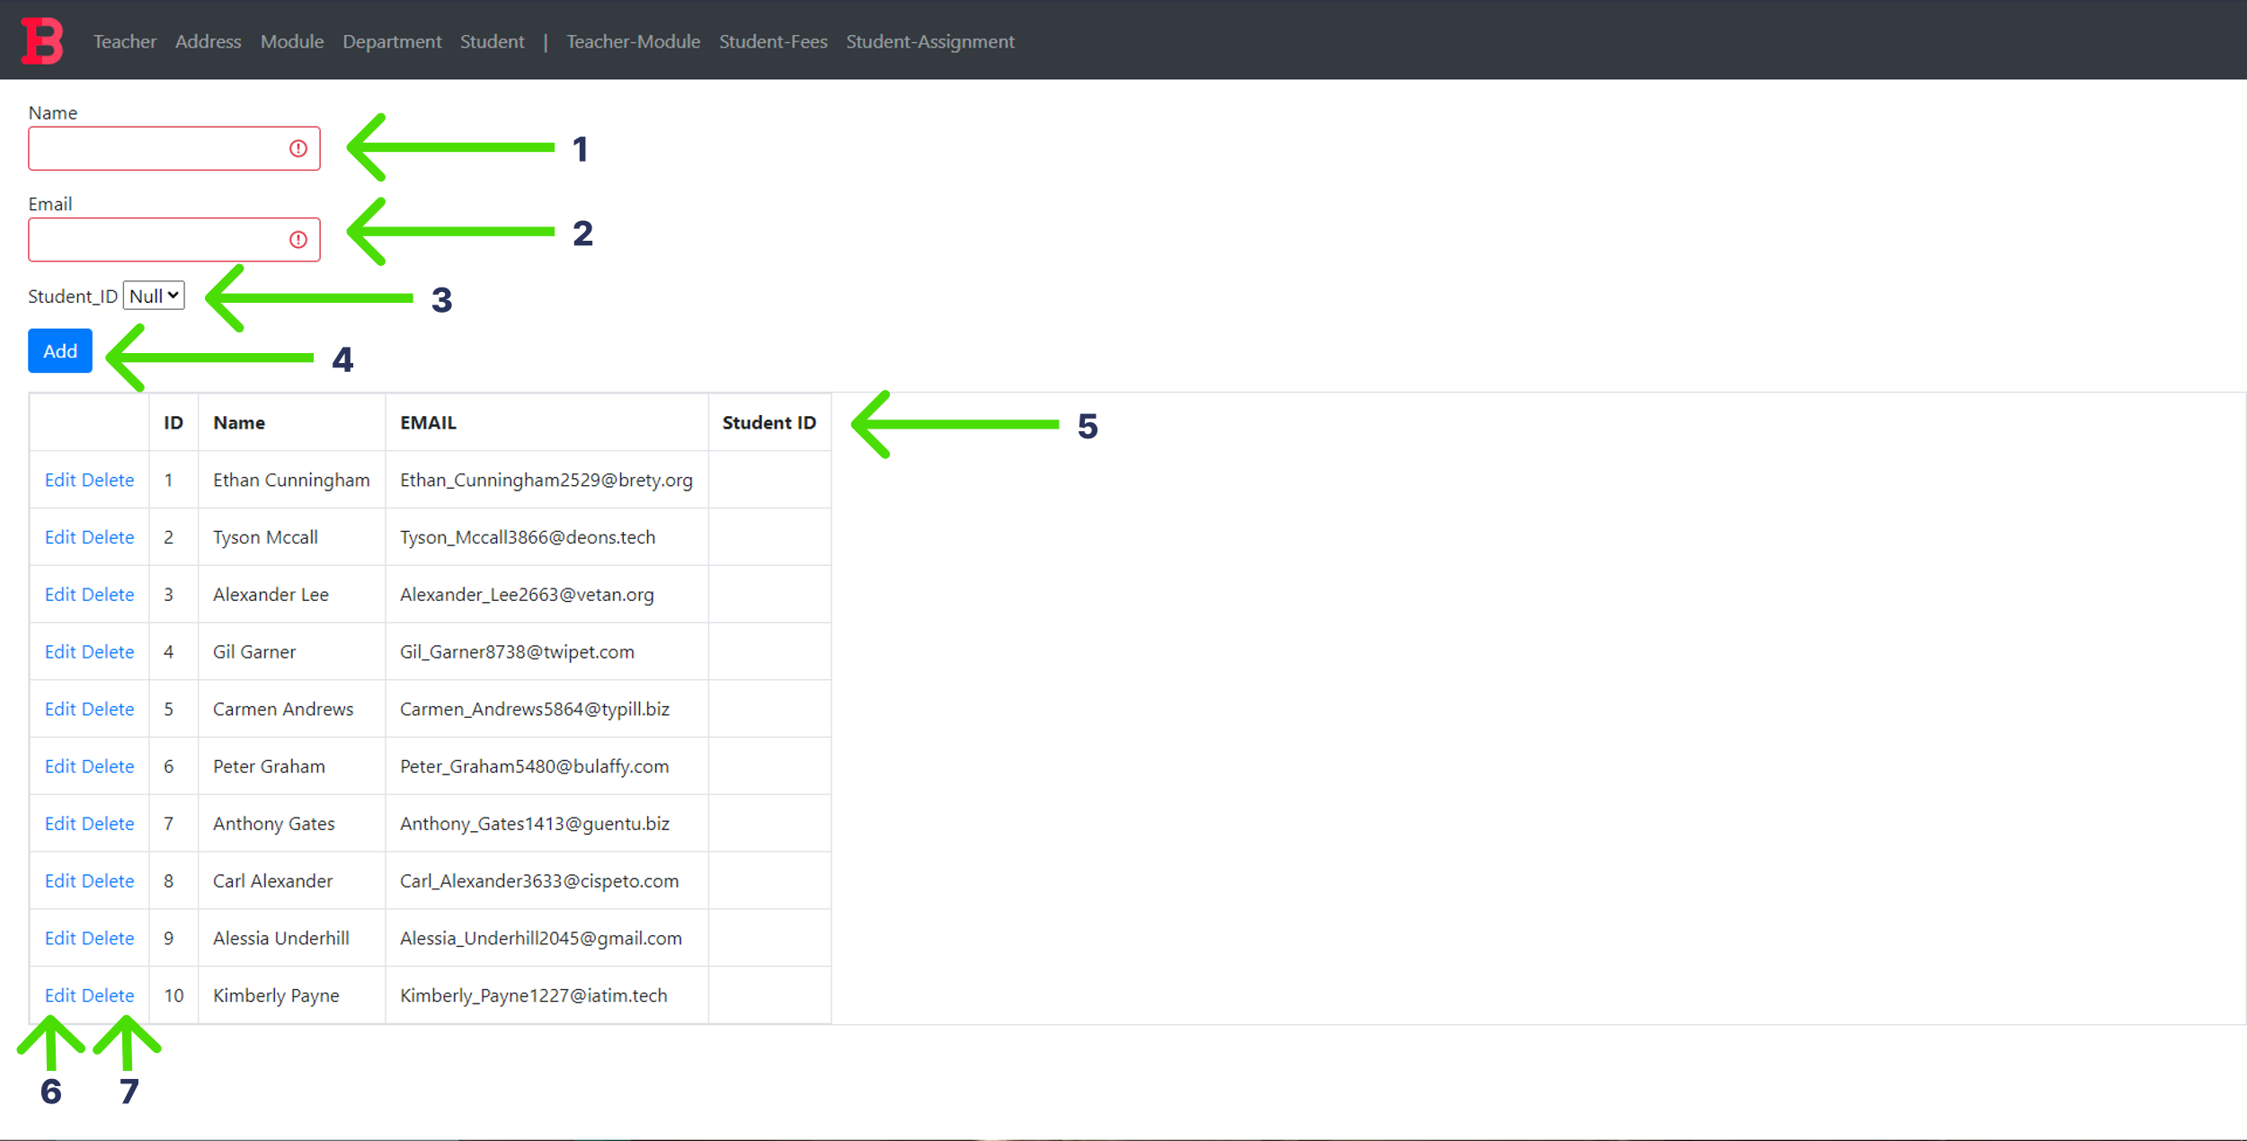

Figure 53: Teacher Form

1. Enter the name of teacher to be added in the name text field. This text field cannot be left empty.
2. Enter the email address of teacher to be added in the email text field. This text field cannot be left empty.
3. If the teacher was a former student, select their student ID from this dropdown. Otherwise, leave it as null.
4. Press the Add button to add data.
5. The teacher details data is displayed in this grid.
6. Press this button to edit data in the grid.
7. Press this button to delete data in the grid.

## Address Form

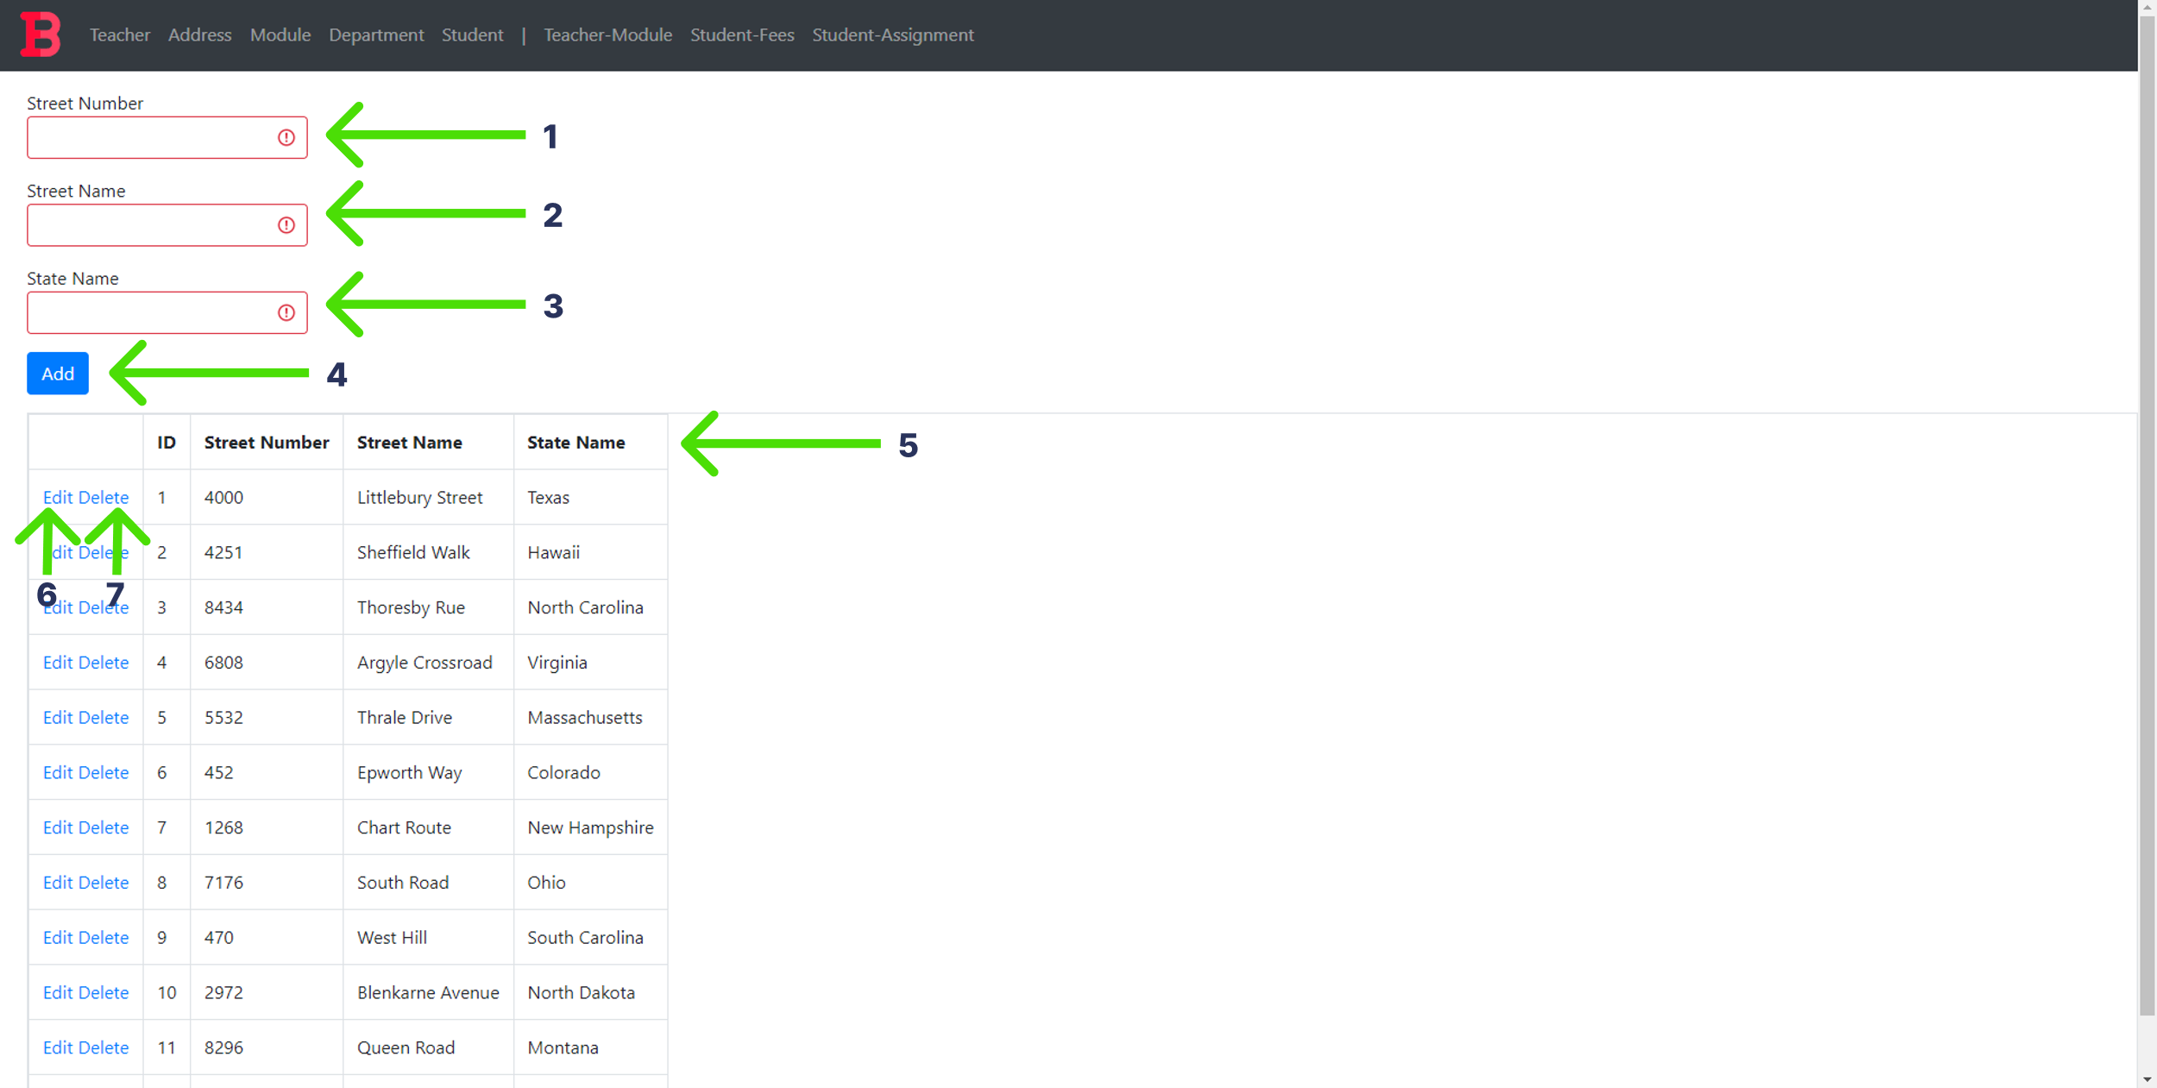

Figure 54: Address Form

1. Enter the Street number of the address in this text field. This text field cannot be left empty.
2. Enter the name of street to be added in this text field. This text field cannot be left empty.
3. Enter the street name of the address to be added in this text field. This text field cannot be left empty.
4. Press the Add button to add data.
5. The teacher details data is displayed in this grid.
6. Press this button to edit data in the grid.
7. Press this button to delete data in the grid.

## Module Form

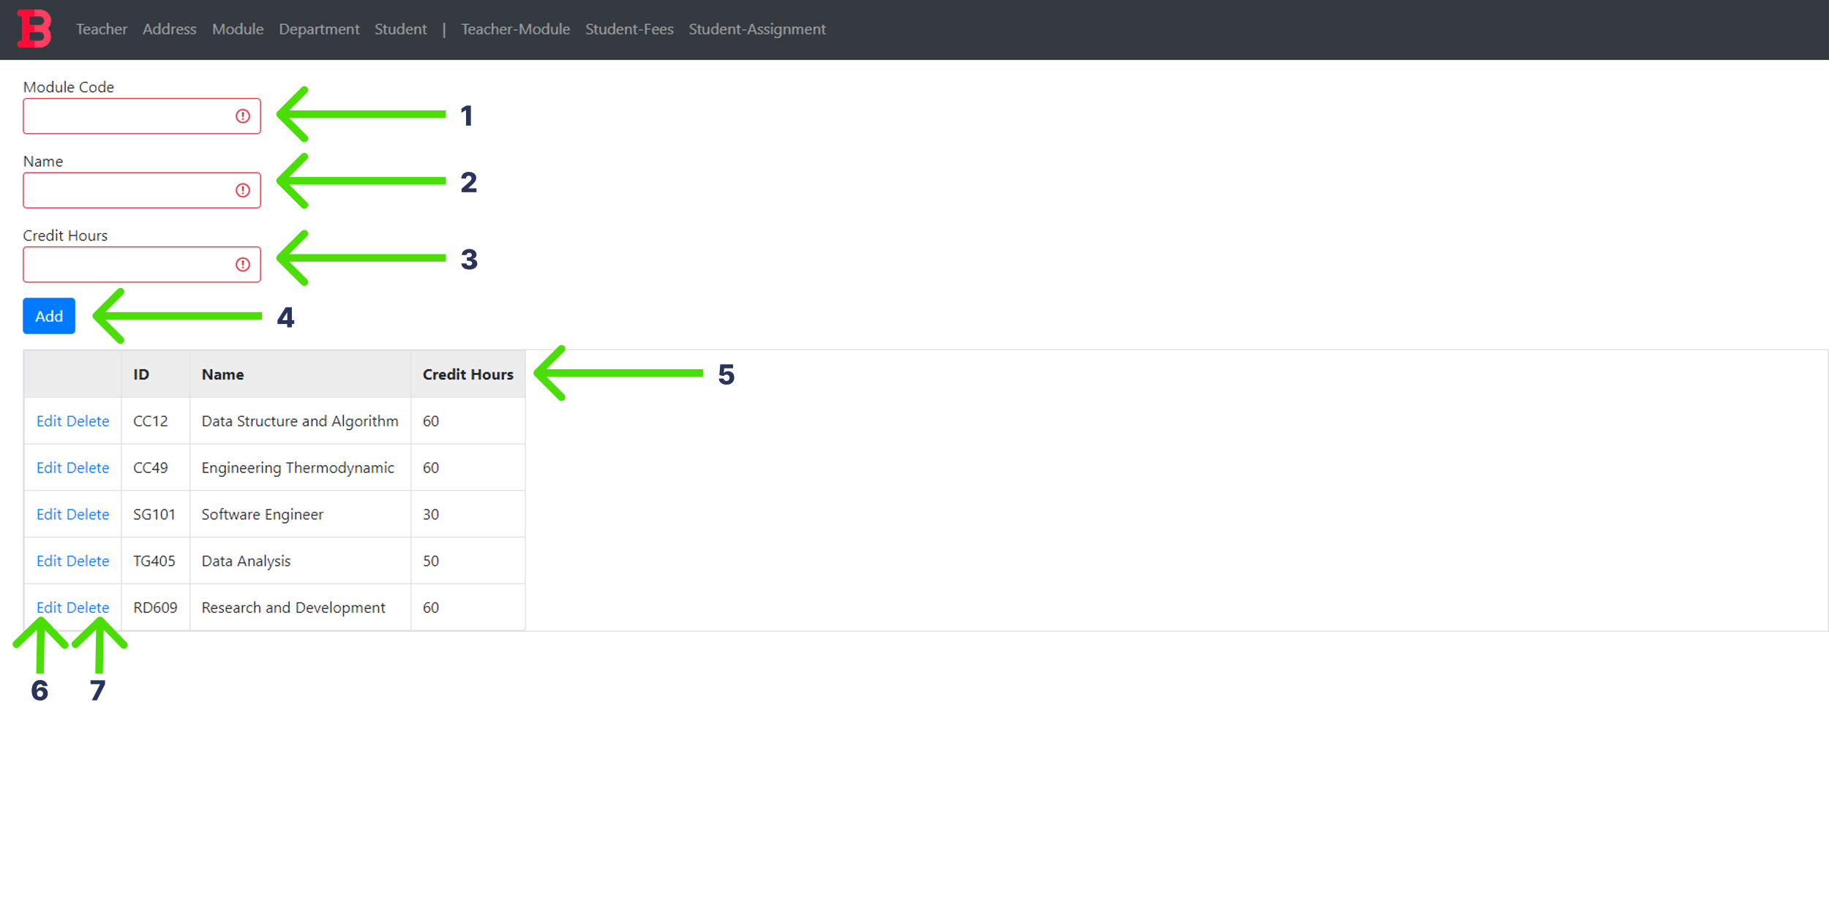

Figure 55: Module Form

1. Enter the code of module to be added in this text field. This text field cannot be left empty.
2. Enter the name of module to be added in this text field. This text field cannot be left empty.
3. Enter the Credit hours of the module in numeric form. This text field cannot be left empty.
4. Press the Add button to add data.
5. The module details data is displayed in this grid.
6. Press this button to edit data in the grid.
7. Press this button to delete data in the grid.

## Department Form

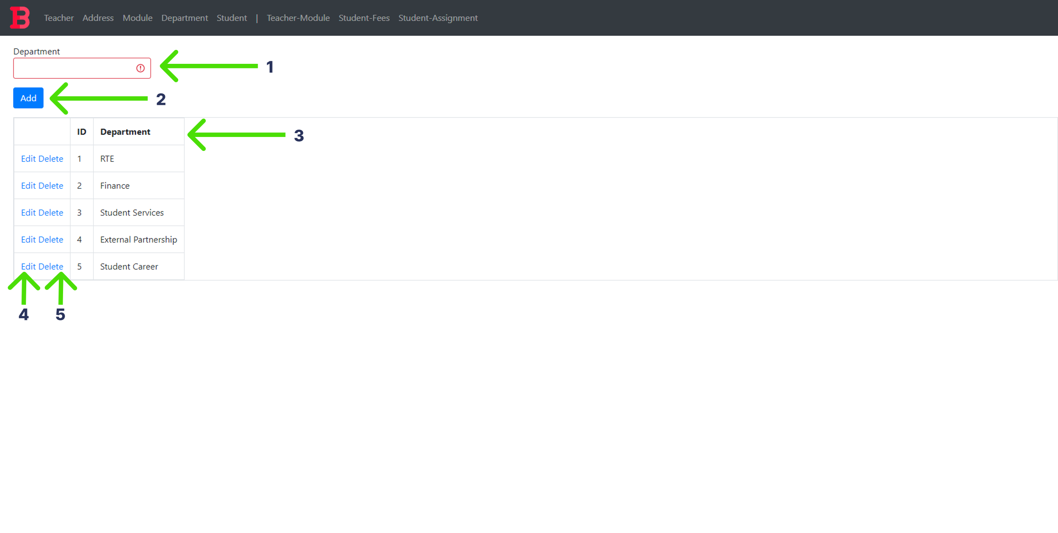

Figure 56: Department Form

1. Enter the name of the department to be added in this text field. This text field cannot be left empty.
2. Press the Add button to add data.
3. The department details data is displayed in this grid.
4. Press this button to edit data in the grid.
5. Press this button to delete data in the grid.

## Student Form

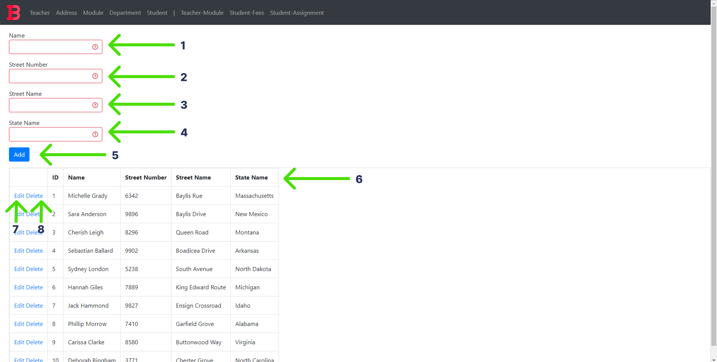

Figure 57: Student Form

1. Enter the name of the student to be added in this text field. This text field cannot be left empty.
2. Enter the street number of the student’s address to be added in this text field in numeric form. This text field cannot be left empty.
3. Enter the street name of the student’s address to be added in this text field. This text field cannot be left empty.
4. Enter the state name of the student’s address to be added in this text field. This text field cannot be left empty.
5. Press the Add button to add data.
6. The student details data is displayed in this grid.
7. Press this button to edit data in the grid.
8. Press this button to delete data in the grid.

## Teacher-Module Form

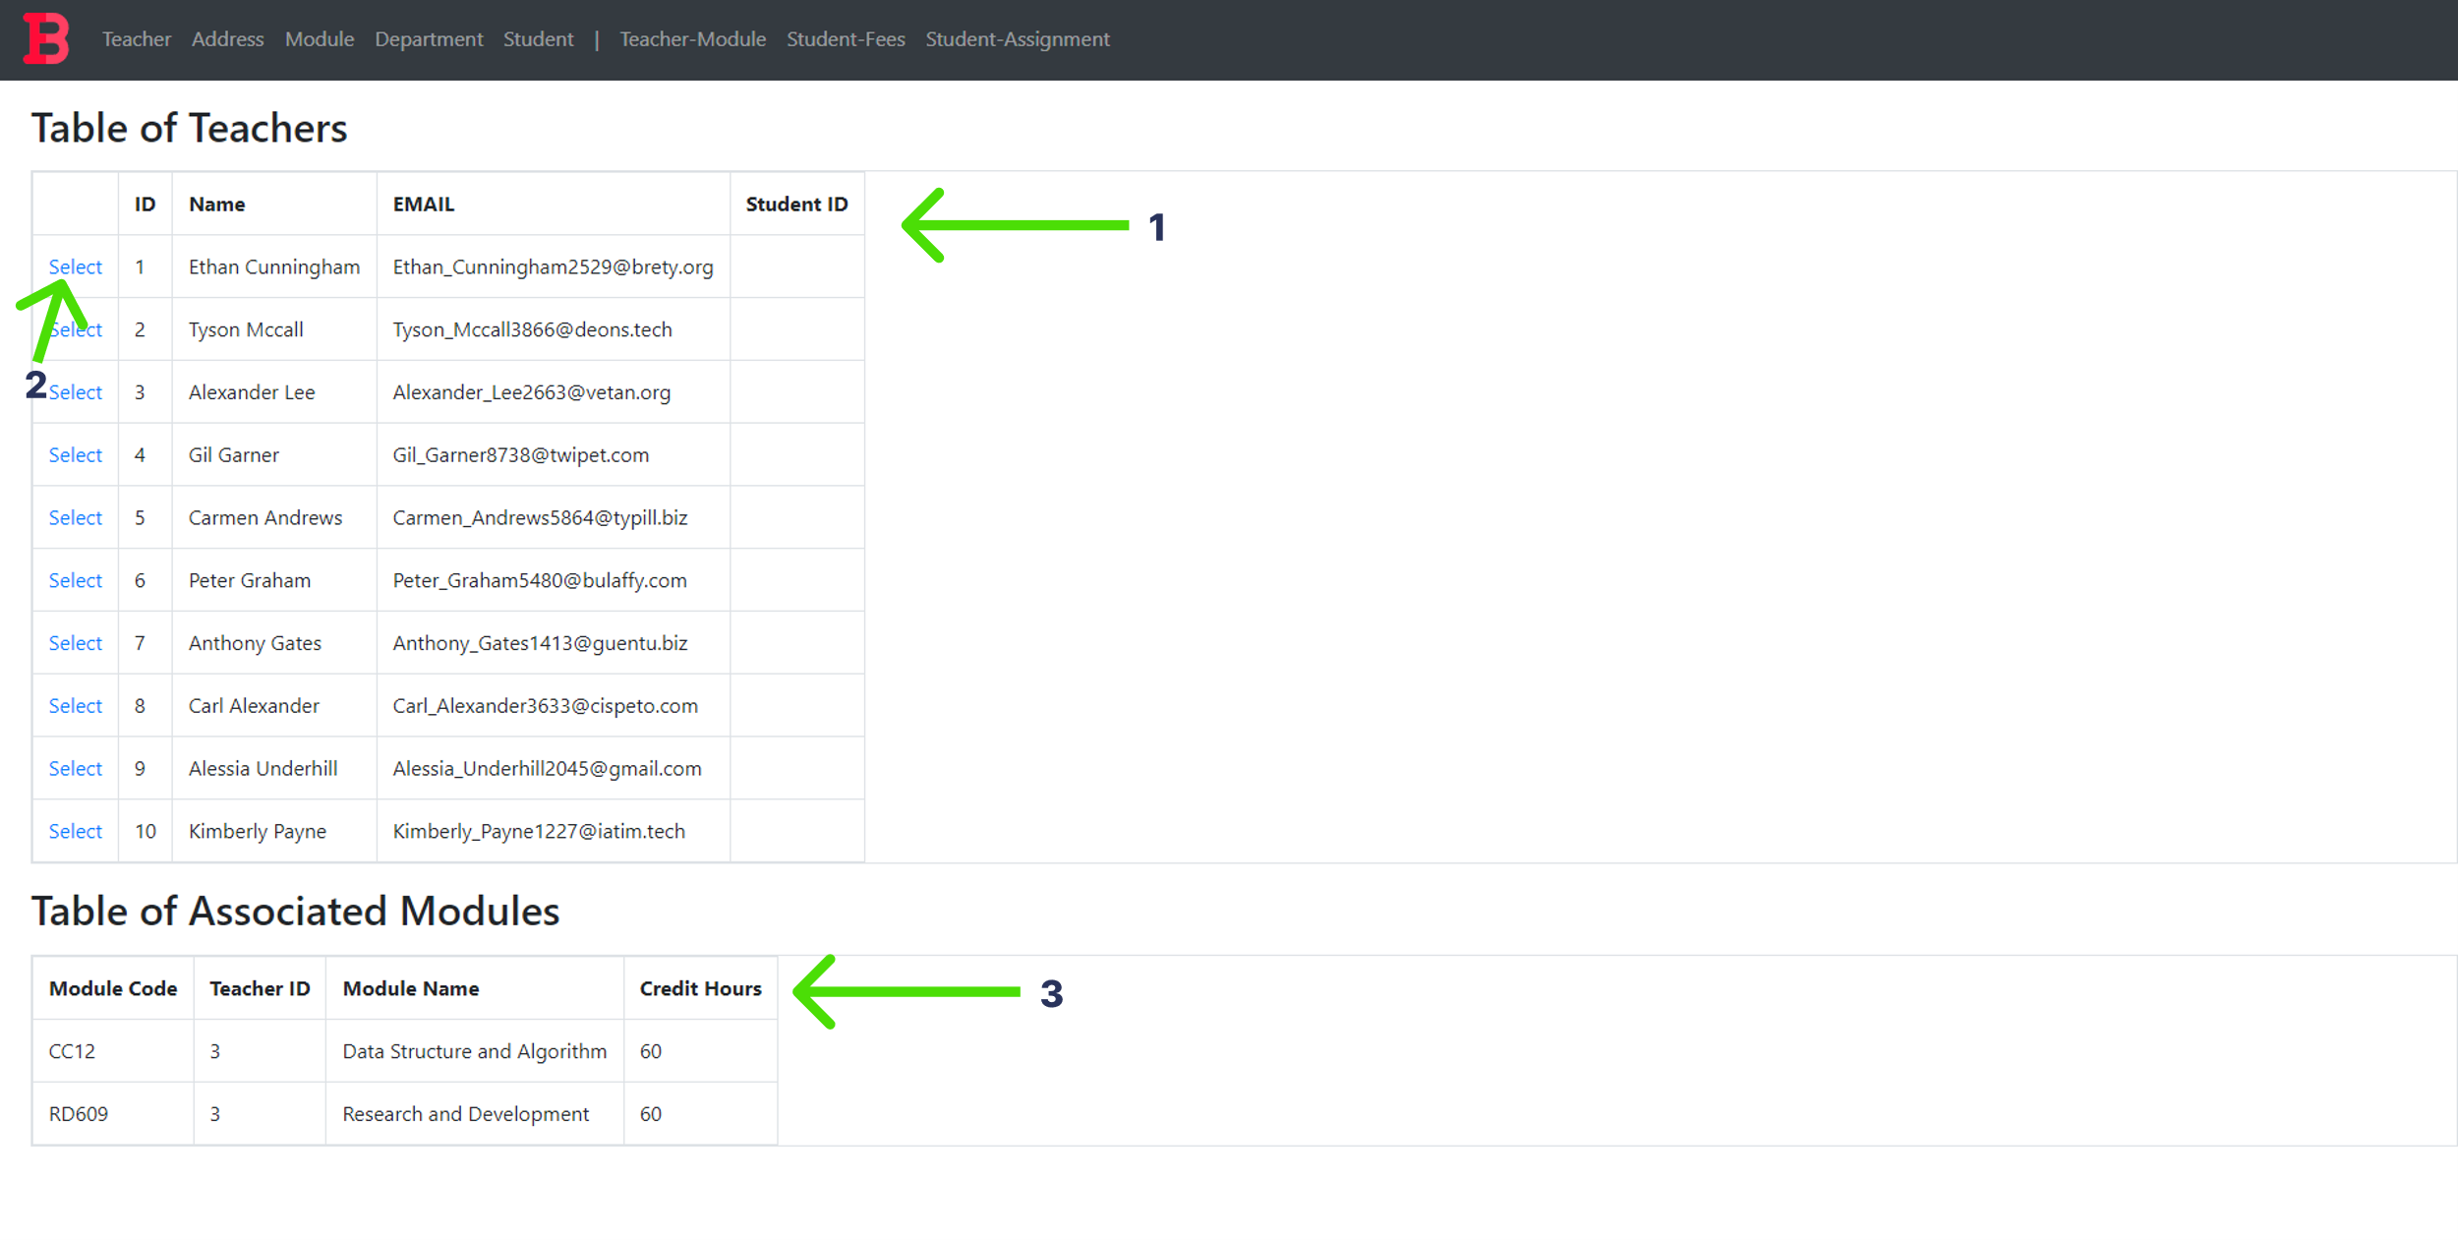

Figure 58: Teacher-Module Form

1. The teacher details data is displayed in this grid.
2. Press this button to select this teacher data and display the modules taught by this teacher.
3. The module details data is displayed in this grid.

## Student-Fees Form

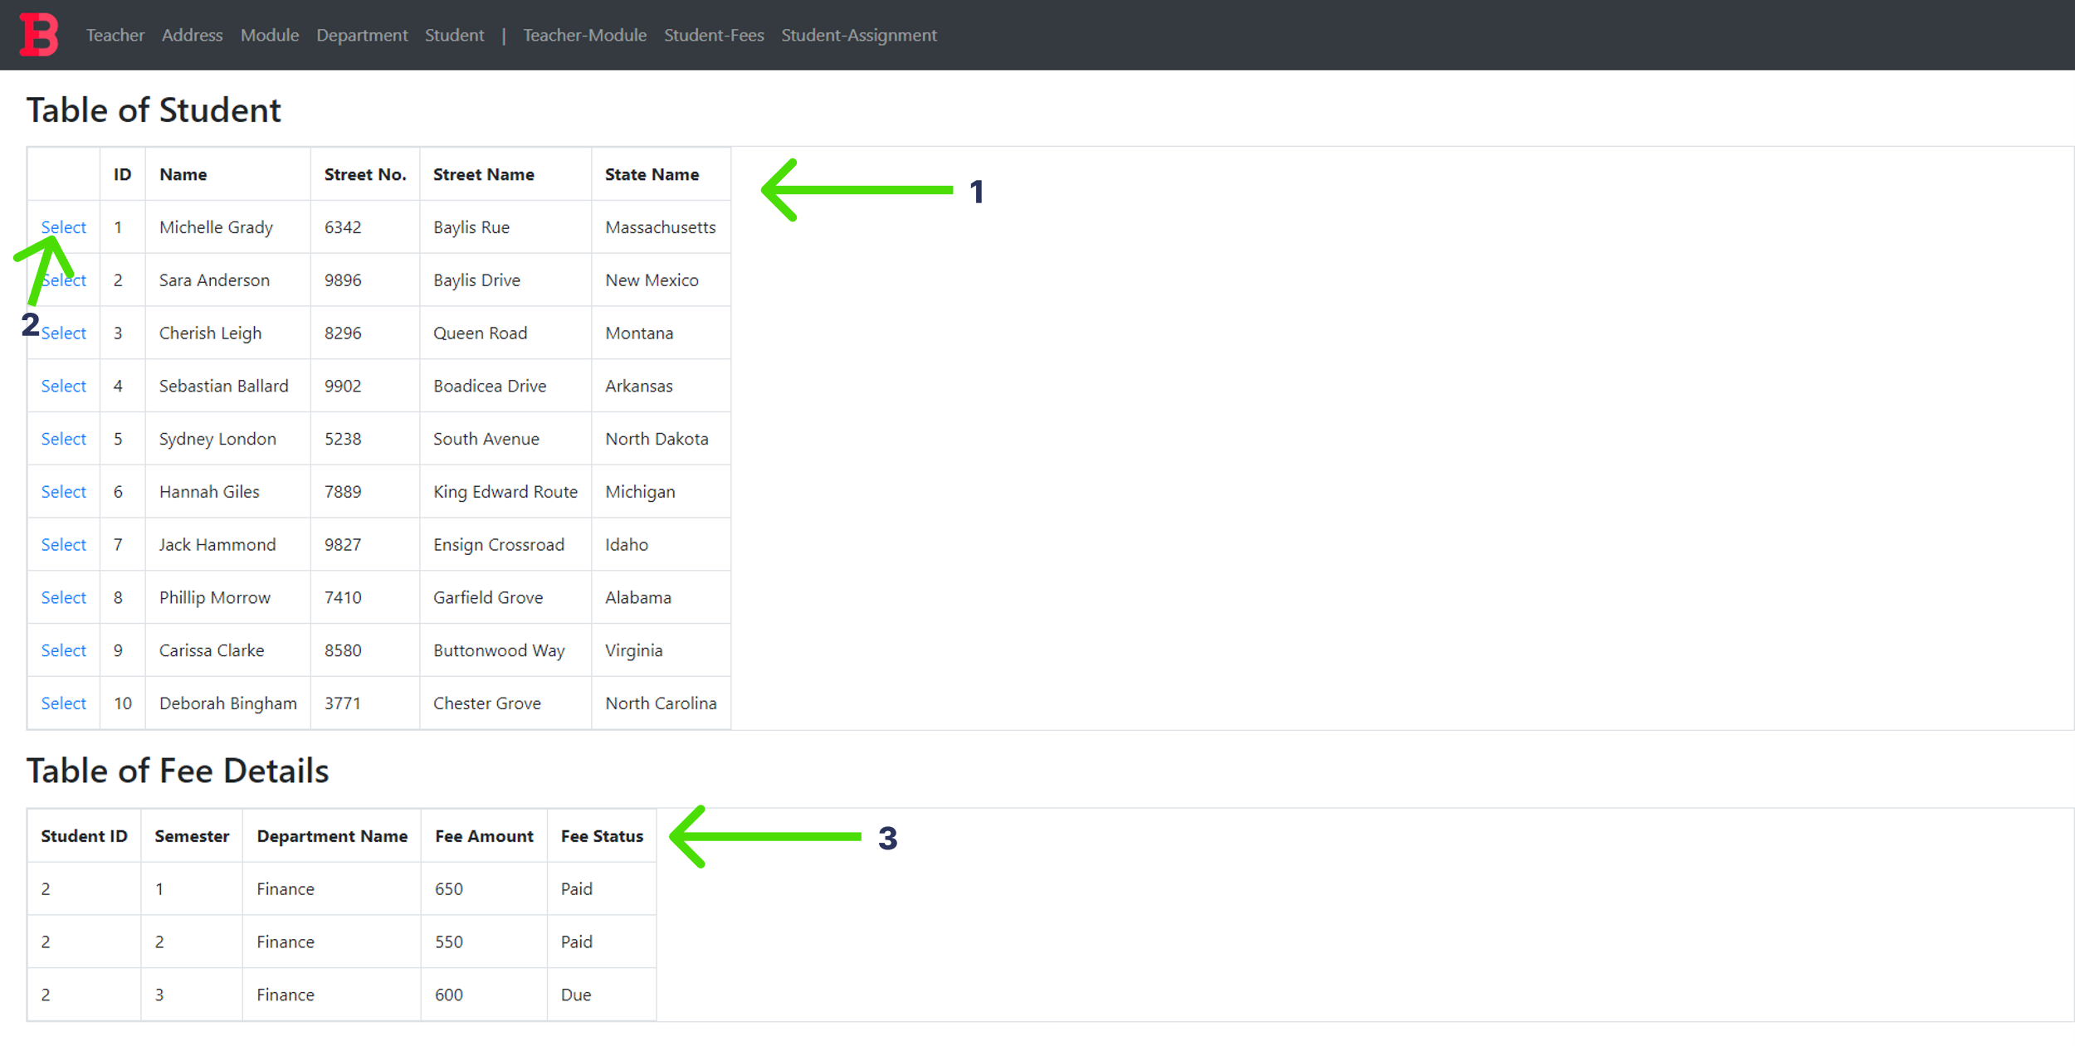

Figure 59: Student_Fees Form

1. The student details data is displayed in this grid.
2. Press this button to select this student data and display the fee details of this student.
3. The fee details data is displayed in this grid.

## Student-Assignment Form

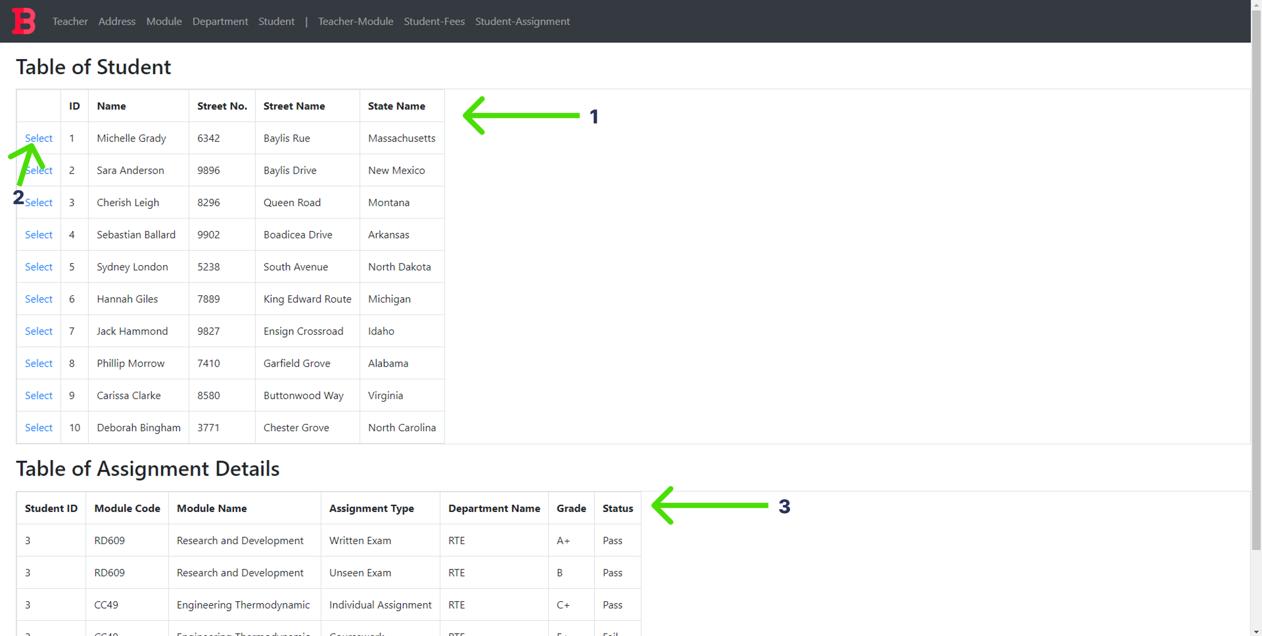

Figure 60: Student_Assignment Form

1. The student details data is displayed in this grid.
2. Press this button to select this student data and display the assignment details of this student.
3. The assignment details data is displayed in this grid.

# Testing

## Basic Forms

### Teacher Form

#### Test 1: View

|  |  |  |
| --- | --- | --- |
| **Test Condition** | **Expected Outcome** | **Obtained Outcome** |
| Load the teacher form and check if data is loaded in the grid. | The data is loaded on page load. | The data was loaded on page load. |

Table 16: Teacher Test 1

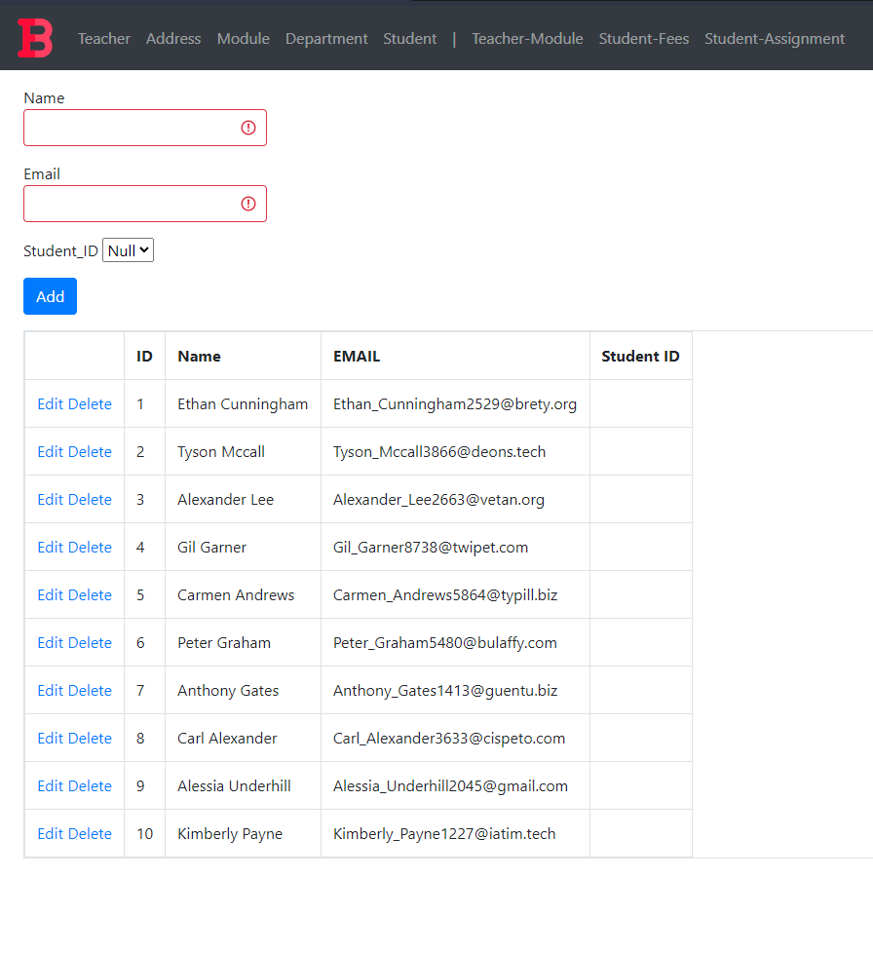

Figure 61: Teacher Test 1 evidence

#### Test 2: Add

|  |  |  |
| --- | --- | --- |
| **Test Condition** | **Expected Outcome** | **Obtained Outcome** |
| Fill the teacher form appropriately and press the add button. | The data is added, and the grid is refreshed with the new data. | The data was added without any errors and the grid was refreshed with the new data. |

Table 17: Teacher Test 2

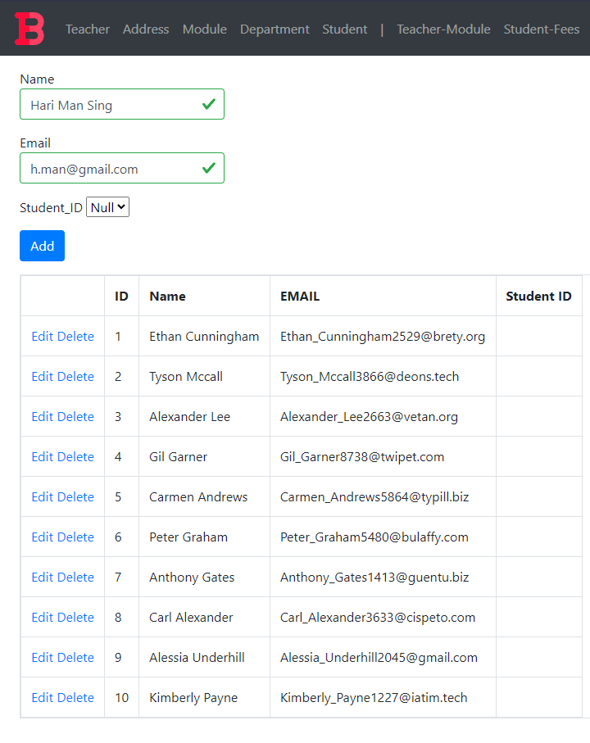

Figure 62: Teacher Test 2 Added Data

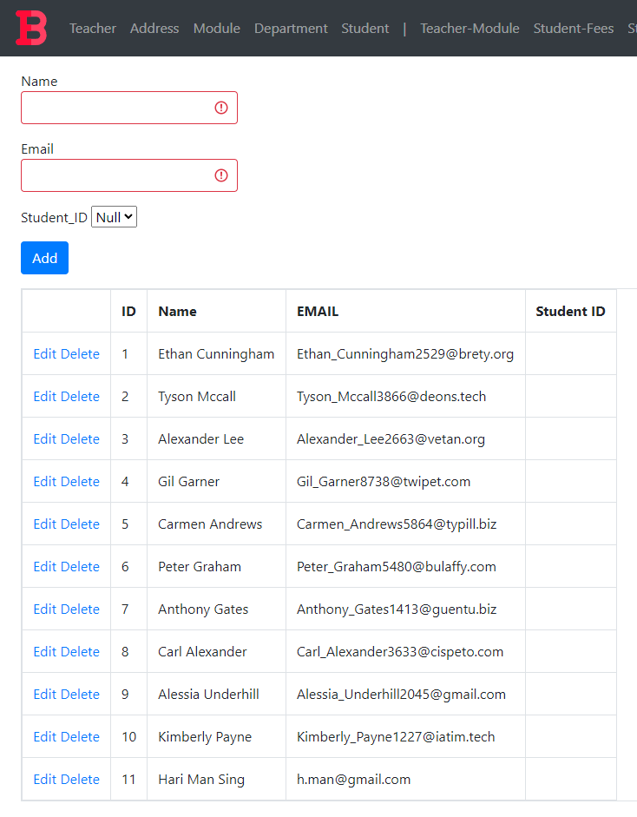

Figure 63: Teacher Test 2 Addition Result

#### Test 3: Edit

|  |  |  |
| --- | --- | --- |
| **Test Condition** | **Expected Outcome** | **Obtained Outcome** |
| Click the edit button | * The add button disappears and an update button appears. * The data in the row gets filled in the available textboxes. | * The add button disappeared and an update button appeared. * The data in the field got filled in the available textboxes. |
| Click the update button | * The update button disappears and the add button reappears * The data in the grid is refreshed with the edited data. | * The update button disappears and the add button reappears * The data in the grid is refreshed with the edited data. |

Table 18: Teacher Test 3

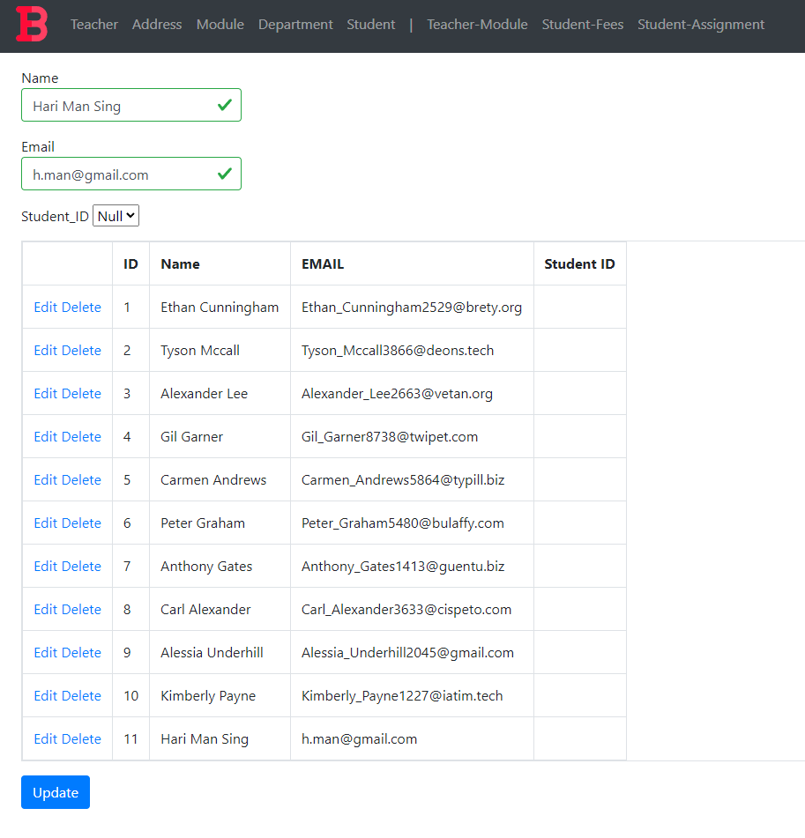

Figure 64: Teacher Test 3 condition 1

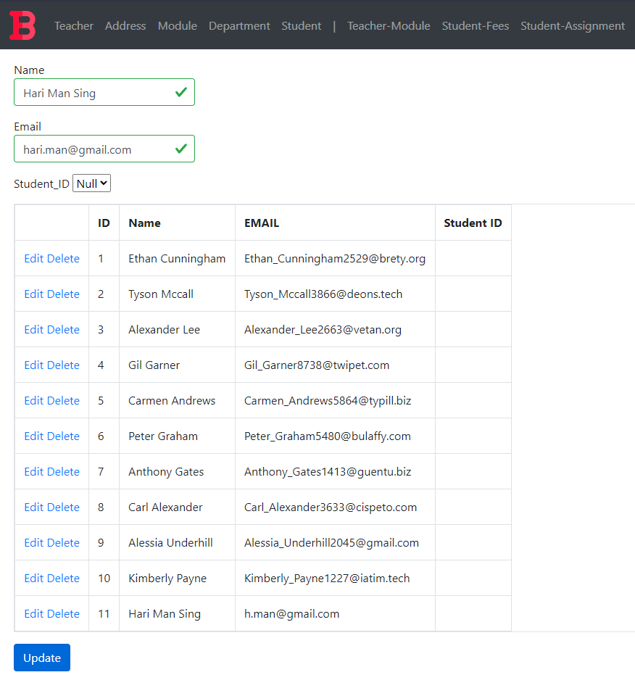

Figure 65: Edited value in Email Textbox

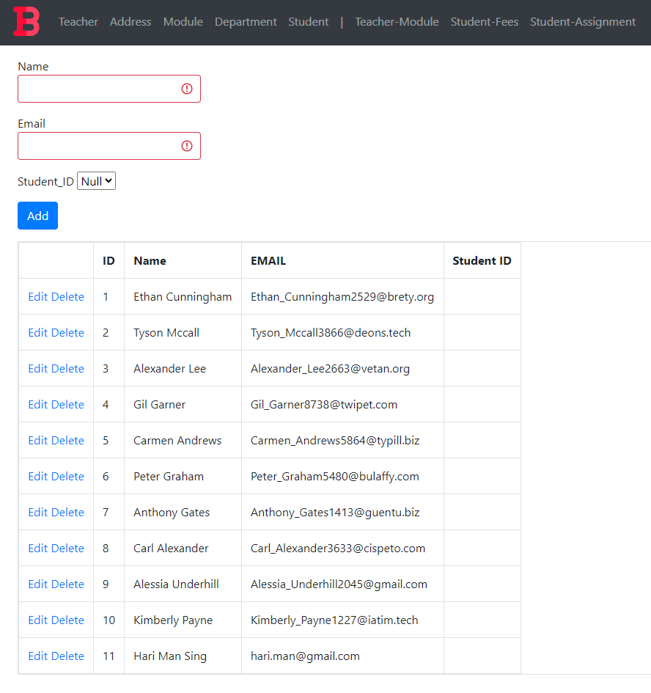

Figure 66: Teacher Test 3 Condition 2

#### Test 4: Delete

|  |  |  |
| --- | --- | --- |
| **Test Condition** | **Expected Outcome** | **Obtained Outcome** |
| Click the delete button. | The grid is refreshed with the data row deleted. | The grid was refreshed with the data row deleted. |

Table 19: Teacher Test 4

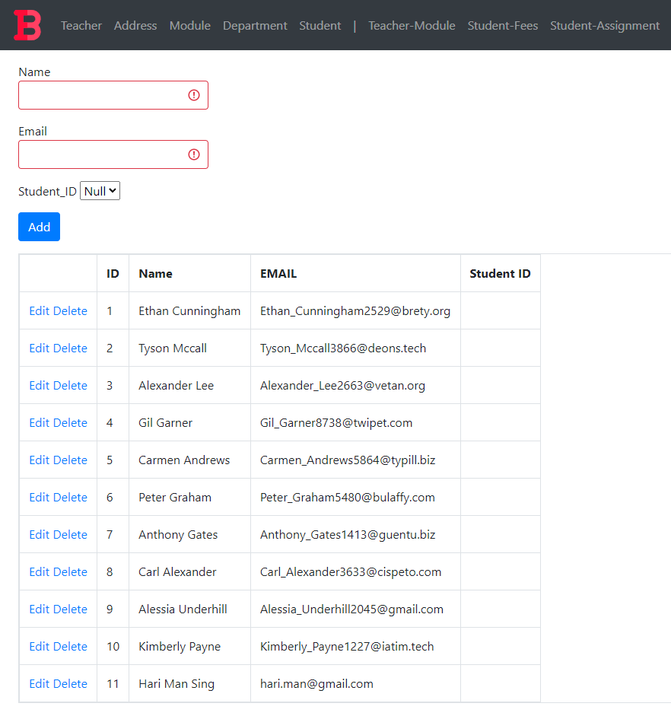

Figure 67: Teacher Grid Pre-Deletion

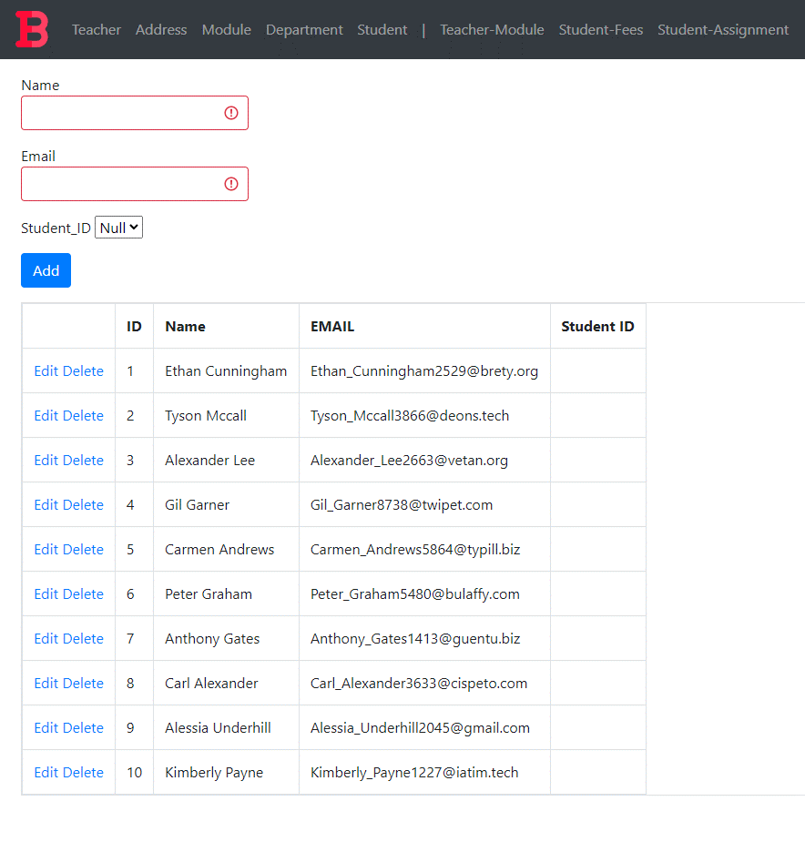

Figure 68: Teacher Grid Post-Deletion

### Address Form

#### Test 1: View

|  |  |  |
| --- | --- | --- |
| **Test Condition** | **Expected Outcome** | **Obtained Outcome** |
| Load the address form and check if data is loaded in the grid. | The data is loaded on page load. | The data was loaded on page load. |

Table 20: Address Test 1

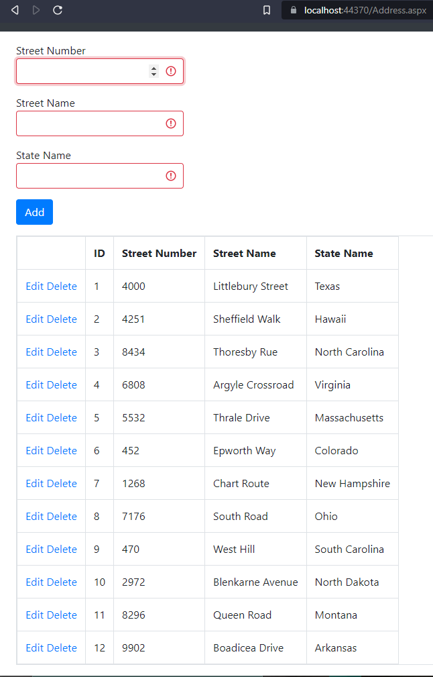

Figure 69: Address Test 1 evidence

#### Test 2: Add

|  |  |  |
| --- | --- | --- |
| **Test Condition** | **Expected Outcome** | **Obtained Outcome** |
| Fill the address form appropriately and press the add button. | The data is added, and the grid is refreshed with the new data. | The data was added without any errors and the grid was refreshed with the new data. |

Table 21: Address Test 2

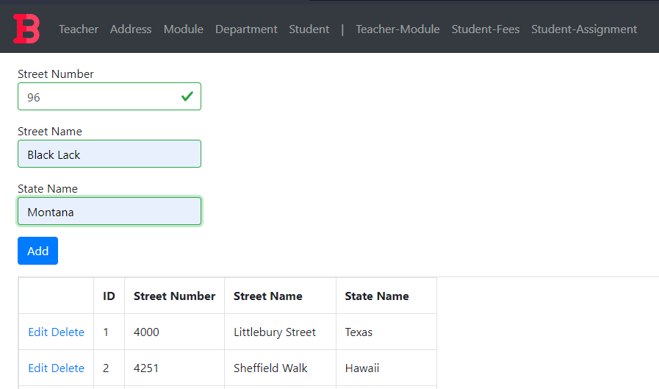

Figure 70: Address Test 2 Data to be Added

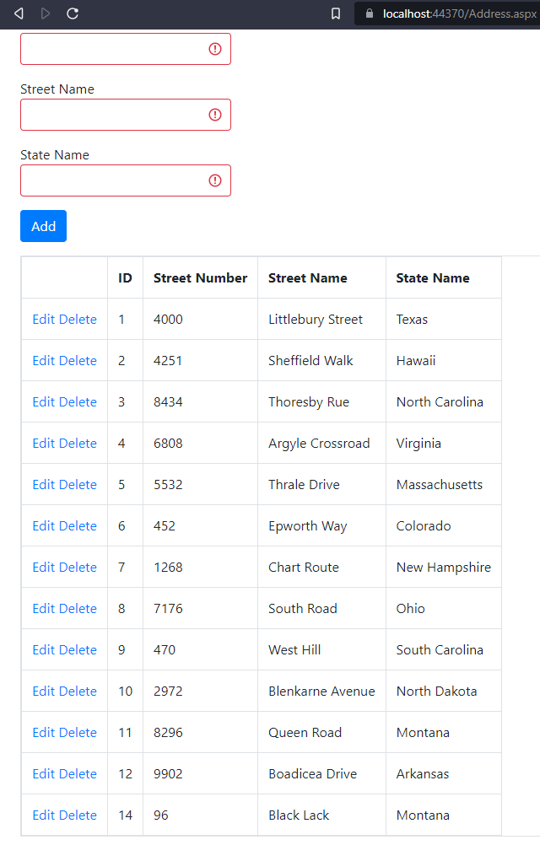

Figure 71: Address Test 2 Addition Result

#### Test 3: Edit

|  |  |  |
| --- | --- | --- |
| **Test Condition** | **Expected Outcome** | **Obtained Outcome** |
| Click the edit button | * The add button disappears and an update button appears. * The data in the row gets filled in the available textboxes. | * The add button disappeared and an update button appeared. * The data in the field got filled in the available textboxes. However, the street number got loaded into all textboxes |

Table 22: Address Test 3 Fail Case

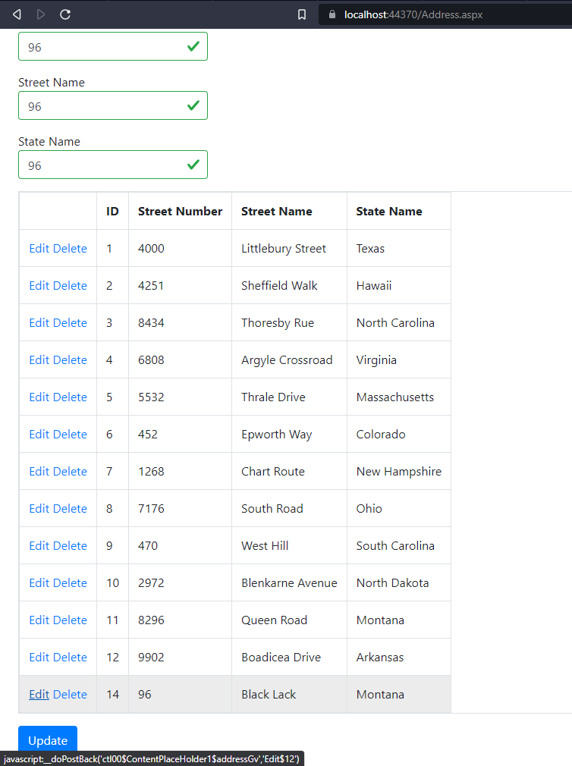

Figure 72: Address Test 3 condition 1 fail case

##### What caused the issue and how it was rectified:

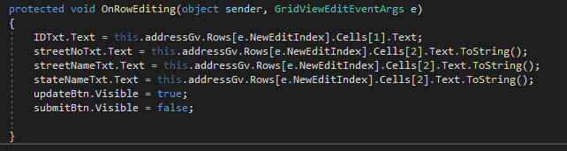

Figure 73: Issue causing the fail case

The textboxes were updated with the grid row cell containing the street number value.

Once they were changed, relevant values got added to the respective textboxes.

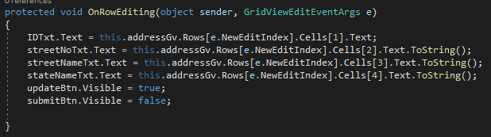

Figure 74: Rectification of the Issue causing the fail case

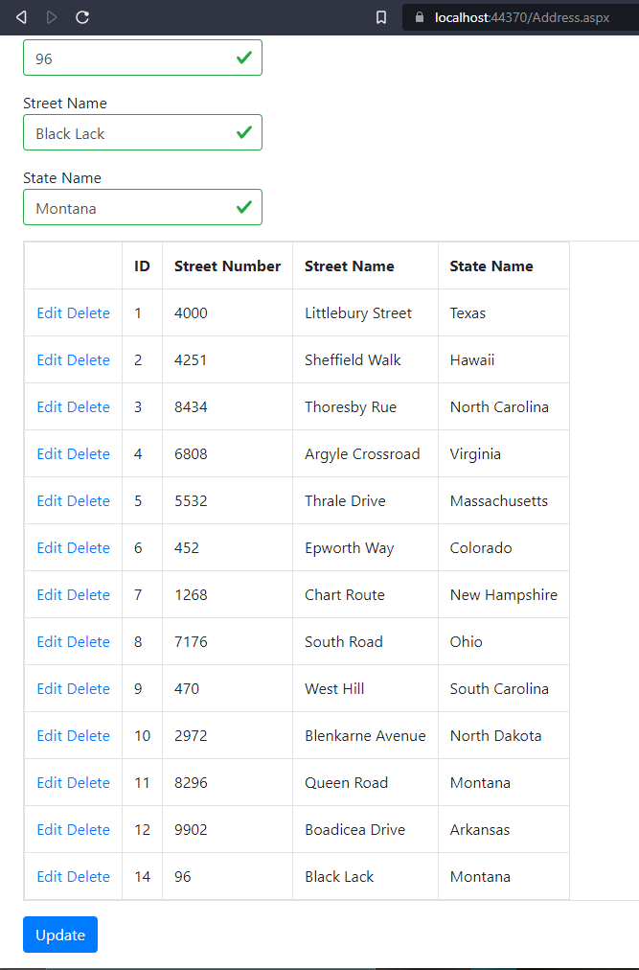

Figure 75: Test 3 Condition 1 post rectification

|  |  |  |
| --- | --- | --- |
| **Test Condition** | **Expected Outcome** | **Obtained Outcome** |
| Click the update button | * The update button disappears and the add button reappears * The data in the grid is refreshed with the edited data. | * The update button disappears and the add button reappears * The data in the grid is refreshed with the edited data. |

Table 23: Address Test 3 condition 2

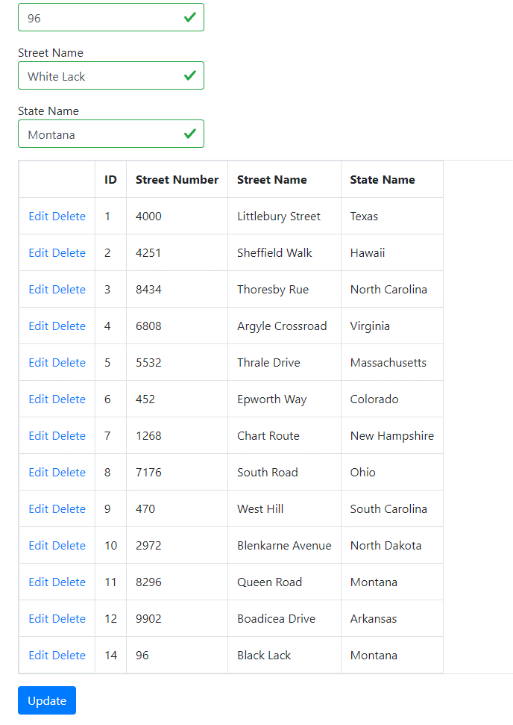

Figure 76: Edited value in Street Name Textbox

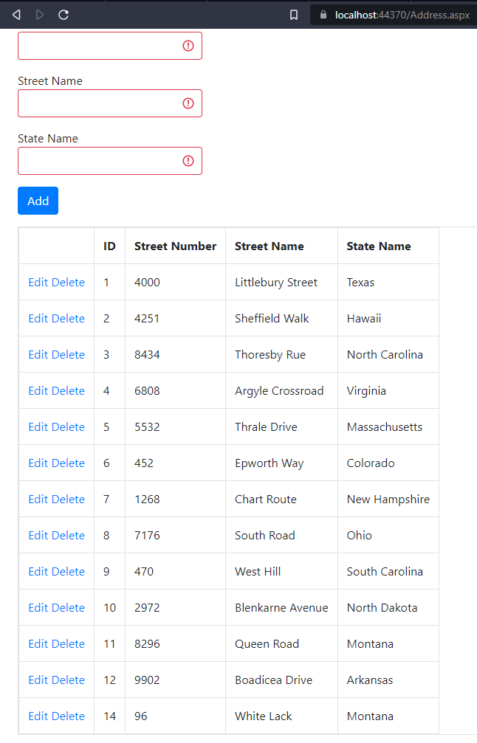

Figure 77: Address Test 3 Condition 2

#### Test 4: Delete

|  |  |  |
| --- | --- | --- |
| **Test Condition** | **Expected Outcome** | **Obtained Outcome** |
| Click the delete button. | The grid is refreshed with the data row deleted. | The grid was refreshed with the data row deleted. |

Table 24: Address Test 4

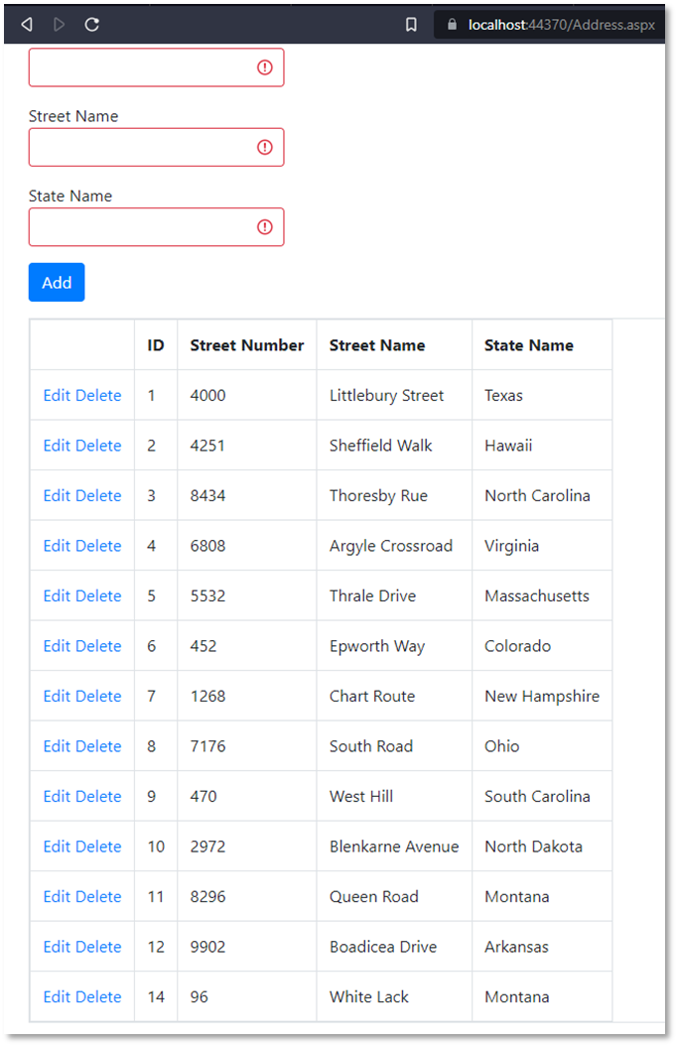

Figure 78: Address Grid Pre-Deletion

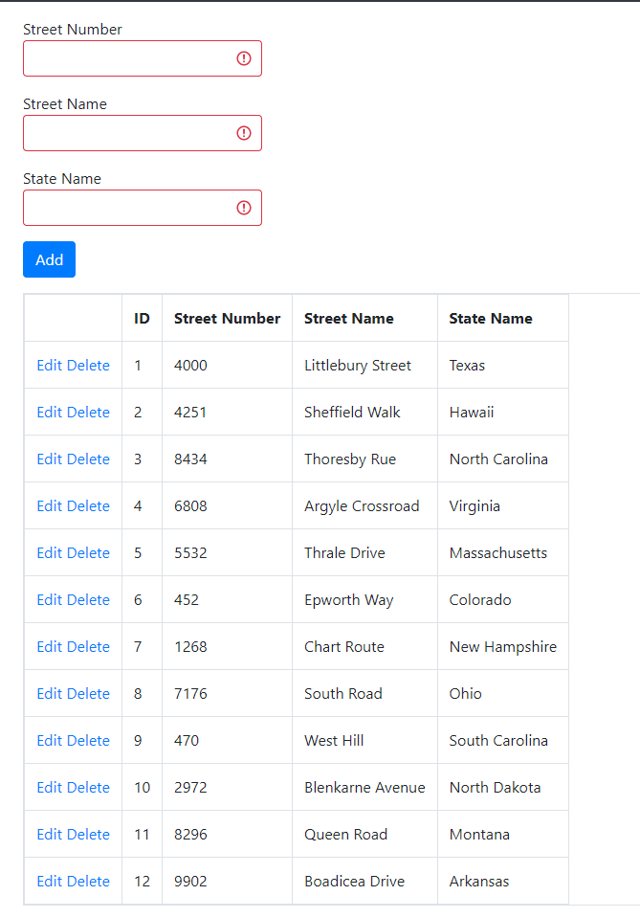

Figure 79: Address Grid Post-Deletion

### Module Form

#### Test 1: View

|  |  |  |
| --- | --- | --- |
| **Test Condition** | **Expected Outcome** | **Obtained Outcome** |
| Load the module form and check if data is loaded in the grid. | The data is loaded on page load. | The data was loaded on page load. |

Table 25: Module Test 1

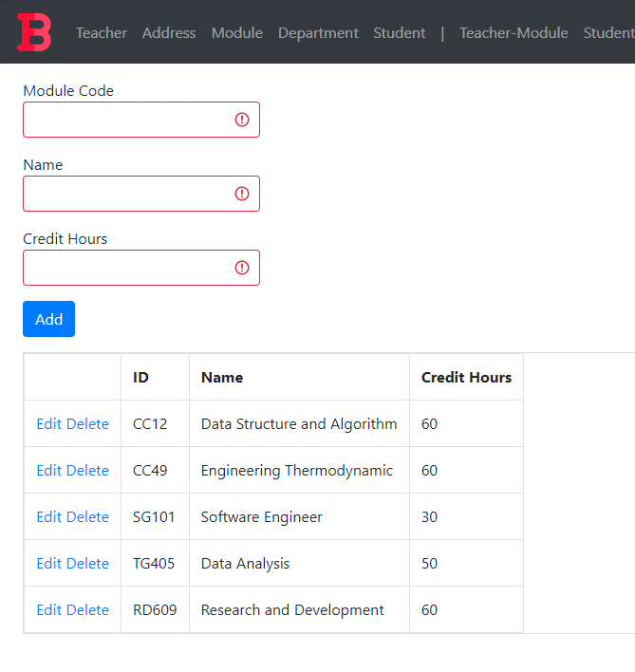

Figure 80: Module Test 1 evidence

#### Test 2: Add

|  |  |  |
| --- | --- | --- |
| **Test Condition** | **Expected Outcome** | **Obtained Outcome** |
| Fill the module form appropriately and press the add button. | The data is added, and the grid is refreshed with the new data. | The data was added without any errors and the grid was refreshed with the new data. |

Table 26: Module Test 2

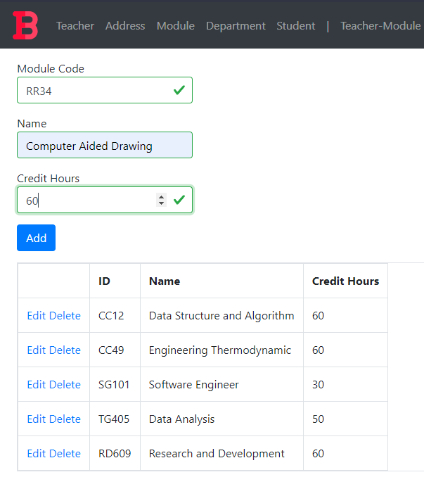

Figure 81: Module Test 2 Data to be Added

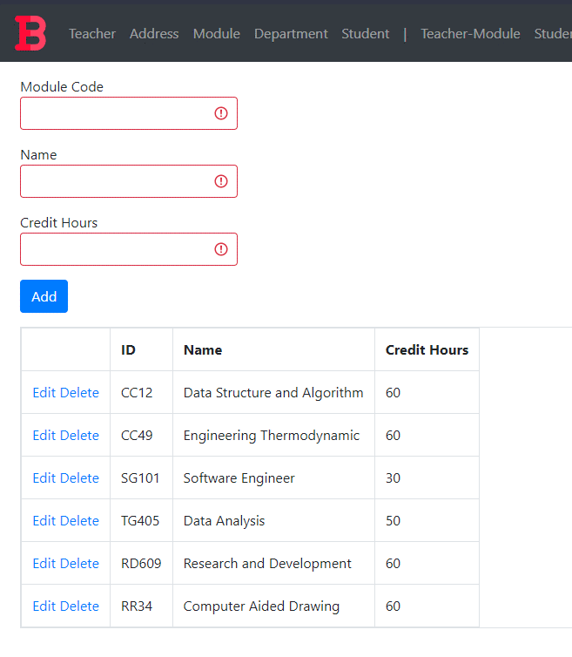

Figure 82: Module Test 2 Addition Result

#### Test 3: Edit

|  |  |  |
| --- | --- | --- |
| **Test Condition** | **Expected Outcome** | **Obtained Outcome** |
| Click the edit button | * The add button disappears and an update button appears. * The data in the row gets filled in the available textboxes. | * The add button disappeared and an update button appeared. * The data in the field got filled in the available textboxes. |
| Click the update button | * The update button disappears and the add button reappears * The data in the grid is refreshed with the edited data. | * The update button disappears and the add button reappears * The data in the grid is refreshed with the edited data. |

Table 27: Module Test 3

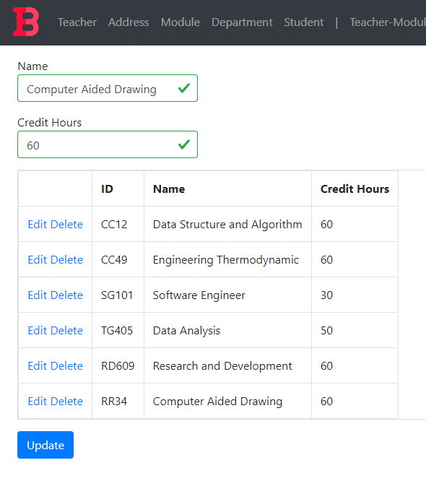

Figure 83: Module Test 3 condition 1

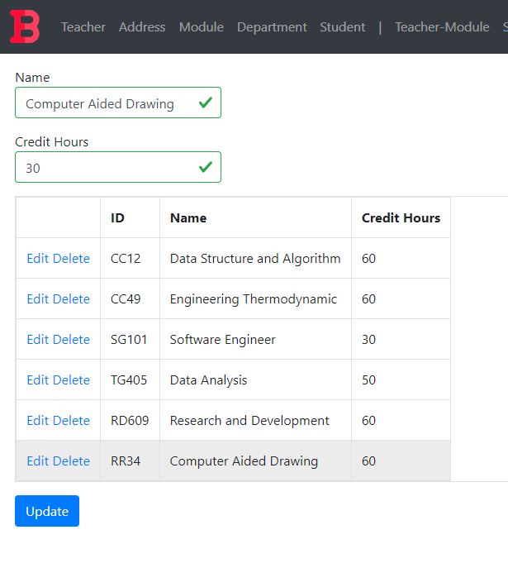

Figure 84: Edited value in Credit Hours Textbox

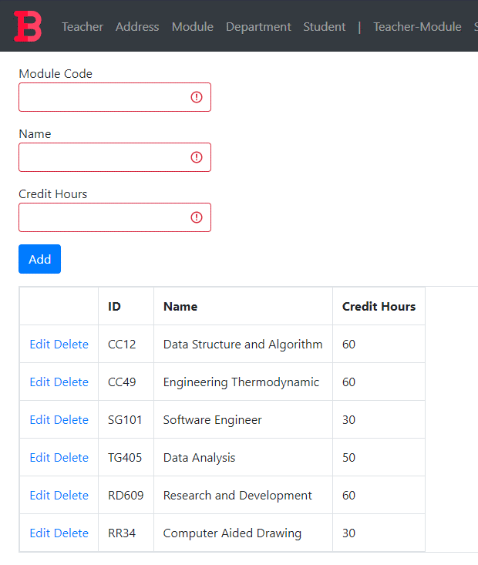

Figure 85: Module Test 3 Condition 2

#### Test 4: Delete

|  |  |  |
| --- | --- | --- |
| **Test Condition** | **Expected Outcome** | **Obtained Outcome** |
| Click the delete button. | The grid is refreshed with the data row deleted. | The grid was refreshed with the data row deleted. |

Table 28: Module Test 4



Figure 86: Address Grid Pre-Deletion

##### What caused the issue and how it was rectified:

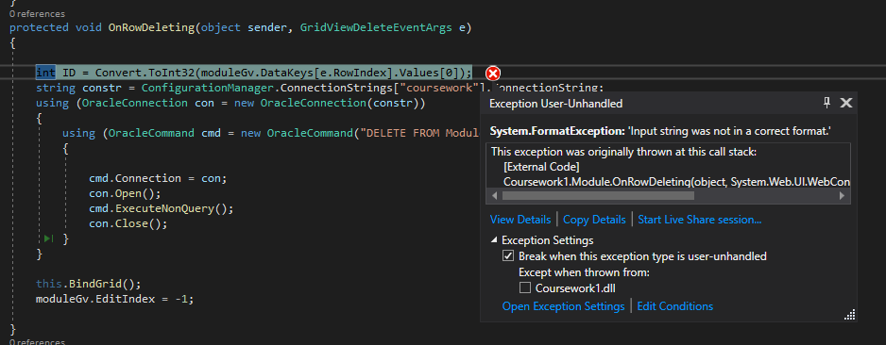

Figure 87: Issue causing the fail case

Unlike the primary keys from other form table, module table had a VARCHAR primary key. Here, I was trying to convert the string into an integer in order to obtain the primary key for the row of data that needed to be deleted. Hence, it caused a format exception and did not carry out the delete procedure.

I set the variable to string and used the value obtained from the grid view row as a string and rectified the issue. This made the deletion procedure go smoothly and uninterrupted.

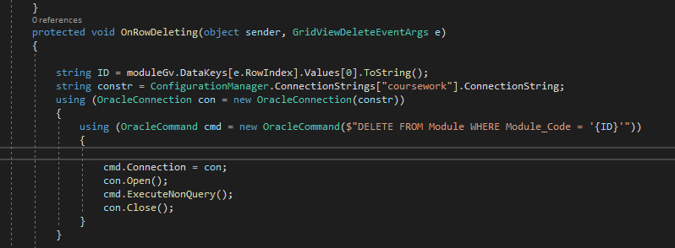

Figure 88: Rectification of the Issue causing the fail case

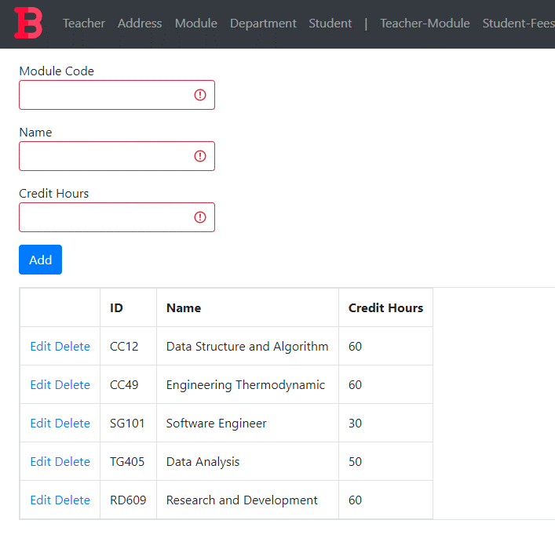

Figure 89: Test 4 post deletion

### Department Form

#### Test 1: View

|  |  |  |
| --- | --- | --- |
| **Test Condition** | **Expected Outcome** | **Obtained Outcome** |
| Load the department form and check if data is loaded in the grid. | The data is loaded on page load. | The data was loaded on page load. |

Table 29: Department Test 1

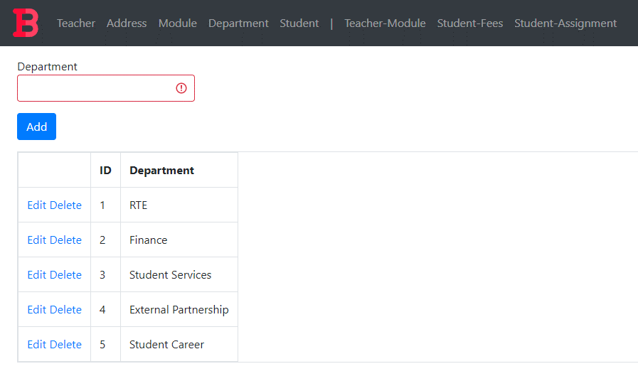

Figure 90: Department Test 1 evidence

#### Test 2: Add

|  |  |  |
| --- | --- | --- |
| **Test Condition** | **Expected Outcome** | **Obtained Outcome** |
| Fill the department form appropriately and press the add button. | The data is added, and the grid is refreshed with the new data. | The data was added without any errors and the grid was refreshed with the new data. |

Table 30: Department Test 2

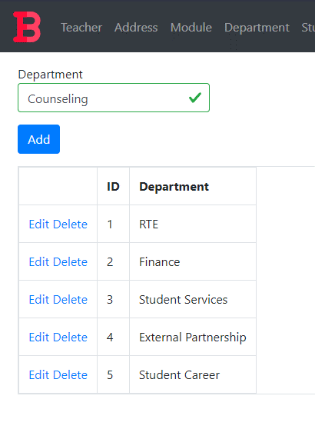

Figure 91: Department Test 2 Added Data

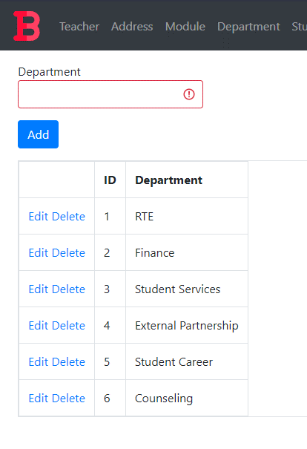

Figure 92: Department Test 2 Addition Result

#### Test 3: Edit

|  |  |  |
| --- | --- | --- |
| **Test Condition** | **Expected Outcome** | **Obtained Outcome** |
| Click the edit button | * The add button disappears and an update button appears. * The data in the row gets filled in the available textboxes. | * The add button disappeared and an update button appeared. * The data in the field got filled in the available textboxes. |
| Click the update button | * The update button disappears and the add button reappears * The data in the grid is refreshed with the edited data. | * The update button disappears and the add button reappears * The data in the grid is refreshed with the edited data. |

Table 31: Department Test 3

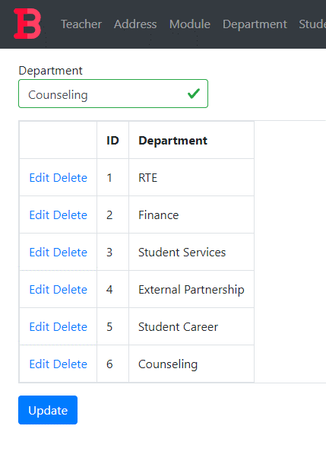

Figure 93: Department Test 3 condition 1

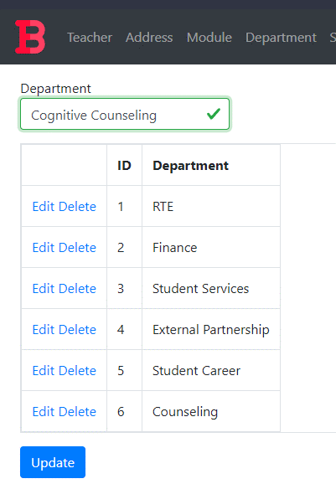

Figure 94: Edited value in Department Textbox

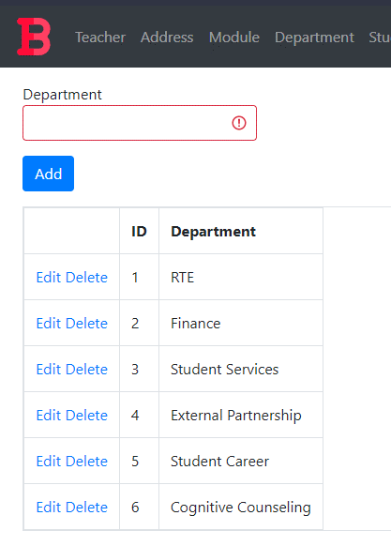

Figure 95: Department Test 3 Condition 2

#### Test 4: Delete

|  |  |  |
| --- | --- | --- |
| **Test Condition** | **Expected Outcome** | **Obtained Outcome** |
| Click the delete button. | The grid is refreshed with the data row deleted. | The grid was refreshed with the data row deleted. |

Table 32: Department Test 4



Figure 96: Department Grid Pre-Deletion

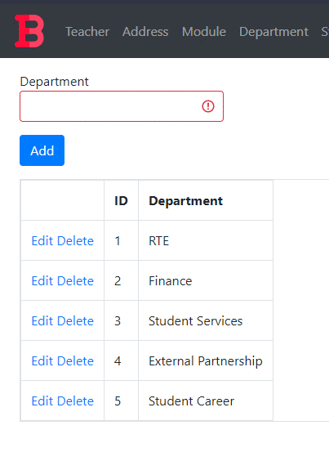

Figure 97: Department Grid Post-Deletion

### Student Form

#### Test 1: View

|  |  |  |
| --- | --- | --- |
| **Test Condition** | **Expected Outcome** | **Obtained Outcome** |
| Load the student form and check if data is loaded in the grid. | The data is loaded on page load. | The data was loaded on page load. |

Table 33: Student Test 1

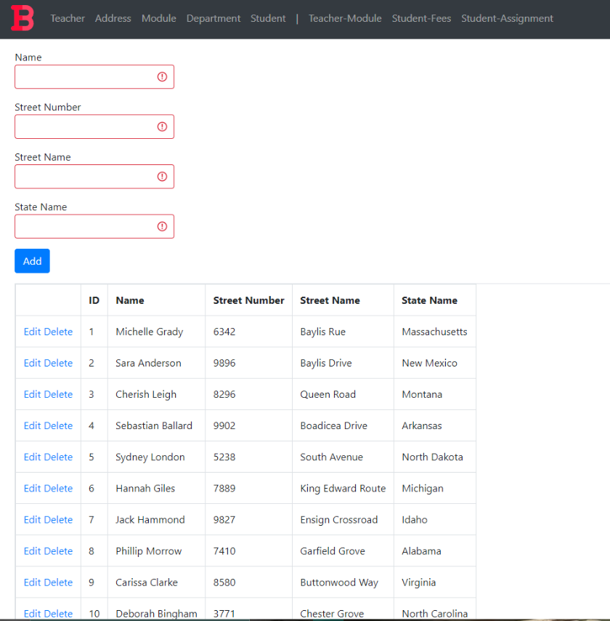

Figure 98: Student Test 1 evidence

#### Test 2: Add

|  |  |  |
| --- | --- | --- |
| **Test Condition** | **Expected Outcome** | **Obtained Outcome** |
| Fill the student form appropriately and press the add button. | The data is added, and the grid is refreshed with the new data. | The data was added without any errors and the grid was refreshed with the new data. |

Table 34: Student Test 2

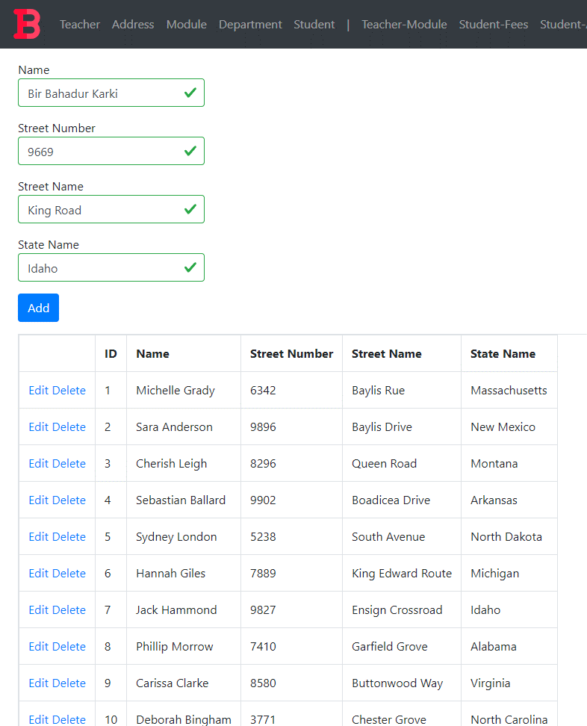

Figure 99: Student Test 2 Added Data

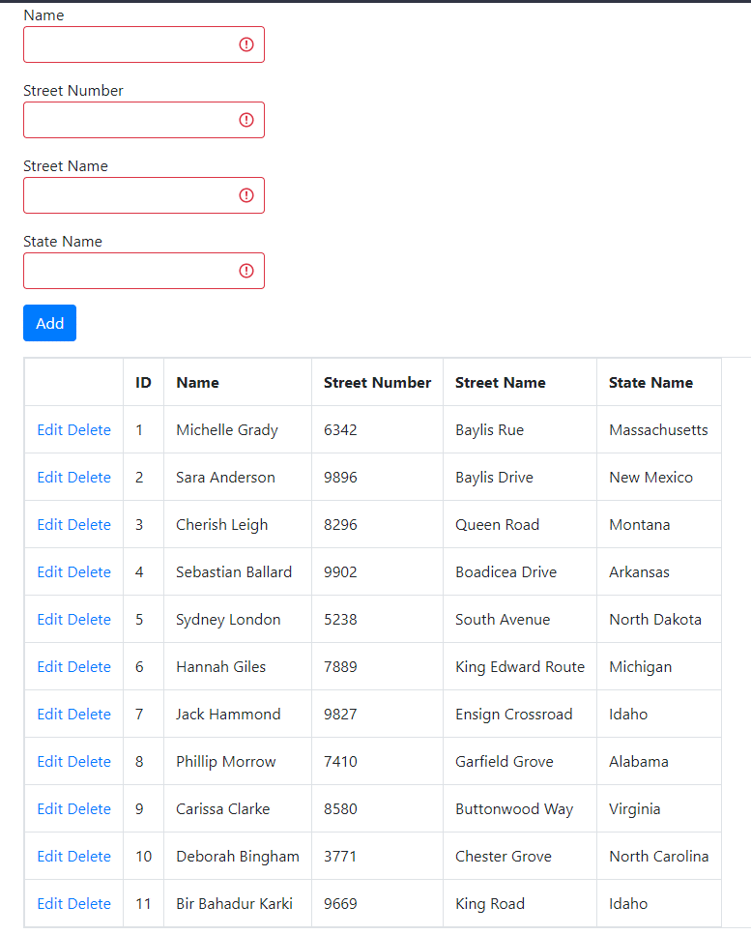

Figure 100: Student Test 2 Addition Result

#### Test 3: Edit

|  |  |  |
| --- | --- | --- |
| **Test Condition** | **Expected Outcome** | **Obtained Outcome** |
| Click the edit button | * The add button disappears and an update button appears. * The data in the row gets filled in the available textboxes. | * The add button disappeared and an update button appeared. * The data in the field got filled in the available textboxes. |
| Click the update button | * The update button disappears and the add button reappears * The data in the grid is refreshed with the edited data. | * The update button disappears and the add button reappears * The data in the grid is refreshed with the edited data. |

Table 35: Student Test 3

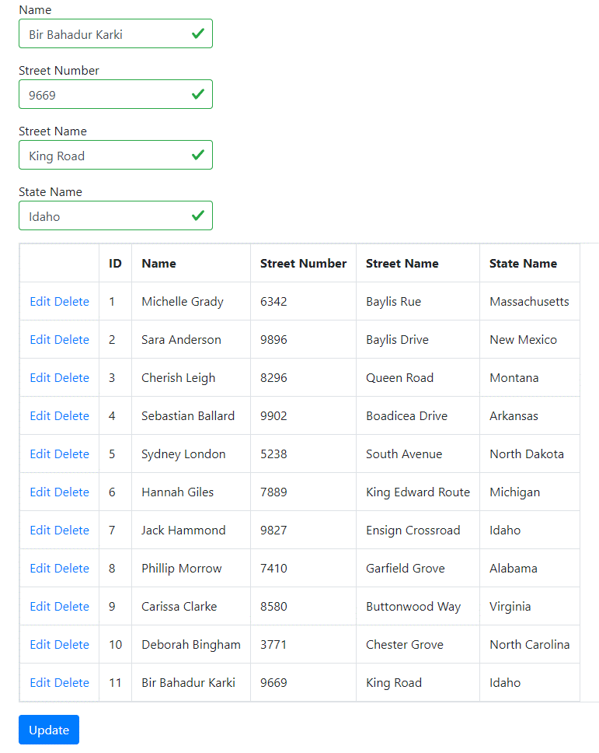

Figure 101: Student Test 3 condition 1

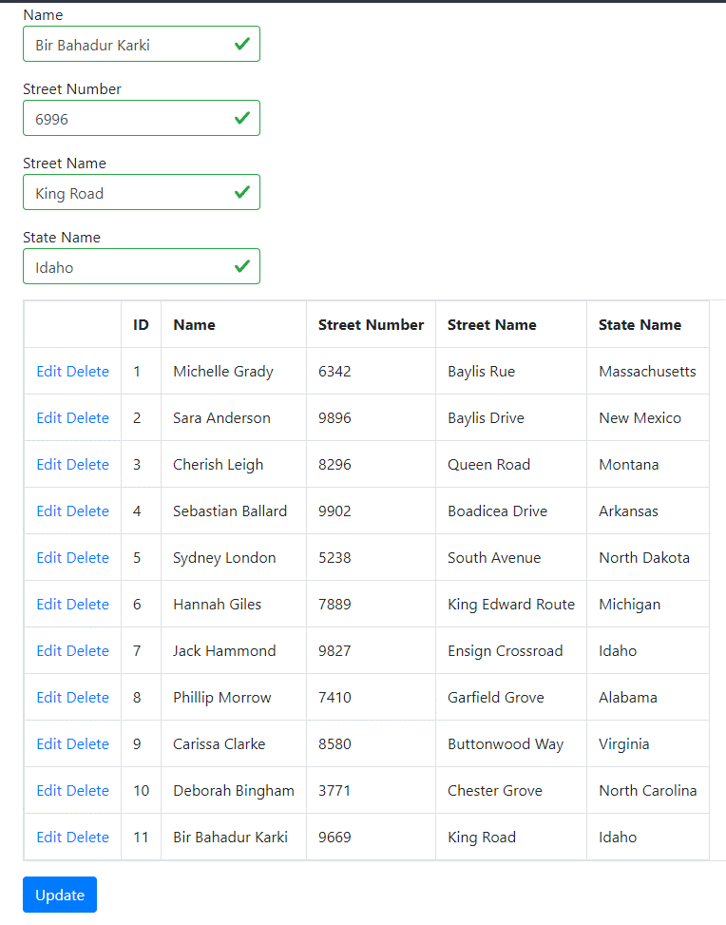

Figure 102: Edited value in Street Number Textbox

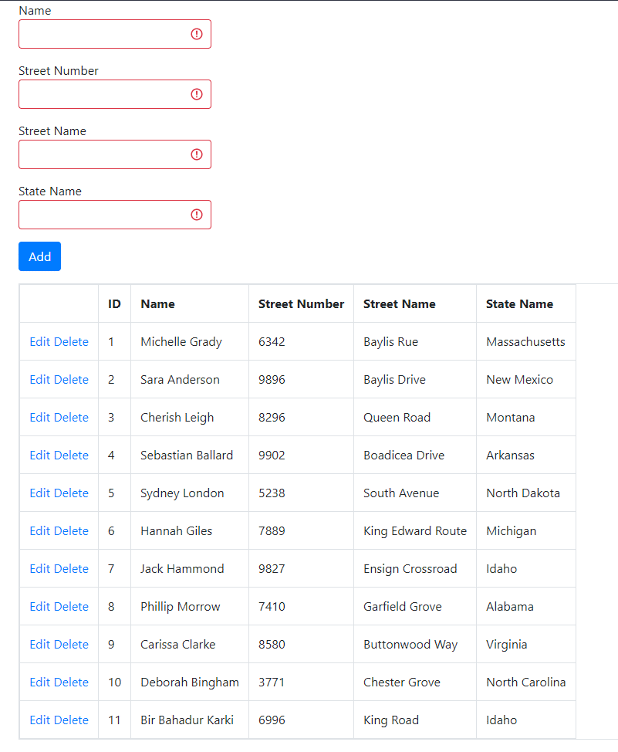

Figure 103: Student Test 3 Condition 2

#### Test 4: Delete

|  |  |  |
| --- | --- | --- |
| **Test Condition** | **Expected Outcome** | **Obtained Outcome** |
| Click the delete button. | The grid is refreshed with the data row deleted. | The grid was refreshed with the data row deleted. |

Table 36: Student Test 4



Figure 104: Student Grid Pre-Deletion

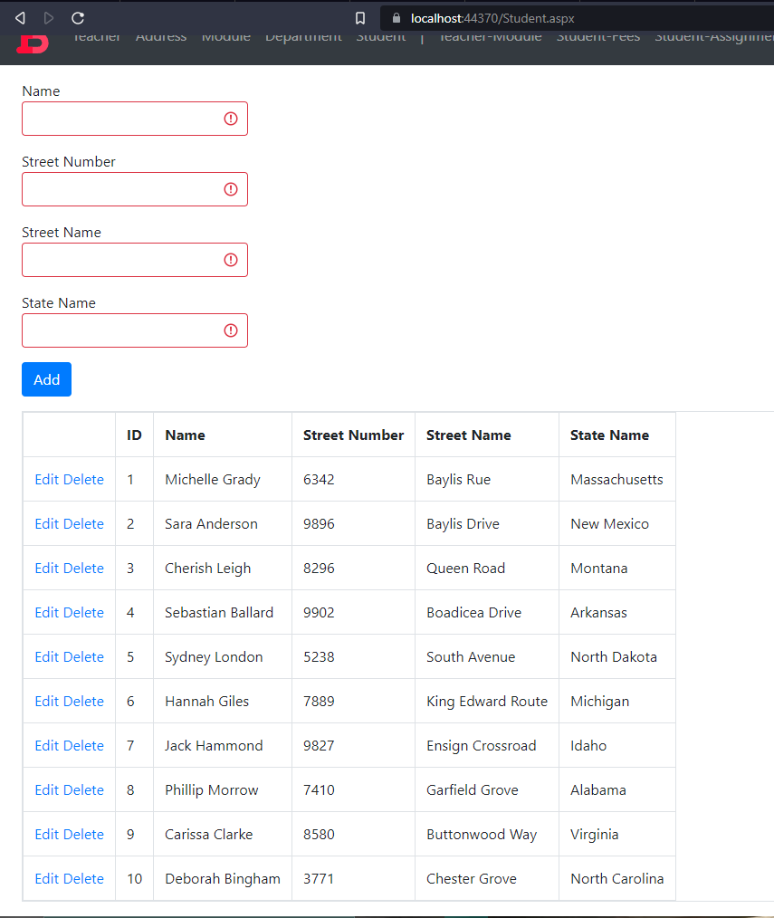

Figure 105: Student Grid Post-Deletion

## Complex Forms

### Teacher-Module Mapping Form

#### Test 1: Page Load

|  |  |  |
| --- | --- | --- |
| **Test Condition** | **Expected Outcome** | **Obtained Outcome** |
| Load the complex form and check if data is loaded in the initial grid. | The data is loaded to the initial grid on page load. | The data was loaded to the initial grid on page load. |

Table 37: Teacher-Module Test 1

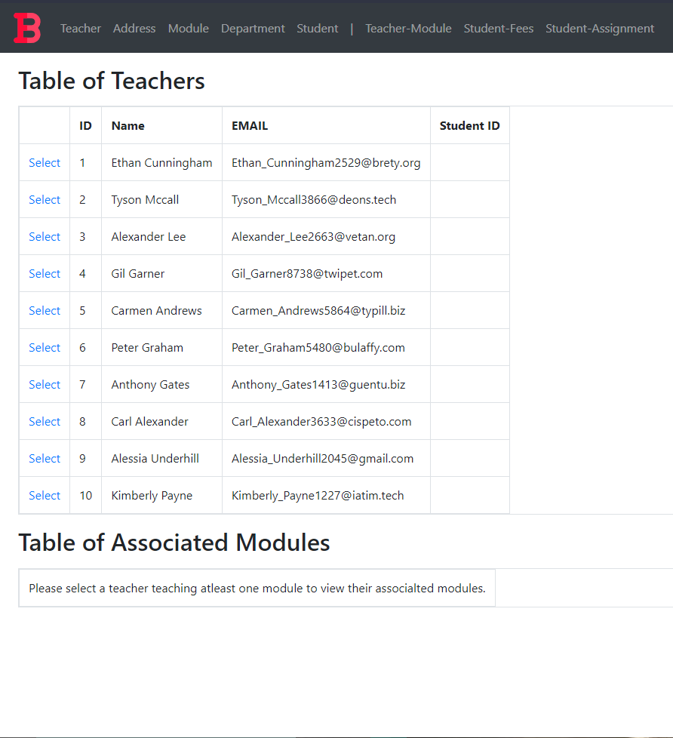

Figure 106: Teacher-Module Test 1 evidence

#### Test 2: Data Load on Selection

|  |  |  |
| --- | --- | --- |
| **Test Condition** | **Expected Outcome** | **Obtained Outcome** |
| Select a data row from the initial grid view and check if the other grid gets loaded with relevant data. | The other grid is loaded with relevant data. | The other grid was loaded with relevant data. |

Table 38: Teacher-Module Test 2

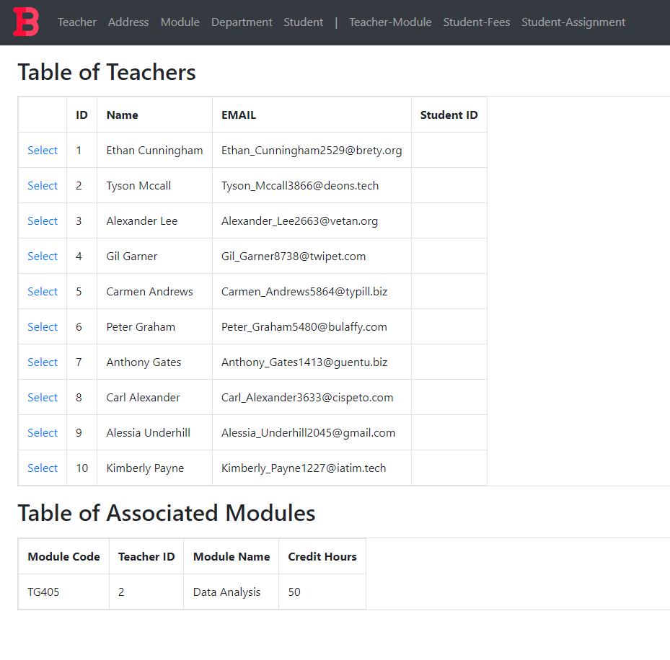

Figure 107: Teacher-Module Test 2 evidence

### Student-Fees Mapping Form

#### Test 1: Page Load

|  |  |  |
| --- | --- | --- |
| **Test Condition** | **Expected Outcome** | **Obtained Outcome** |
| Load the complex form and check if data is loaded in the initial grid. | The data is loaded to the initial grid on page load. | The data was loaded to the initial grid on page load. |

Table 39: Student-Fees Test 1

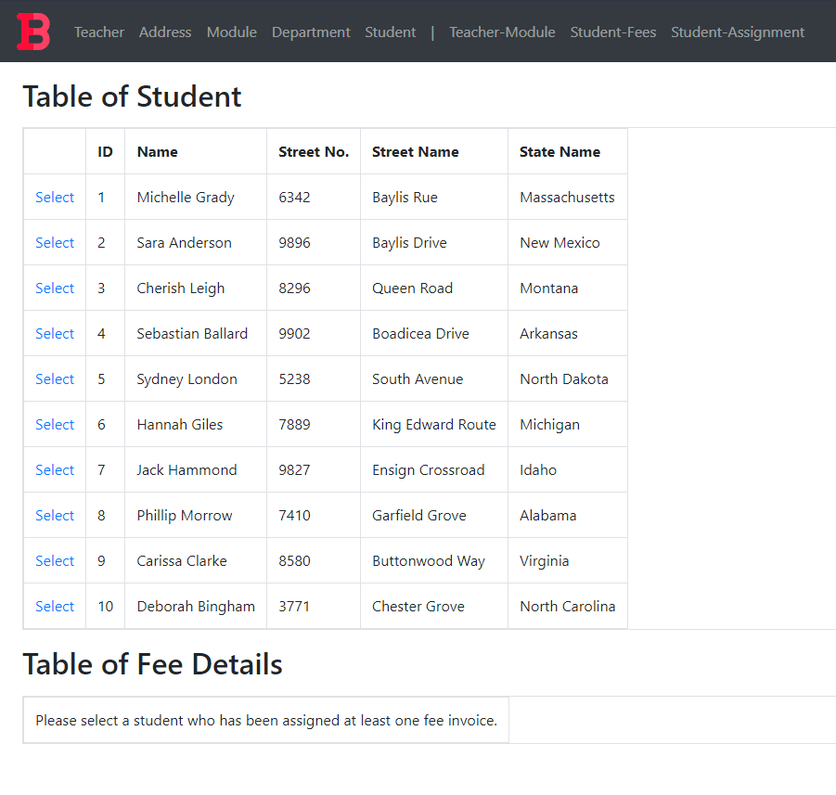

Figure 108: Student-Fees Test 1 evidence

#### Test 2: Data Load on Selection

|  |  |  |
| --- | --- | --- |
| **Test Condition** | **Expected Outcome** | **Obtained Outcome** |
| Select a data row from the initial grid view and check if the other grid gets loaded with relevant data. | The other grid is loaded with relevant data. | The other grid was loaded with relevant data. |

Table 40: Student-Fees Test 2

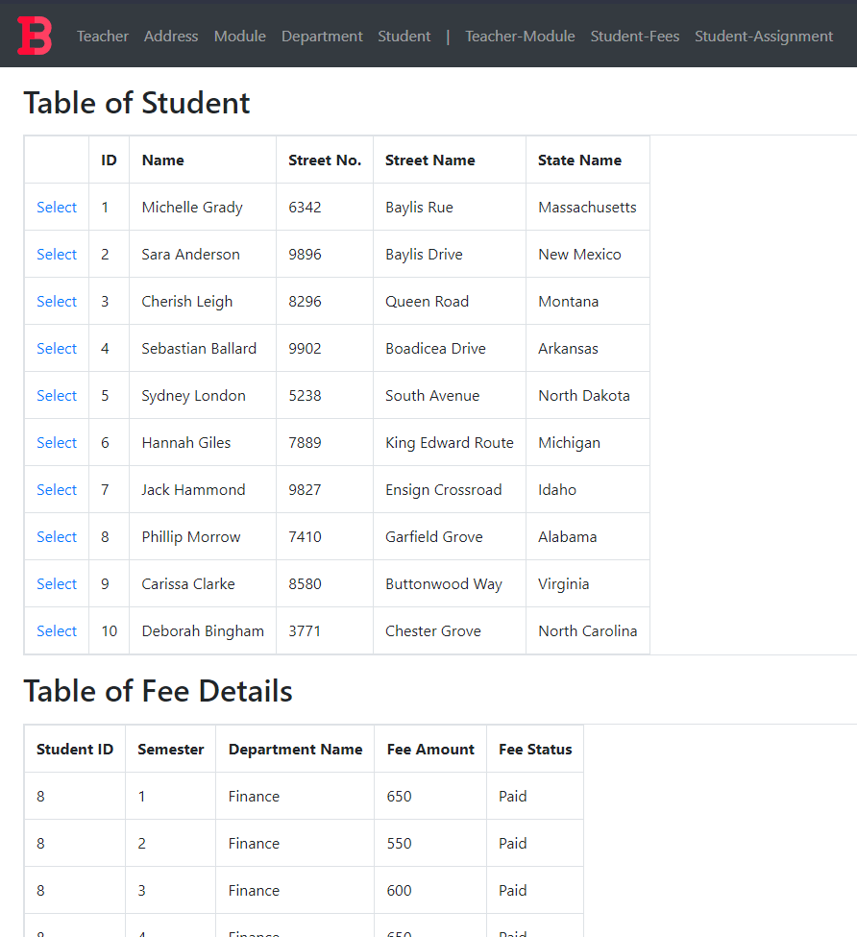

Figure 109: Student-Fees Test 2 evidence

### Student-Assignment Mapping Form

#### Test 1: Page Load

|  |  |  |
| --- | --- | --- |
| **Test Condition** | **Expected Outcome** | **Obtained Outcome** |
| Load the complex form and check if data is loaded in the initial grid. | The data is loaded to the initial grid on page load. | The data was loaded to the initial grid on page load. |

Table 41: Student-Assignment Test 1

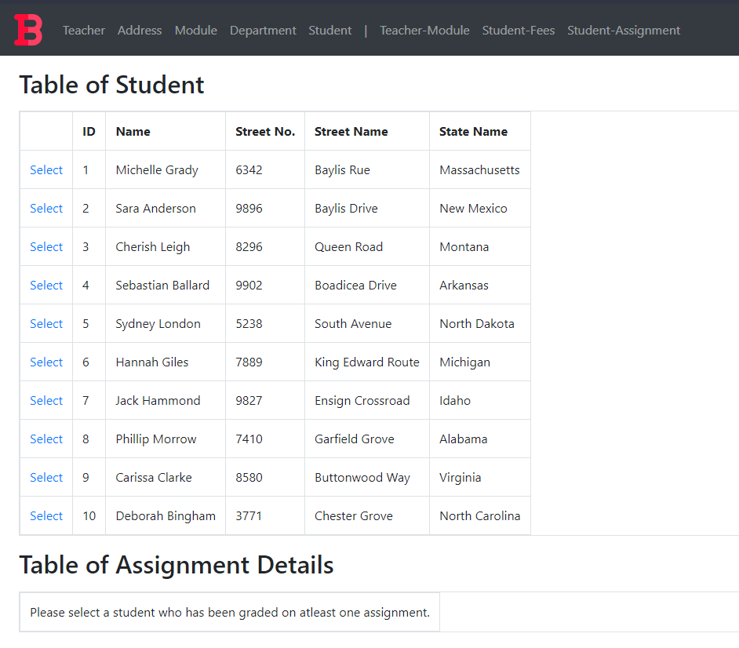

Figure 110: Student-Assignment Test 1 evidence

#### Test 2: Data Load on Selection

|  |  |  |
| --- | --- | --- |
| **Test Condition** | **Expected Outcome** | **Obtained Outcome** |
| Select a data row from the initial grid view and check if the other grid gets loaded with relevant data. | The other grid is loaded with relevant data. | The other grid was loaded with relevant data. |

Table 42: Student-Assignment Test 2

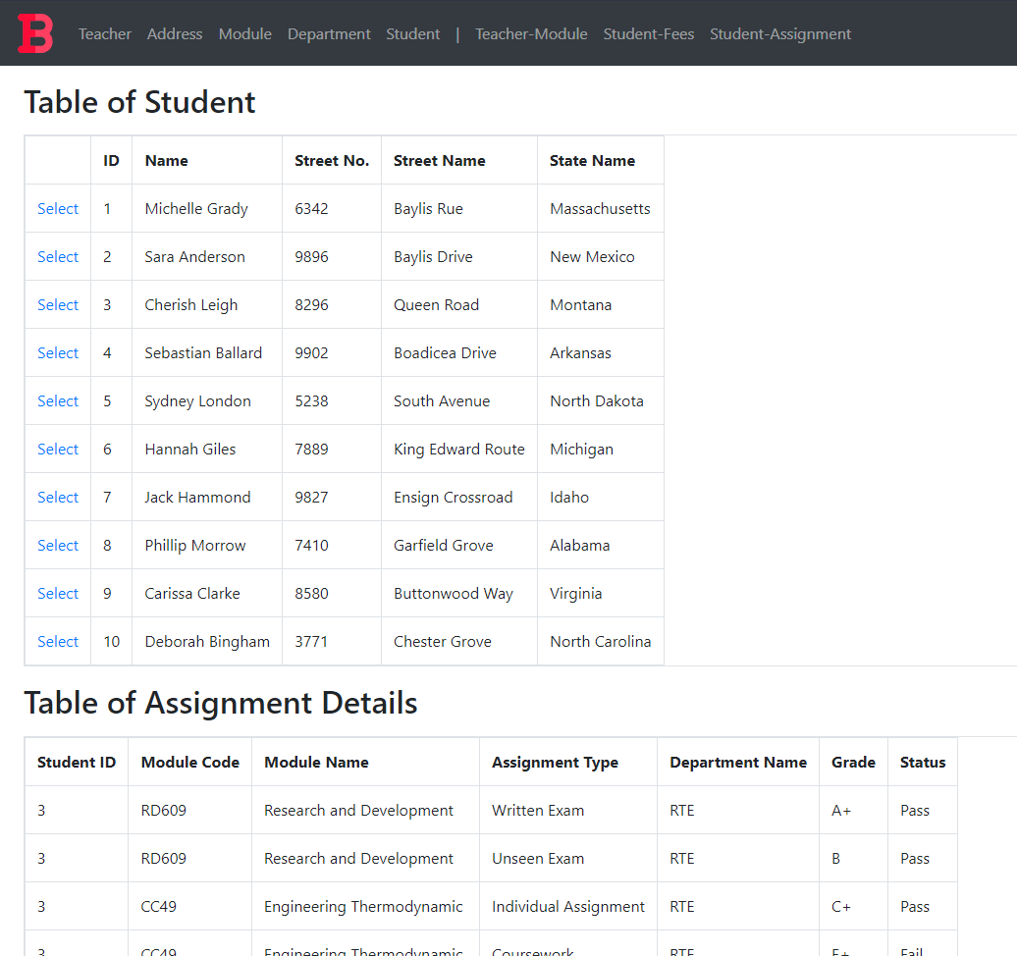

Figure 111: Student-Assignment Test 2 evidence

# Further Discussion

The project was a simple one, but it provided a lot of insight on oracle databases and dotnet webforms. While the database normalization, integration with assumptions, creation and data population portions were familiar to what we had already been taught, the dotnet webform creation was a unique experience in this project. As dotnet was used previously for another module to create a windows form application, I was already familiar with the dotnet syntax. Similarly, web development was also quite familiar since I had experience working with JavaScript frontend frameworks like React.

However, web development with dotnet was almost completely different than what I had experience with. The project taught me about real world business scenarios. I learned how normalization, being the useful tool that it is, sometimes does not give what we need, about how redundancy must be sometimes added artificially to keep record of things. The project also helped me better understand dotnet as a framework for web development, about how master classes can be used for page layouts, about how libraries like bootstrap can be used to visually enhance a webpage without too much effort and about HTML5 technologies such as input validation. The project also taught me about Oracle SQL sequences and triggers for auto generation of keys, about how Oracle Developer and Oracle Developer Data Modeler can be used to visualize databases, easily edit, or create tables, and generate DDL scripts. It also deepened my understanding about user permissions and Oracle database connection with third parties such as visual studio.

# Conclusion

The coursework completion fueled my feel confidence to create a database based on real world business scenario to store data in a professional manner. Since the coursework was about creating a database record system and a web application for a college, it has lots of applicability in the real world as most colleges and schools use a database to record their data. Not only schools but a lot of management systems are built the same way with different business scenarios.

All in all, the help from teachers and timely self-research turned the project from what I believe would be intimidating to a simple and fun project that taught me a ton of techniques. While the project was a simple one it taught me more about oracle, dotnet for web development and more about problem solving in general.